Plastic is new, case is OEM. Only a few hundred in stock, so hurry:)

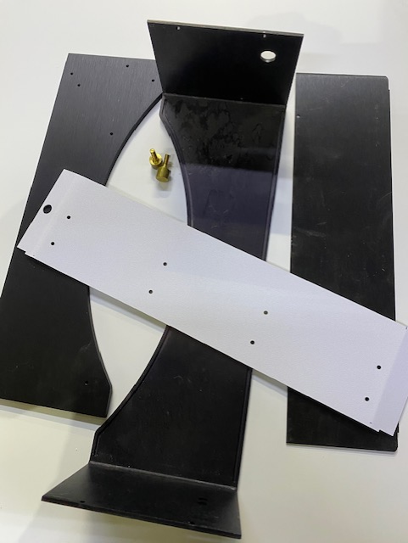

Then you need to find these parts or similar (hobby shop) below for a minimum build. You will need to cut and drill the brass strips. So mostly a drill and tape measure and a screw driver and some crimp connectors. You can add a charge plug to connect directly to the robot or add led charge indicators, etc...

brass screws 4-40 x 3/8
https://www.amazon.com/Hillman-Group-2057-Slotted-Machine/dp/B00HYKFFTA

brass strips

Amazon.com: K & S Precision Metals 9721 Brass Strip, 0.032" Thickness x 1/2" Width x 36" Length, 5 pcs, Made in USA : Industrial & Scientific

battery charger

Amazon.com : Moultrie 6-Volt Battery Charger : Sports & Outdoors

rubber feet

8 Small Round Rubber Feet Bumpers W/Screws - .250 H X .671 D - Made in USA - Amazon.com

Here is an original one 's picture

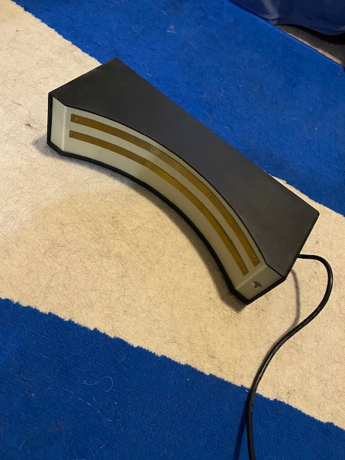

Email me for details smallrobot@hotmail.com

