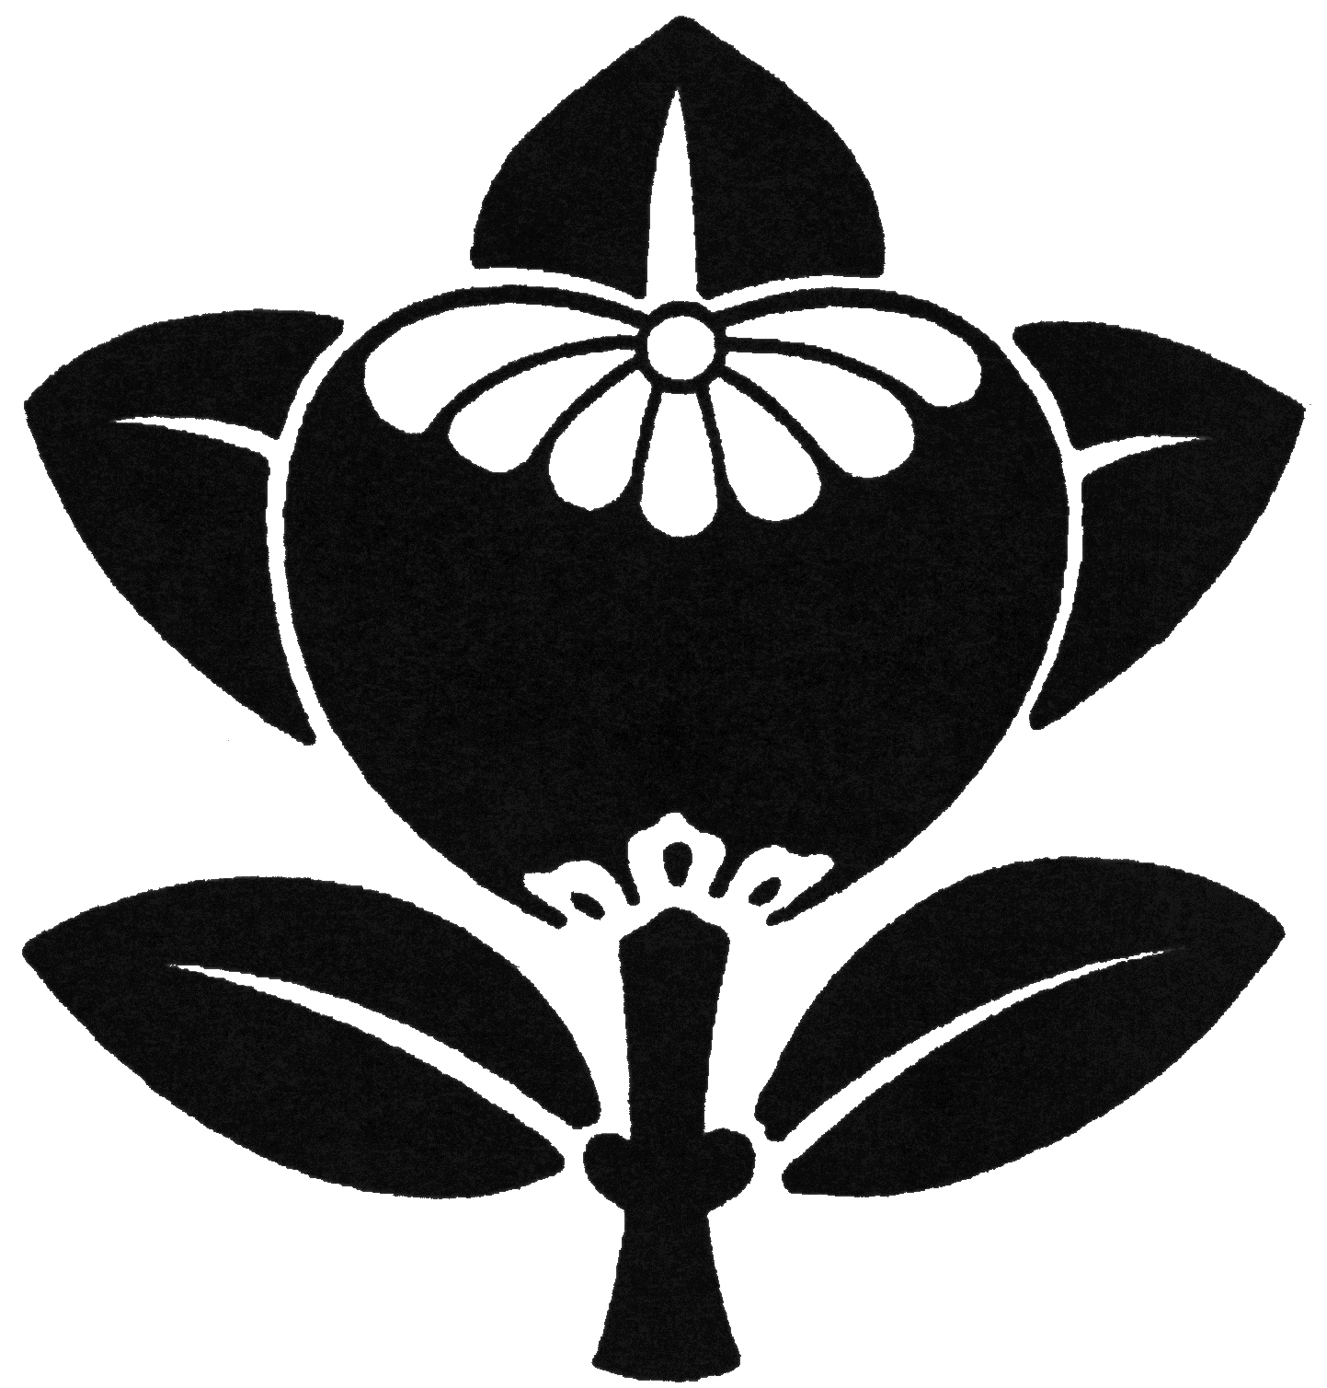
2019 MONTHLY PROGRAM

Meetings of the Ikenobo Ikebana Society Blue Ridge Chapter are held on the 3rd Thursday of each month at 10:00 a.m., First Congregational Church of Hendersonville, 1735 Fifth Avenue West, Hendersonville NC 28739. For information, please call 828-696-4103.

January - No Meeting

February 21 - Sumi-e and Calligraphy. Cultural Program: Emiko Suzuki and Nobuyo Tanaka. Raffle tickets for Sumi-e. Ginza.

March 21 – Demo/Workshop: Sayo Harris. Free Style with a Grocery Store Bouquet.

April 18 – Ikenobo 101/201: Beverly Barbour and Ann Baxter. Lecture only.

May 16– Demo/Workshop: Stephanie English. Shoka Shofutai Futakabu-ike.

June 25-26. Spring Workshop. Emiko Suzuki.

​July 18- Demo/Workshop: Stephanie English. Shoka Shimputai Futakabu-ike.

August 15— Demo/Workshop: Emiko Suzuki. Free Style with Dahlias in a Basket.

September 19 – Shoka Shofutai Hanging: Noriko Rajagopalan. Demo Only. Ginza.

October 22-23 – Fall Workshop. Visiting Professor from Japan.

November 16 – “Shimenawa, A Japanese New Year’s Decoration”. Workshop. Emiko Suzuki. NOTE: this is a Saturday meeting (Noon-2pm).

December 19- Holiday Luncheon/Certificate Recognition.

