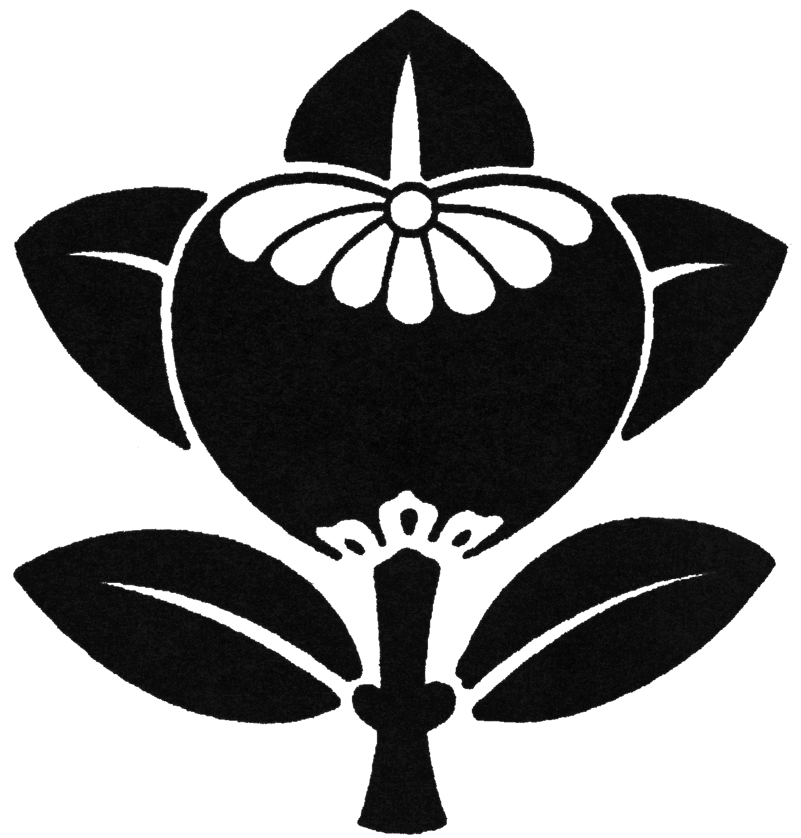
Ikenobo Ikebana Blue Ridge Chapter
2021 MONTHLY PROGRAMS

Meetings of the Ikenobo Ikebana Society Blue Ridge Chapter are held on the 3rd Thursday of each month at 10:00 a.m., First Congregational Church of Hendersonville, 1735 Fifth Avenue West, Hendersonville NC 28739. For information, please call 828-696-4103. Meetings are temporarily cancelled for the public due to COVID-19 restrictions.

January - No Meeting

February 18 – Cultural program by Laura Felt: Obi and Online Ginza

March 18 - Dan Dell’ Agnese: Zoom Ikebana Critique

April 15 - Demo by Noriko Rajagopalan: Basic Shoka Shofutai

May 20 - Demo by Laura Felt and Emiko Suzuki: Miniature Free Style

June 17 - Beverly Barbour and Emiko Suzuki: All About Hosta

​July 15 – Demo by Sayo Harris: Ikebana from a Garden

August 19 – Garden Tour and Plant Sale at Laura Felt’s home

September 14 & 15 – Fall Workshop: Visiting Professor from Japan

October 21 – Demo by Emiko Suzuki: Rikka Shimputai

November 13 – Demo by Laura Felt: How to Make an Art in Bloom Piece

December 16 - Holiday Meeting / Certificate Recognition

Note:
We may have to change the contents of the program in the future, so please read the monthly newsletter and announcements carefully.

