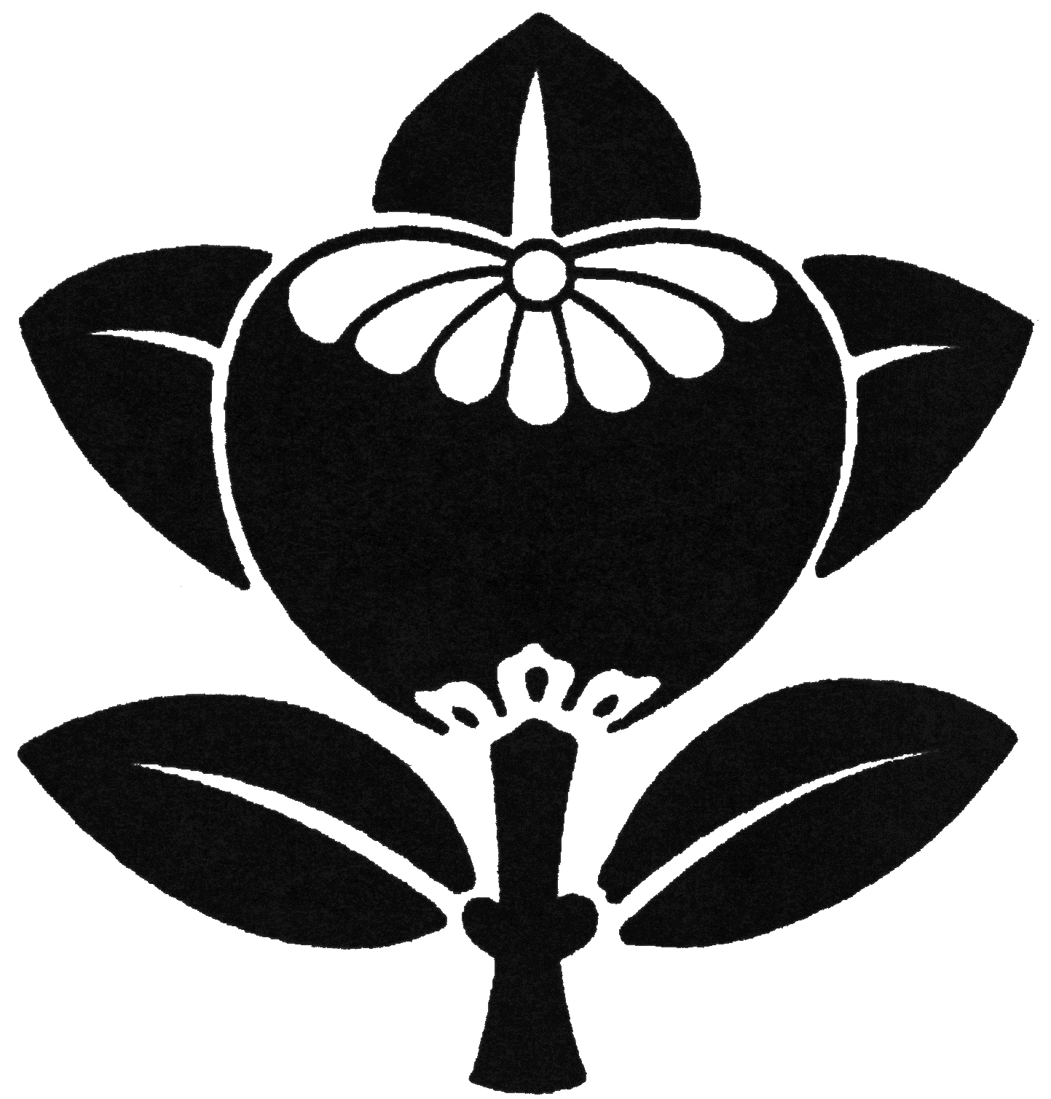

2022 MONTHLY PROGRAM

Meetings of the Ikenobo Ikebana Society Blue Ridge Chapter are held on the 3rd Thursday of each month at 10:00 a.m., First Congregational Church of Hendersonville, 1735 Fifth Avenue West, Hendersonville NC 28739. For information, please call 828-696-4103.

January - No Meeting

February 17 – Cultural program: Emiko Suzuki. Virtual Tea Ceremony on Zoom

March 17 – Virtual Ikebana Critique: Dan Dell ‘Agnese. Ask Dan Part II on Zoom

April 21 – Demo only (in person): Dede Walton and Emiko Suzuki. How to convert Shoka Shimputai to Rikka Shimputai at WNC Japanese Culture Center in Asheville.
Members only (Only a limited number of people)

May 19 – Zoom program: Basic Shoka and Advanced Shoka by Noriko Rajagopalan. Botanical Moment: Using Azaleas and Rhododendron in Ikenobo Arrangements by Beverly Barbour

June 16 – Demo only: Laura Felt and Emiko Suzuki. No No’s in Ikenobo Ikebana at Laura’s house and garden. Ginza and plant sale

July 21 – Demo &Workshop: Sayo Harris. Program TBA

August 23 & 24 – Summer Workshop: Visiting Professor from Japan

September 15 – Demo & Workshop: Peggy Snow. Free Style with Glass Container

October 20 – Demo & Workshop: Linda Boland and Pam Kolb. Ikebana with Rose

November 12 – Weekend Meeting. Demo & Workshop: Emiko Suzuki. Ikebana for the Holiday Season

December 15 - Holiday Luncheon/Certificate Recognition at Hendersonville CC

