

**MICROLEVEL INTERVENTION**

**INTERNATIONAL WOMEN’S DAY CELEBRATION 2021**

**#ChooseToChallenge**

**Nanhe Kadam Project**

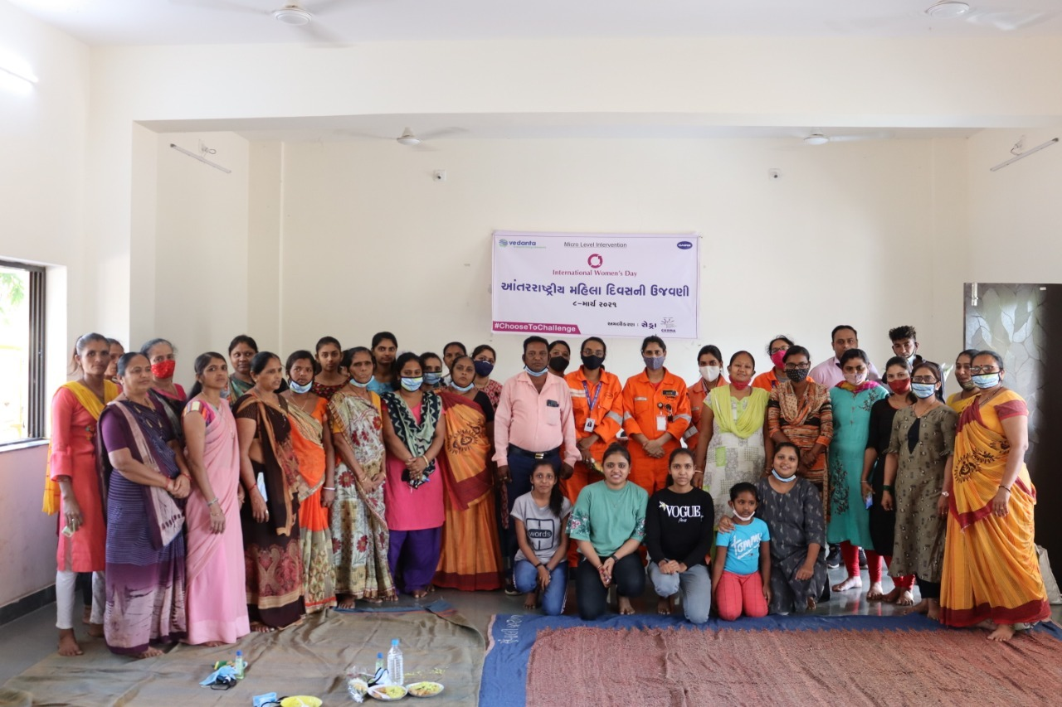

**Submitted by:**

**Centre for Education Developmental Research and Action**  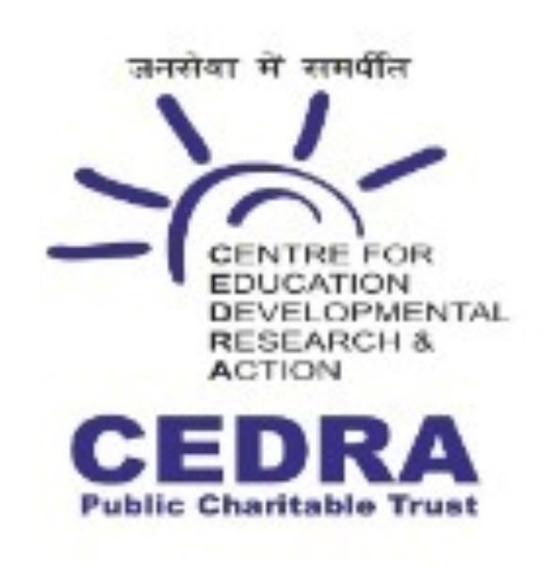

**The MLI at a glance**

**Name of Activity :**  International Women’s Day Celebration 2021

**Date & Time :** 09-03-2021 & 3:00pm to 5:00pm

**Place :** Community Hall, Suvali Village, Hazira, Surat

**Objective :** To Increase Awareness on Women Empowerment through Income Generation Activity (IGA).

**Target Group :** Women of the village

**Resource Person :** Mrs. Falguniben – Taluka Livelihood Manager,

**No. of Participants :** 64 Women & Adolescents

**List of Guests :**

|  |  |  |
| --- | --- | --- |
| No. | Name | Designation |
| 1 | Mrs. Vasantiben Patel | Taluka Panchayat Member & President of Roshni Sakhi Mandal, Damka Village |
| 2. | Mrs. Ankitaben Patel | Wise President of Roshni Sakhi Mandal, Damka Village |
| 3. | Mrs. Falguniben | Manager - Taluka Livelihood |
| 4. | Mrs. Jalpaben Patel | Assistant Manager - Taluka Livelihood |
| 5. | Mrs. Nayanaben Rathod | Sarpanch – Suvali Village |
| 6. | Mr. Bipinbhai Patel | Deputy Sarpanch – Suvali Village |
| 7. | Mrs. Reenaben Tailor | Talati – Suvali Village |
| 8. | Mrs. Heenaben Patel | FHW – Suvali PHC |
| 9. | Mrs. Krishnaben | LT – Suvali PHC |
| 10. | Ms. Ruchi Sangwan | Manager – Security (Vedanta Limited) |
| 11. | Ms. Poonam Saini | Project Engineer (Vedanta Limited) |
| 12. | Mr. Ajay Choursia | Senior Executive – HR & Admin (Vedanta Limited) |
| 13. | Ms. Kangkana Kalita | Graduate Engineer Trainee (Vedanta Limited) |
| 14. | Ms. Priyanka Kadam | Graduate Engineer Trainee (Vedanta Limited) |

**The Report**

**About International Women’s Day:**

International Women’s Day is a time to reflect on progress made, to call for change and to celebrate acts of courage and determination by ordinary women who have played an extraordinary role in the history of their countries and communities.

It is also an opportunity to consider how to accelerate the [2030 Agenda](http://www.unwomen.org/en/what-we-do/post-2015), building momentum for the effective implementation of the [Sustainable Development Goals](http://www.un.org/sustainabledevelopment/), especially goal number 5: Achieve gender equality and empower all women and girls; and number 4: Ensure inclusive and quality education for all and promote lifelong learning.

Some key targets of the 2030 Agenda:

By 2030, ensure that all girls and boys complete free, equitable and quality primary and secondary education leading to relevant and Goal-4 effective learning outcomes.

By 2030, ensure that all girls and boys have access to quality early childhood development, care and pre-primary education so that they are ready for primary education.

End all forms of discrimination against all women and girls everywhere.

Eliminate all forms of violence against all women and girls in the public and private spheres, including trafficking and sexual and other types of exploitation.

Eliminate all harmful practices, such as child, early and forced marriage and female genital mutilation.

**Activity Detail:**

VEDANTA Limited- Cairn Oil & Gas and CEDRA have organized an International Women’s Day Celebration Program at Suvali Village on 9th March 2021 to ***Increase Awareness on Women Empowerment through Income Generation Activity (IGA).*** Project team called an active Self Help Group – Roshni Sakhi Mandal form Damka Village who run their small home industries with making income generating products like papad, papadi, pickle, chicki, laddu etc. project team also called a Taluka livelihood Manager – Mrs. Falguniben to clear the concept of SHG

The program was started with welcome speech by a Suvali Primary School teacher Mrs. Darshanaben Raval. After that all guests and the all members of Roshni Sakhi Mandal Damka were welcomed by flower buckets. Mrs. Darshanaben Raval delivered a lecture about Women’s Day and covered the following topics:

* About International Women’s Day
* Why we celebrate International Women’s Day
* Impotence of International Women’s Day
* Role of women in society
* How we prove our importance in society

Ms. Ruchi Sangwan – Security Manager of Vedanta limited delivered a motivational speech on Important of Women’s Day.

Chief Guest of the program Mrs. Vasantiben Patel who is the president of Roshni Sakhi Mandal and the Taluka Panchayat member also delivered a motivation speech about women’s day and covered the following topics

* About International Women’s Day
* What can a woman can do
* About Roshani Sakhi Mandal Group
* Sakhi Mandal group’s Activities
* About their income generating products
* How they make the products
* How they sell the products
* Active participants of all group member

Mrs. Vasantiben and their group run a Small Home Industry name ROSHNAI GRUH UDYOG. Project team specially called them to present themselves to encourage and motivate suvali village self help groups and their members.

Mrs. Falguniben – a Taluka Livelihood Manager and Mrs. Jalpaben patel – asst. manager from Taluka Panchayat – Choryasi Taluka has also delivered speech and cleared all the doubt related to SHG group.

Project team honored the chief guest Mrs. Vasantiben on behalf of Roshni Sakhi Mandal by a gift to attend the program with her group.

To encourage the SHG members, Project team distributed refreshment made by Roshni Gruh Udyog. Project team also distributed a mask, a sanitizer and a steel glass to each participant as a memorable gift on the celebration of International women’s day.

The overall event was managed and implemented by CEDRA (Centre for Education Developmental Research and Action) NGO as a CSR partner of CAIRN-VEDANTA under Micro Level Intervention (MLI) Project. Mr. Mayur Patel, Coordinator, CEDRA remained present throughout the event for smooth functioning of the program alongside guests from CAIRN-VEDANTA, Village and Taluka Panchayats and Government departments.

**Pictures:**

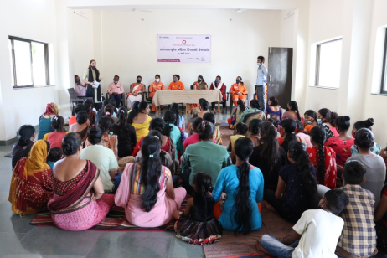 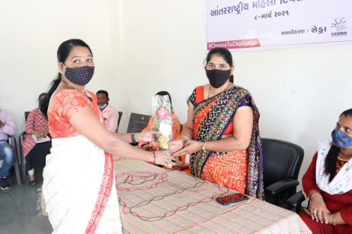 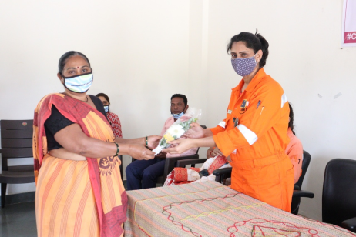

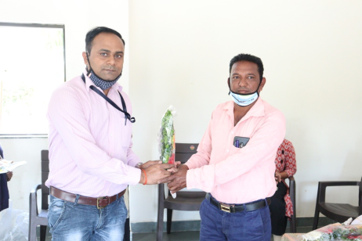 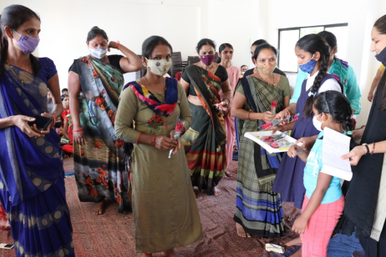 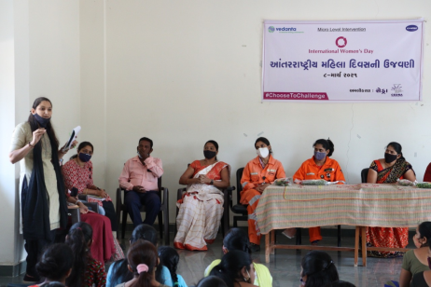

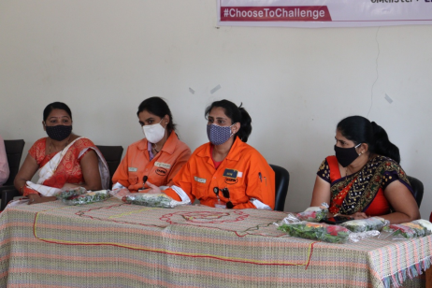 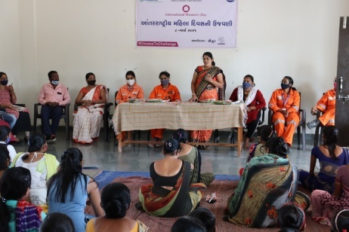 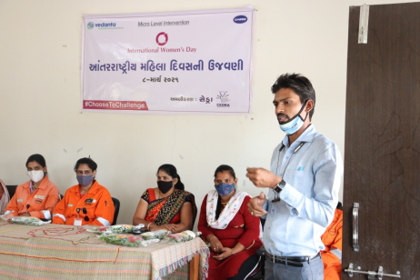

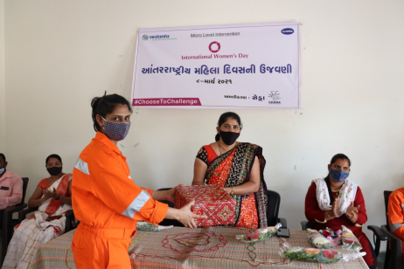 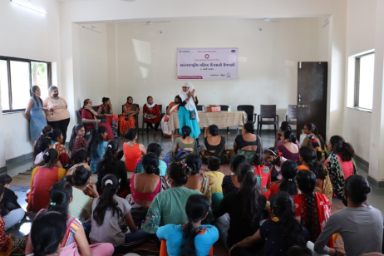 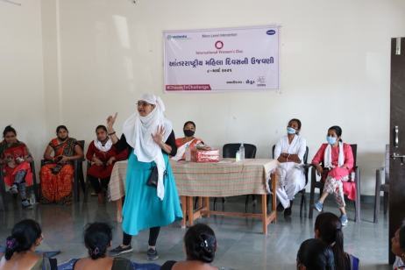

-: Reported By:-

