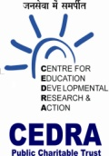
COVID-19 Relief Activities by CEDRA
Year 20-21
As a non-profit organization, CEDRA has conducted various activities online as well as offline to support a very noble cause by making awareness videos, stories, and online inspirational sessions on COVID-19.
These activities will help a person to overcome the difficult situation caused by the Corona Virus and keep the spirits high for never giving up.
Below are the links and description for the various virtual activities we have conducted:

VIRTUAL ACTIVITIES
The links provided will guide you through the virtual activities, videos, stories and inspiration thorough music/songs conducted by CEDRA in order to spread awareness on COVID-19.
COVID AWARENESS through SOCIAL MEDIA
https://www.facebook.com/sanjayvincent/videos/10217679961733939/
"Live the life you have today" :
https://www.facebook.com/sanjayvincent/videos/10218271723007601/
Also live sessions and music videos were conducted and posted on Facebook through different experts to motivate people how to handle various difficult situations in this pandemic.
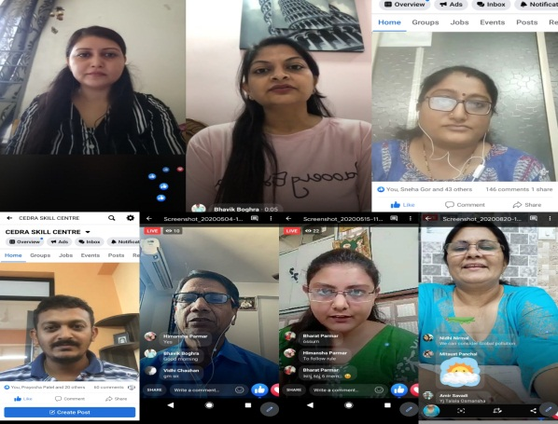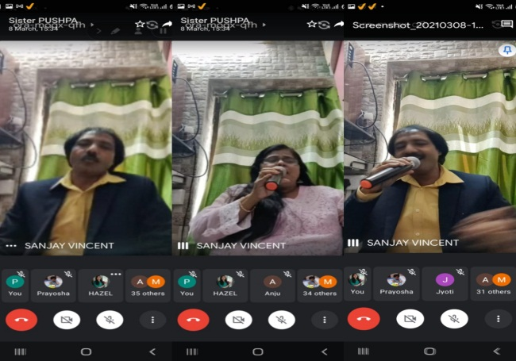

HUMANS IN LOCKDOWN:
We have also created a website where our expert counselors helped the people to overcome depression caused by loss of job/family member or any other mental stress caused by the pandemic. This website also provided platform to youth and others to share their inspirational stories which can provide motivations to the youth who are facing depression and lonely due to the situation. All were inspired to share their stories under the title of:
Sharing our Quarantine Story and Spreading the message of happiness in this tough situation
For more information and updates pls visit our websites;
https//humansinlockdown.cedra.in and www.cedra.in
PHYSICAL ACTIVITIES
As a part of Quest Alliance S2S course in CEDRA skill center, we had conducted some activities involving the students to spread awareness on COVID-19. The students had made posters on positive and negative aspects involved to encounter the pandemic situation and how to keep ourselves safe and healthy.
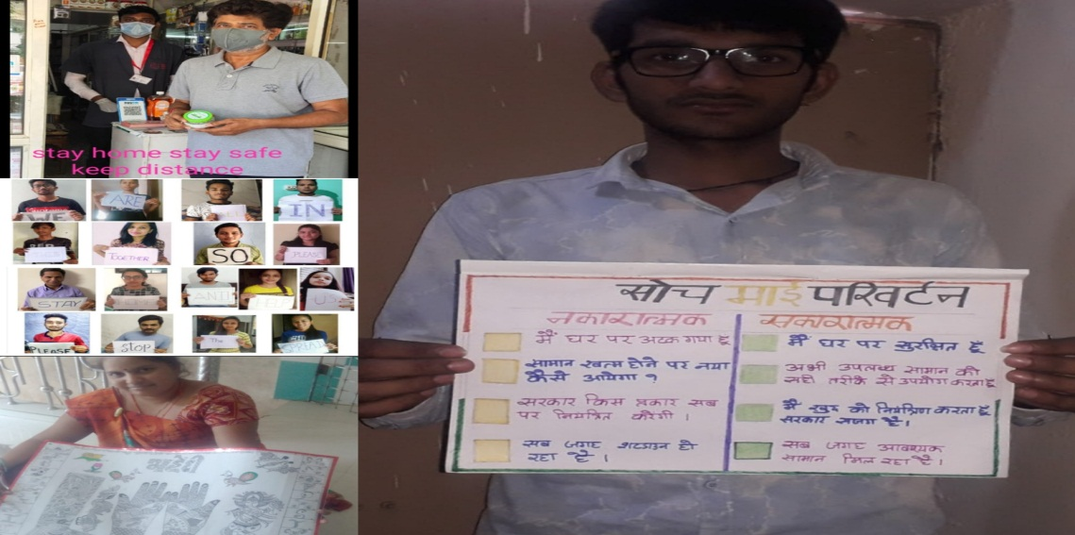
Helping the needy is a very important part of our initiative. We at CEDRA distributed ration kits, face masks and sanitizers to our students and the less fortunate people who were facing financial crisis due to the pandemic.
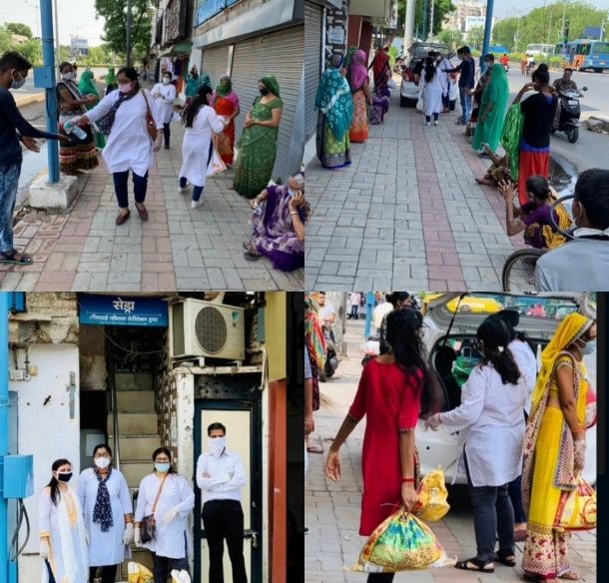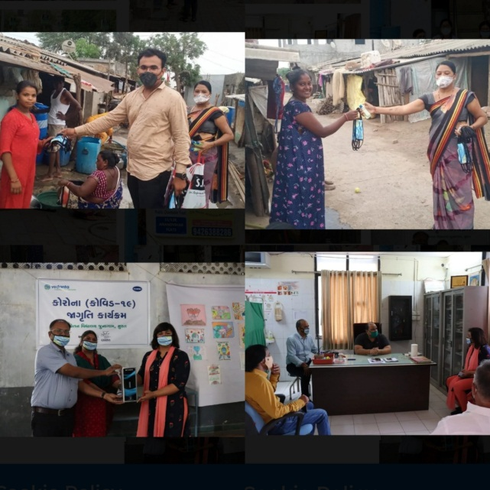

Thank You

