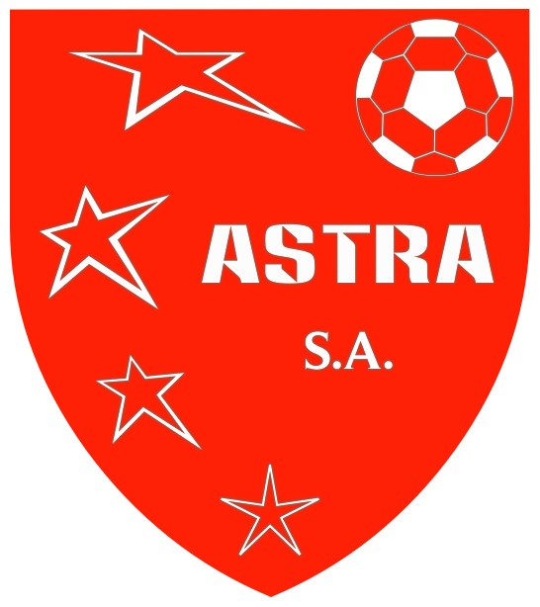

Player Registration Form

Team Interest: U- _______ Boys Girls
Player Info: Name _____________________________ Birth Date ________________
Address ____________________________________ City, Zip ____________________
Home Phone __________________ Current School & Grade ______________________
Mother’s Name _____________________________ Home Phone _________________
Cell Phone __________________ Email Address _______________________________
Father’s Name _______________________________ Home Phone _________________
Cell Phone __________________ Email Address _______________________________
Emergency Contact Name & Phone #: ________________________________________
Please list player’s soccer experience and positions played/desired below:

Waiver and Release:
Please read this form carefully and be aware that in signing up for and participating in programs/activities, you will be expressly assuming the risk and legal liability and waiving and releasing all claims for injuries, damages or loss which you or your minor child/ward might sustain as a result of participating in any and all activities connected with and associated with said programs/activities (including transportation services/vehicle operations, when provided).
The undersigned recognizes and acknowledges that there are certain risks of physical injury to participants in these programs/activities, and voluntarily agrees to assume full risk of any and all injuries, damages or loss, regardless of severity, that my minor child/ward or I may sustain as a result of said participation. I further agree to waive and relinquish all claims against Astra Soccer Academy, including its officers, directors, officials, agents, volunteers and employees (hereinafter collectively referred as the Academy), which I or my minor child/ward may have (or that accrue to me or my child/ward) as a result of participating in these programs/activities. I hereby release and forever discharge the Academy from any and all claims for injuries, damages or loss that my minor child/ward or I may have or which may accrue to me or my minor child/ward arising out of, connected with, or, in any way associated with these programs/activities.
In the event of an emergency, I authorize the Astra Soccer Academy to secure from any accredited hospital and/or physician any treatment deemed necessary for immediate care of my minor child/ward and agree I will be responsible for any and all medical services rendered.

I have read and fully understand the above information, warning of risk, and waiver and release of all claims.

Parent Signature ___________________________________ Date _________________________

