

SAFETY BULLETIN

Winter Driving Advisory: Four-wheel Drive and Speed Adjustment Misconceptions
On January 17, 2022, an SMG Associate experienced a vehicle event. The Associate began driving in Marion County (Indianapolis, IN) on Interstate-69 northbound without any regional (weather) advisory alerts detected. After driving 100 miles north on I-69 northbound into Huntington County (Markle, IN), icy conditions were encountered as the Associate drove within the Interstate-69 northbound fast lane at a designated speed limit (70 mph) and in a four-wheel drive (high) setting. A separate third-party vehicle began swerving (sliding) sporadically on the Interstate-69 northbound slow lane, and horizontally slid from the Interstate-69 northbound slow to fast lanes. The Associate attempted adjusting to the other vehicle in these changing (icy) weather conditions, but ultimately both vehicles experienced a collision. No injuries were sustained from any parties involved.
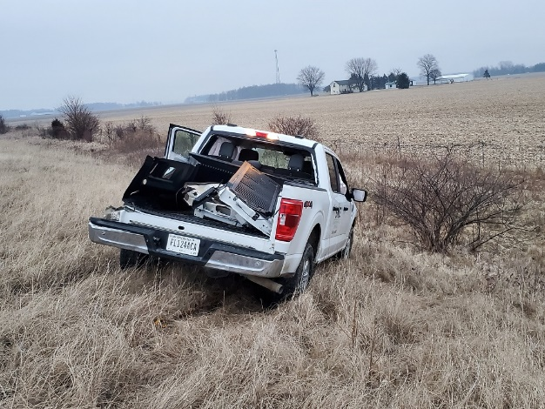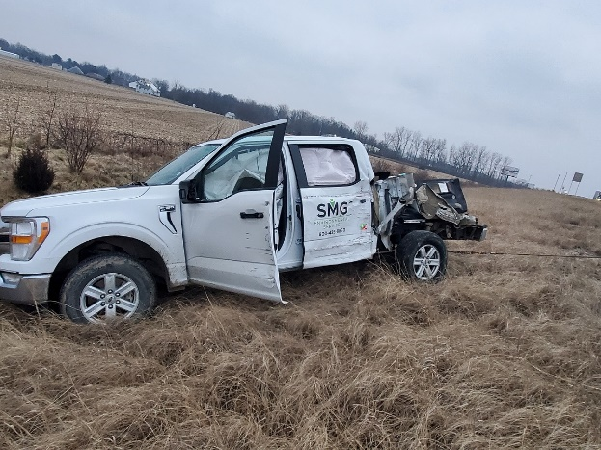

- U.S. Department of Transportation (DOT):
- 70% of the Nation’s roads are located in snowy regions, which receive more than five inches average snowfall annually.
- Each year, 24% of weather-related vehicle crashes occur on snowy, slushy or icy pavement.
- 1,300 people are killed and more than 116,800 people are injured in vehicle crashes on snowy, slushy or icy pavement annually.
- Root cause analysis identified four-wheel drive (high) and speed settings to be identifying factors in the Associate’s vehicle event.
- Key factor for ice/snow driving performance is not between the two-wheel and four-wheel vehicle capability, but the vehicle’s ability to grip the road surface between the road and tire (also known as “traction”).
- Misconception: Four-Wheel Drive Improves Braking
- False: a vehicle with two-wheel drive has the same braking system a four-wheel drive vehicle does, so there is no advantage here.
- It can also be identified that a heavier vehicle with greater surface area is even harder to stop.
- Misconception: Four-Wheel Drive Improves Steering
- False: this myth is perpetuated because the four-wheel drive system may help to initially start the vehicle and change direction, but does not improve steering capability whatsoever.
- Misconception: Four-Wheel Drive Improves Traction
- False: the four-wheel drive system only makes the wheels turn and spin, and does not improve the contact between the road and tire.
- Misconception: four-wheel drive helps on the ice and snow is falsely and overconfidently perpetuated because general vehicles with four-wheel capability have generally larger tires and greater surface area for ice and snow to get into the tread.
- While the vehicle’s owner manual states, “four-wheel drive high range provides additional traction for loose or slippery road surfaces,” the SMG Fleet Management Team advises for four-wheel drive (high) to not be initiated above 60 mph on general roadways.
- Misconception: Driving the Speed Limit in Changing Conditions is a Safe Practice
- False: State law requires drivers to move at a speed that is “reasonable and proper” for the road conditions, not the speed limit.
- Drivers can begin sliding off the road on certain types of black icing at 10 mph or less!
- Drivers often aren’t prepared for winter driving and forget to take it slow. Remember to drive well below the posted speed limit and leave plenty of room between cars.
- Remember: ice and snow, take it slow!
- Indiana Department of Transportation (INDOT) Winter Advisory Recommendations:
- Be Prepared:
- Before leaving home, find out about the driving conditions throughout different regions you’re driving in.
- Remove any ice/snow on your vehicle’s windows, lights, brake lights and signals. Make sure you can see and be seen.
- Leave plenty of time to reach your destination safely. It’s not worth putting yourself and others in a dangerous situation to be on time.
- Keep a winter survival kit in your vehicle, including a flashlight, batteries, blanket, snacks, water, gloves, boots, ice scraper/snowbrush, road flares and first-aid kit. To safely distribute the weight of your vehicle in changing roadway conditions, consider adding 04 – 06 sandbags in the truck bed to evenly distribute the vehicle’s weight from front to back.
- Caution: Slippery When Wet!
- Remember to drive well below the posted speed limit and leave plenty of room between cars.
- Take it slow when approaching intersections, off-ramps, bridges or shady areas – all hot spots for black ice. Remember: ice and snow, take it slow!
- Stay attentive and reduce speed. Know what’s going on around you.
- No matter what type of vehicle you drive, you may not be able to stop any faster or maintain control any better in four-wheel drive once you lose traction.
- Proceed with Caution!
- The faster you’re going, the longer it will take to stop. When accelerating on ice or snow, take it slow.
- Give yourself space. It takes extra time and extra distance to bring a vehicle to stop on icy/snowy roads.
- Brake early, brake slowly, brake correctly and never slam on the brakes. If you have anti-lock brakes, press the pedal down firmly and hold it. If you don’t have anti-lock brakes, gently pump the pedal.
- Do not use cruise control and avoid abrupt steering maneuvers. When merging into traffic, take it slow. Sudden movements can cause your vehicle to slide.

REMEMBER: ICE AND SNOW, TAKE IT SLOW!

For Internal Use Only – Please do not forward outside of the SMG Team.
Respectfully,
Keisha Lopez
Safety Support Coordinator

M: 606.634.4941
8335 Keystone Crossing, Ste 103, Indianapolis, IN 46240
Did you know we launched a contractor safety and prequalification data management tool? Check it out here

