Safety Alert: Motor Vehicle Incident

Alert Type: Vehicle Incident – Collision
Description: An associate traveled southwest on a four-lane road with a center turn lane when a driver of a privately-owned vehicle attempted to turn northeast from a side street and struck the company vehicle, resulting in a Vehicle incident.
What Happened: At approximately 12:00 PM, on April 20, 2023, the associate traveled southwest in the right lane and noticed a semi-truck stopped approximately 300 feet ahead with activated hazard warning lights. A driver of a privately-owned vehicle attempted to cross several lanes of traffic and turned northeast and struck the company vehicle as it passed the semi-truck.
What Resulted: Both vehicles sustained damage and a portion of the SMG vehicle stopped in the oncoming traffic lane. Neither driver sustained injuries. The Safety & Fleet Manager received a possible accident alert from the GeoTab device and contacted the associate. A tow truck removed the company vehicle and the associate’s leadership arrived on scene to assist.
What positive actions were taken:
- Our associate utilized Key 1 – Aim High in Steering which provided more time and allowed a safe lane change.
- Our associate reduced speed to pass the inoperable vehicle which reduced the severity of the impact and damage.
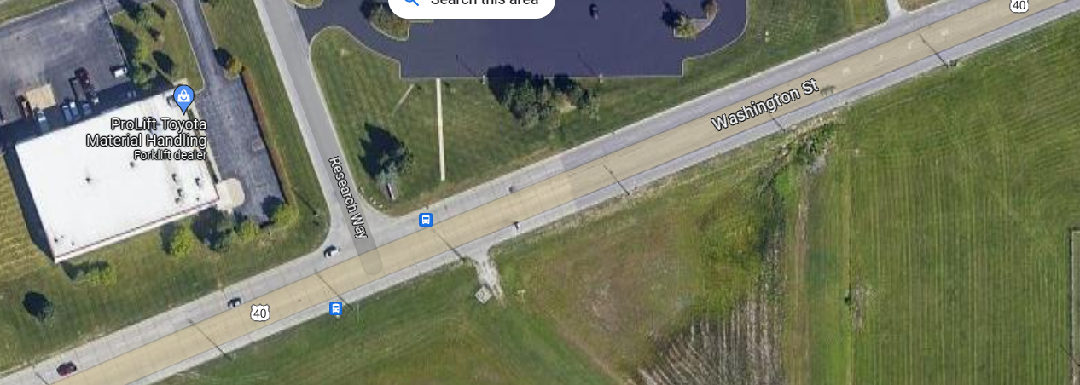

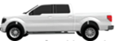
V1
V2
V3
V1-SMG Vehicle
V2-POV
V3-Semi-truck
V1 in left lane traveled SW on Washington Street and passed V3 which was stopped in right lane waiting to turn north on Research Way.
V2 turned east on Washington St. and struck V1 on passenger side front.

