Safety Alert: Vehicle Vandalism & Theft of Company Property

Alert Type: Vehicle Vandalism & Theft of Company Property
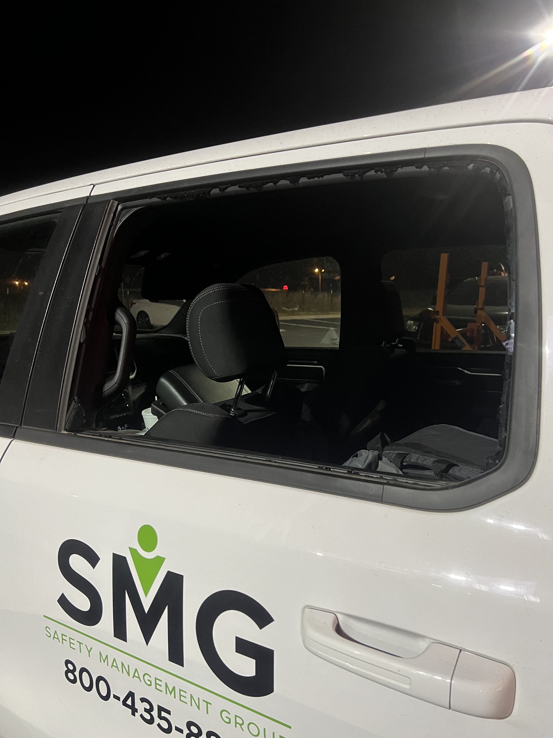
Description: An associate traveled overnight and parked in a hotel parking lot on February 27, 2023.
What Happened: At approximately 1:30 AM, on February 28, 2023, the associate went to the truck to retrieve an item and discovered a broken back window on the driver’s side.
What Resulted: The associate checked the truck and discovered a missing backpack that contained an iPad, client documents and training material. The associate contacted the local police and the hotel staff.
How can we prevent similar incidents:
- When traveling overnight, remove all backpacks, bags, GPS units, etc. from the vehicle.
- Laptops or tablets should never be left in a vehicle overnight due to not only the potential for theft, but also condensation that is created due to temperature extremes can harm these devices.
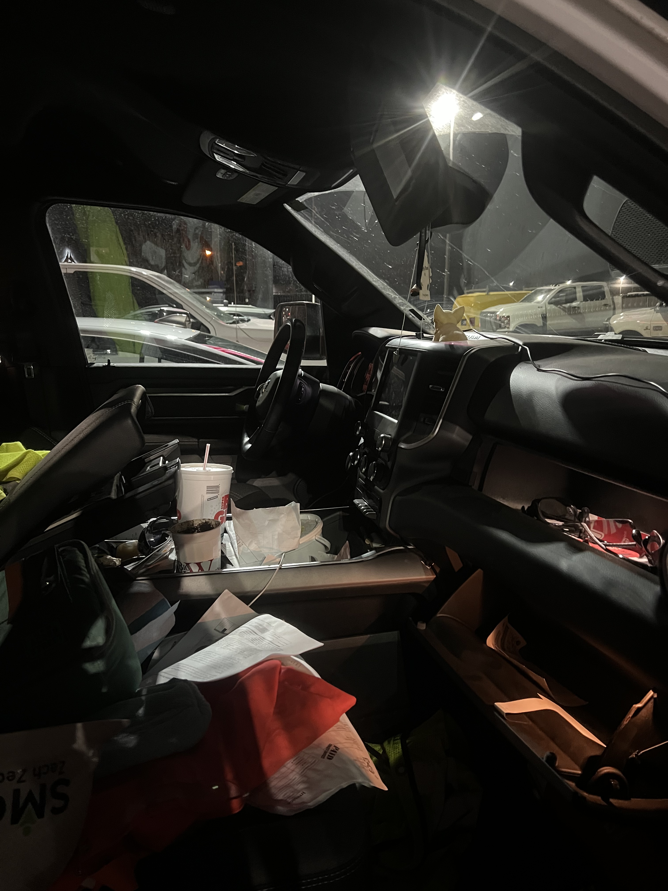
- Park in a well-lit area.
- Remove charging cords or place them out of plain sight in the arm rest storage or glove box to remove the perception of any mobile device in the vehicle.
- Lock all doors and roll up all windows.

Reminder: Associates who operate Company vehicles must ensure the vehicle and its contents are protected from damage. Associates must secure the vehicle and store items inside the vehicle in a manner that does not invite vandalism or theft. ~ Company Vehicle Driving Policy

