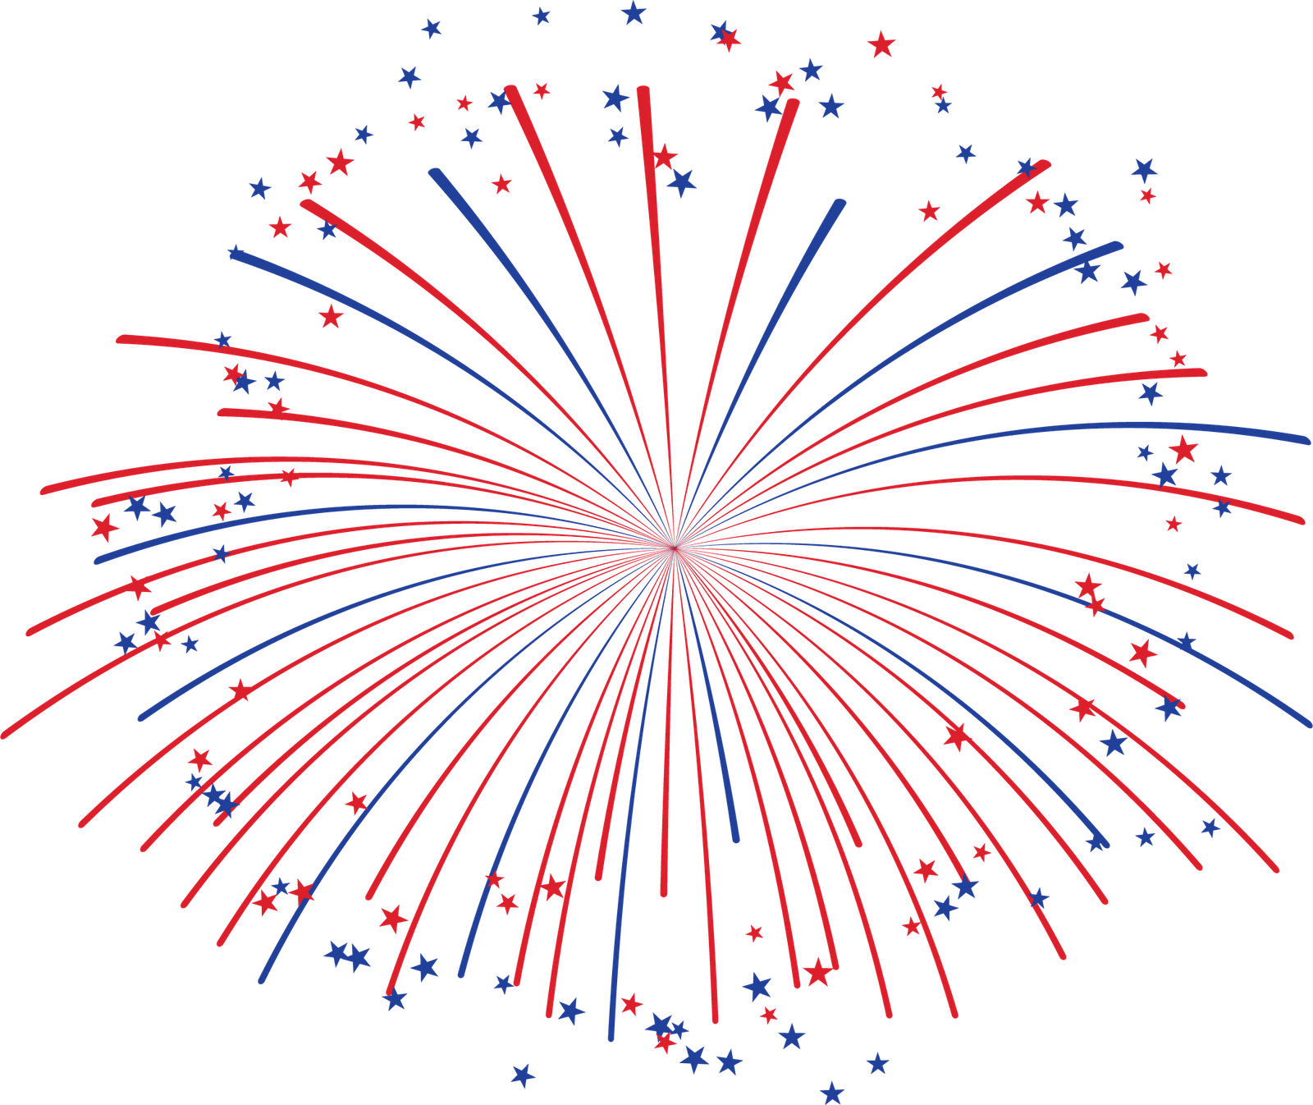
4th of July Weekend
Safety Measures

Fireworks

Swimming

COVID-19 Precautions

Drinking

Heat

