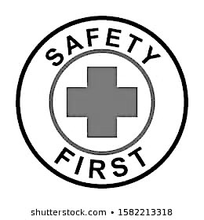

Emergency Kit

In case of a situation arising in which the students must stay

overnight, we are asking all families to bring in the following

in \***a gallon Ziploc bag**\*:

1.) Small flashlight with extra batteries

2.) Change of clothing, including socks and a light jacket or sweatshirt.

This is also useful for accidents during the year.

3.) Toothbrush and toothpaste

4.) Family photo and a caring note

5.) Small special toy (optional)

6.) Any and all personal medications

7.) Emergency blanket **

(**Emergency blanket can be found for approx. $8.00 on Amazon)

Please do NOT include any type of food. The school has on hand emergency food, lanterns, first aid kits, water, utensils and radios.

Student: ______________________________ Teacher: __________________

Mother: ______________________________ Phone: __________________

Email: ______________________________ Cell: _____________________

Father: _______________________________ Phone: ___________________

Email: _______________________________ Cell: _____________________

Out of state phone lines are generally easier to access or are restored sooner than local lines during an emergency. We therefore would like you to give us an emergency contact number out of the area. We will contact you as soon as we are able.

Name & Number of person out of the area:

____________________________________________________________________