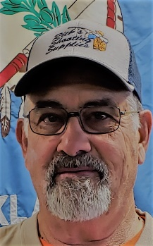

PRESIDENT Ron Bliss

18575 SW 29th St., El Reno, OK 73036

405-641-8979



VICE-PRESIDENT Rick Bliss

PO Box 2642

Ponca City, OK 74602

580-716-2365

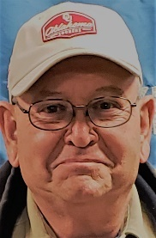

3RD DIRECTOR Mike Cook

No 7, North 28th

Duncan, OK 73533

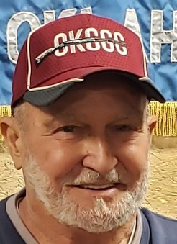

4TH DIRECTOR Paul Hooper

808 County Street 2932

Tuttle, OK 73089

405-535-2720

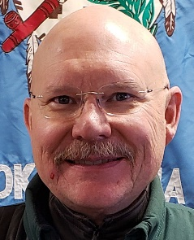

5TH DIRECTOR Lyndon Shumaker

9505 Clayton Park Rd

El Reno, OK 73036

405-815-9237

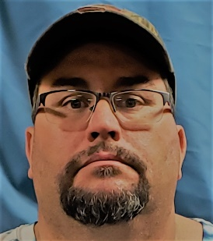

6TH DIRECTOR John Ewing

10501 NW 40th

Yukon, OK 73099



7TH DIRECTOR Kevin Nanke

15817 Harts Mill Road

Edmond, OK 73013

405-694-1790

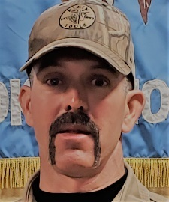

8TH DIRECTOR Eric Kappus (Appointed)

17450 SW 59th St

El Reno, OK 73036

405-642-1454

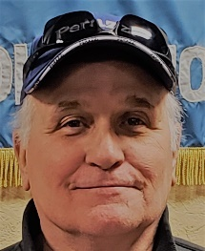

9TH DIRECTOR Jack Murphy (Appointed)

Rt 1, Box 493

Nowata, OK 741048



10th DIRECTOR Nathan Lemke

2435 Townsend Dr

El Reno, OK 73036

405-274-9825



11th DIRECTOR Dennis Patrick

6421 S. Highway 81

El Reno, OK 73036

405-627-4184

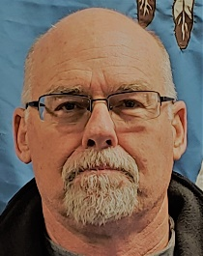

EX OFFICIO Brian Northrup

1704 E. Bradley Dr.

El Reno, OK 73036

405-274-1771



ATA DELEGATE Tim Diester

5509 S. Monty Dr.

Oklahoma City, OK 73119

405-417-2236



ALTERNATE ATA DELEGATE Patrick Stacy

1608 N. 14th

Frederick, OK 73452



TRAP FIELD COORDINATOR

Marcus Escalera

405-593-3657



WEBMASTER Mikie Hooper

808 County St 2932

Tuttle, OK 73089

405-326-7553

Email: mikiehooper@yahoo.com