
PRESIDENT Mike Grove
701 East 14th Street
Holdenville, OK 74848
405-997-9844

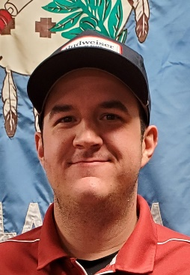

VICE PRESIDENT Chance Fleming
12116 SW 17th
Yukon, OK 73099
580-302-3156

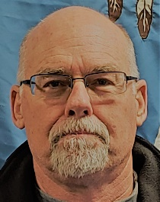
SECRETARY-TREASURER Brian Northup
ALTERNATE ATA DELEGATE
1704 E. Bradley Dr.
El Reno, OK 73036
405-274-1771


DIRECTOR Paul Hooper
Trap Maintenance & Target Setting
808 County Street 2932
Tuttle, OK 73089
405-535-2720

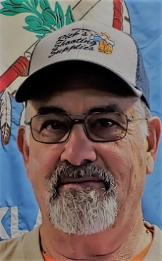
DIRECTOR Ron Bliss
State & Zone Shoot Director, Camping Mgr
Trap/Scorers Mgr
18575 SW 29th St.
El Reno, OK 73036
405-641-8979


DIRECTOR Dennis Patrick
Public Relations, Computer Operations
Trap/Scorers Mgt
6421 S. Highway 81
El Reno, OK 73036
405-627-4184

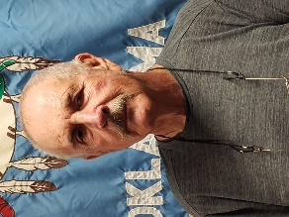
DIRECTOR Richard Dekker
Housekeeping, Condiments & General Supplies
12000 SW 26th
Yukon, OK 73099
405-640-8532


DIRECTOR Nathan Lemke
General Maintenance, Water Mgt
Trap/Scorers Mgt
Work with 4-H Youth on Minor Maintenance
2435 Townsend Dr
El Reno, OK 73036
405-274-9825

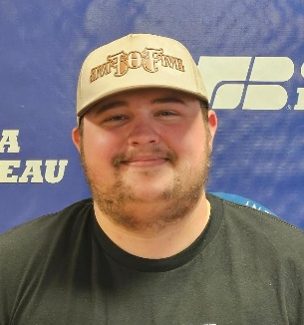
DIRECTOR Brayden Bliss
Redlands Shooting Coach
908 Eagle Ridge Run
Tuttle, OK 73089
405-320-9937
Email: braydenbliss84@gmail.com

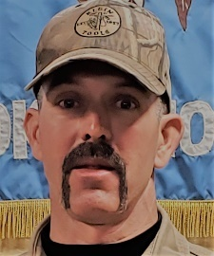
DIRECTOR Eric Kappus
Electrical Maintenance & Canadian County 4-H Coordinator
17450 SW 59th St
El Reno, OK 73036
405-642-1454

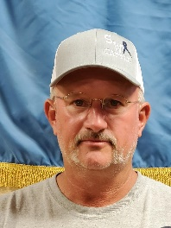
DIRECTOR Paul Hightower
AIM Coordinator & Red Dirt Gun Club Mgr
12049 N. 2020 Rd.
Elk City, OK 73644
580-799-5543


DIRECTOR Tom Richey
Speaker Maintenance & Repair & General Support
7600 N Rockwell Ave
Oklahoma City, OK 73132
405-205-5211


DIRECTOR AT LARGE Richard Coit
Assists with Club Operations and Maintenance
1113 Camelot Dr
Clinton, OK 73601
580-744-0354

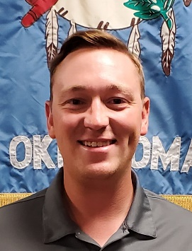
DIRECTOR Corbin Grybowski
PO Box 712
Arapaho, OK 73620
580-445-8276


DIRECTOR Tim Mount
Mowing and grounds upkeep
1409 Nelm Drive
Mustang, OK 73064
405-317-8833
Jitter226@cox.net

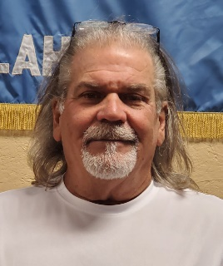
DIRECTOR Michael Gould
Mowing and grounds upkeep
951 County Street 2989
Blanchard, OK 73010
405-409-5230


DIRECTOR – Spencer Scotten
5005 Darlington Rd
El Reno, OK 73036
417-684-4743

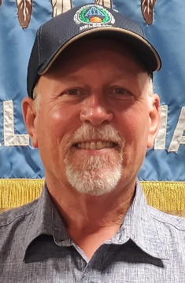
ATA Delegate – Jeff Trayer
13104 East 135th Place North
Collinsville, OK 74021
918-932-4029


WEBMASTER Mikie Hooper
808 County St 2932
Tuttle, OK 73089
405-326-7553
Email: mikiehooper@yahoo.com

