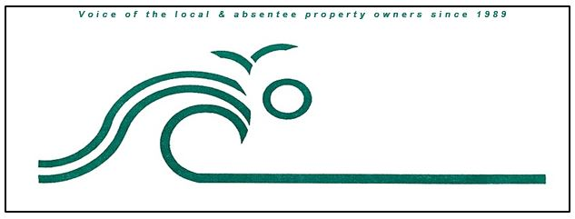

**Fruitville Beach Civic Association**

**PO Box 482**

**Corolla, NC 27927**

[**https://www.fruitvillebeach.com/**](https://www.fruitvillebeach.com/)

**Membership Request**

Please remit one (1) completed form (postal or email) and $30 payment per property owner to:

FBCA

PO Box 482

Corolla, NC 27927 OR [FBCAMembership@gmail.com](mailto:FBCAMembership@gmail.com)

**Please note:** Payment via check or credit card using PayPal may be submitted on our website at <https://www.fruitvillebeach.com> . After submitting payment, please email this form to the email address above.

Name Click here to enter text.

Mailing Address (include city, state & zip code) Click here to enter text.

Cell Phone Click here to enter text.

E-mail Address* Click here to enter text.

Beach 911 Address Click here to enter text.

Subdivision Click here to enter text.

Paid Amount Click here to enter text.

Date of payment Click here to enter a date.

Method of payment Choose an item.

**Please check if you are willing to be contacted about serving on the FBCA Board**

Visit our website at: <https://www.fruitvillebeach.com>

Join our Facebook page: [Fruitville Beach Civic Association](https://www.facebook.com/groups/5616285088414127)

* Including an email address helps defray the cost of mailing newsletters