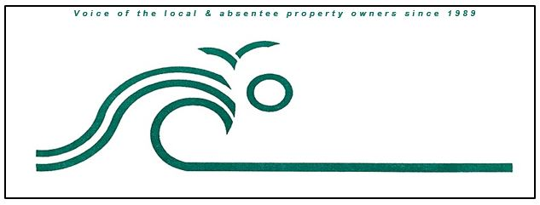

**Fruitville Beach Civic Association**

**PO Box 482**

**Corolla, NC 27927**

[**https://www.fruitvillebeach.com/**](https://www.fruitvillebeach.com/)

**Membership Request**

Please remit one (1) completed form (email or snail mail) and $30 payment per property owner to:

FBCA

PO Box 482

Corolla, NC 27927 OR [FBCAMembership@gmail.com](mailto:FBCAMembership@gmail.com)

**Please note:** Payment via check or credit card using PayPal may be submitted on our website at <https://www.fruitvillebeach.com> . After submitting payment, please email this form to the email address above.

Name _________________ ________________________________________________________

Mailing Address _____________ ____________________________________________________

City _________________________ _____ State _________ Zip Code __________________

Phone # _________________________________ _______________

E Mail Address ______________________________ ______________________________

Beach 911 Address ______ ___________________________________________________

Subdivision ____________ ___________________________________________________

Paid Amount & Submission method $ _____ Credit Card _____ Check # ________ Cash __ __

**Please check if you are willing to be contacted about serving on the FBCA Board**

Please visit our website at: <https://www.fruitvillebeach.com>

Email us at: [FBCAMembership@gmail.com](mailto:FBCAMembership@gmail.com)

* Including an email address helps defray the cost of mailing newsletters