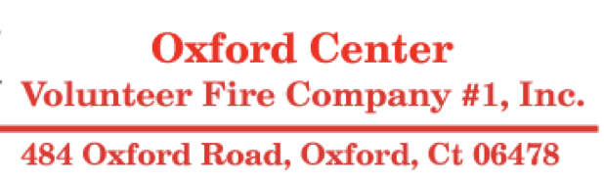
15th Annual Car Show Ad Book
Oxford Center Fire Company is planning the printing of 300 ad books that will be distributed to participants at our car show on July 12, 2025. Oxford Center Fire Company is a volunteer fire company providing 24-hours, 7 days-a-week services to the Town of Oxford and mutual aid to the surrounding communities.
We would like to thank you in advance for your consideration and support of our fundraiser!
Best regards,
Mark Krassner Jenna Blood
Chairman / Car Show Committee. 475-281-9582
203-627-5727
_____________________________________________________________________

Business Name: ________________________________________________________________
Address: ______________________________________________________________________
City: __________________________ State: ________Phone: ____________________________
Ad Size: (please circle what ad size you decide)
¼ Page $ 40.00 Trophy and ½ page $100.00
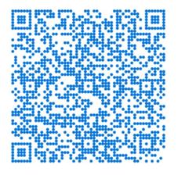
½ Page $ 60.00 Trophy and Full page $175.00
Full Page $110.00
Please circle payment type: Cash--- Card---Check (checks payable to OCFC)
---Venmo (Venmo name @OCFC1).

*Please provide a piece of artwork that you would like in the ad book.
Add must be submitted by June 20, 2025. Artwork can be emailed to: CenterFire.CarShow@Gmail.com or handed in with this form. Acceptable Formats are JPG, GIF or PDF*

