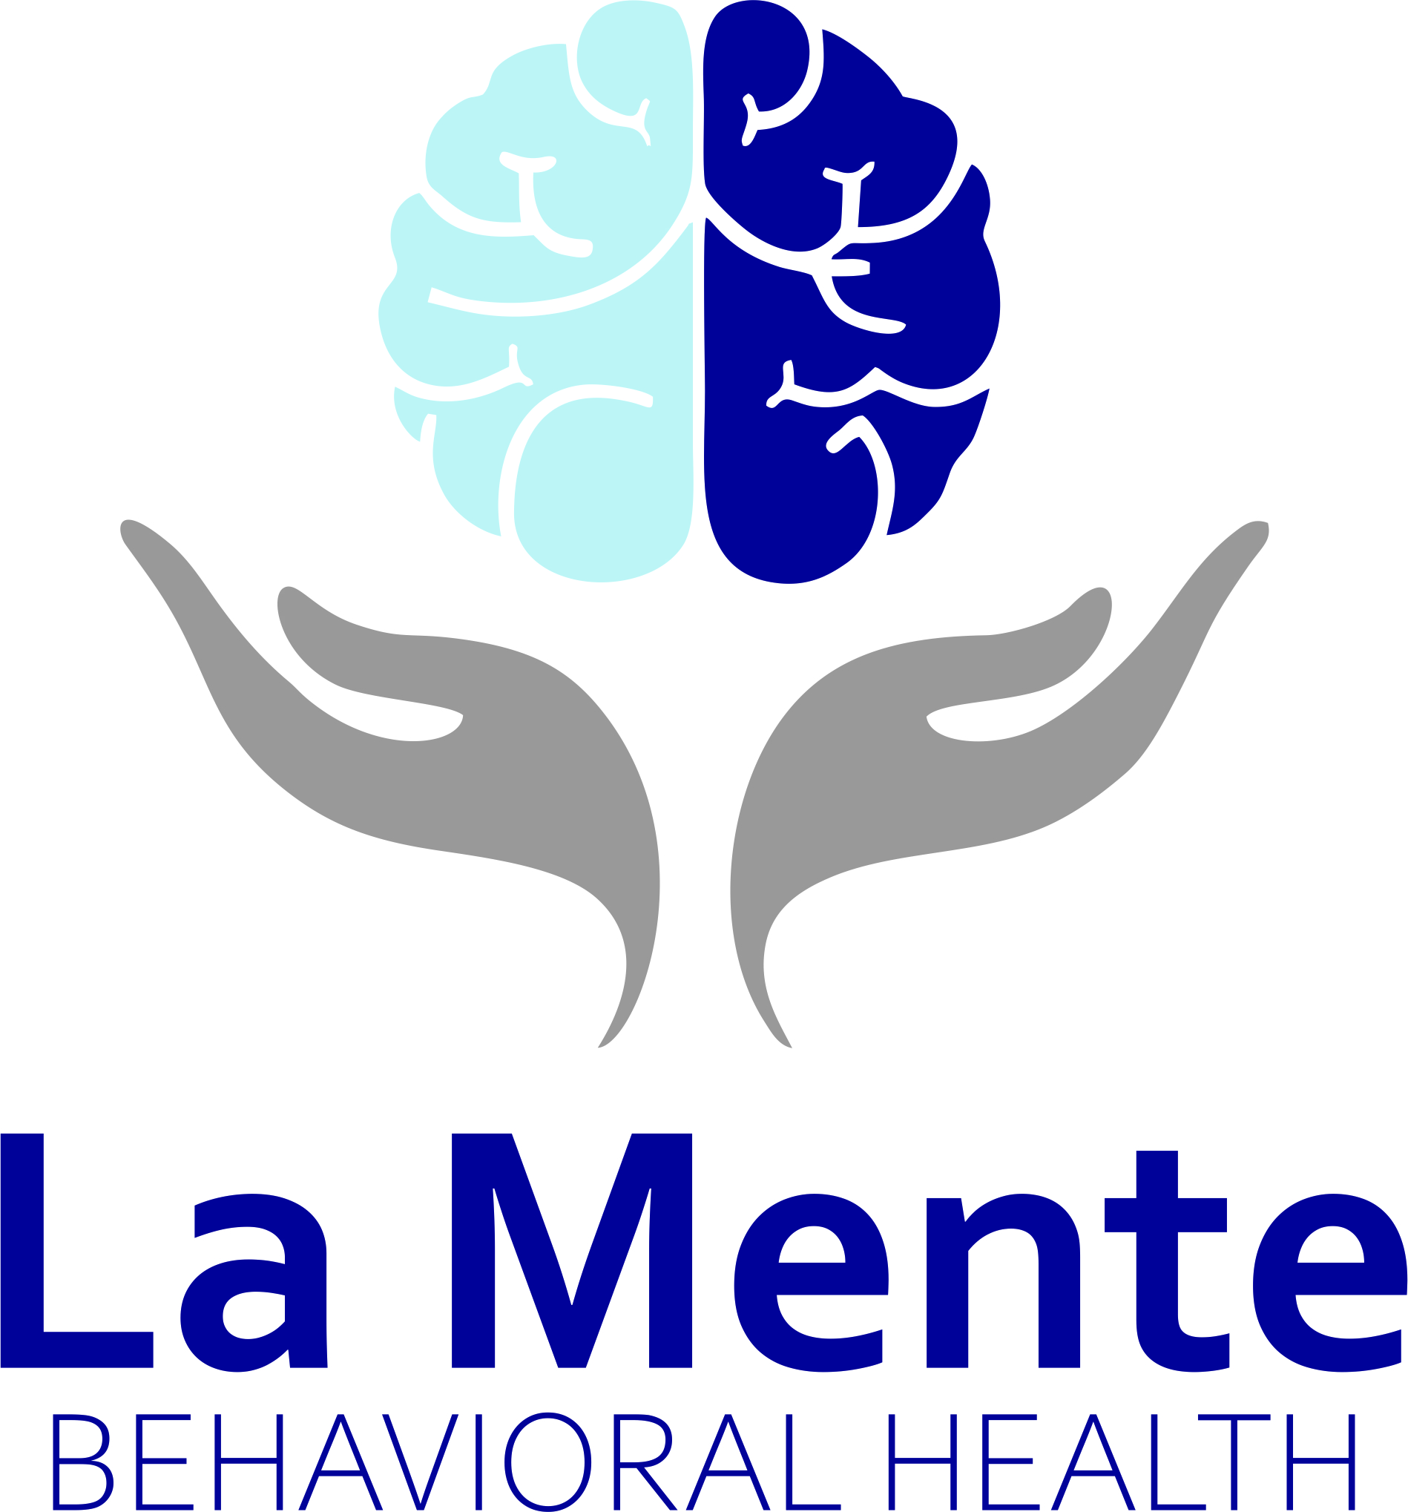
CONSENT FOR CARE AND TREATMENT
TO THE PATIENT: You have the right, as a patient, to be informed about your condition and the recommend medial or diagnostic procedure to be used, so that you may make the decision whether or not to undergo any suggested treatment or procedure after knowing the risk and hazards involved. At his point of your care, no specific treatment plan has been recommended. This consent for is simply an effort to obtain your permission to perform the evaluation necessary to identify the appropriate treatment and /or medication for any identified conditions.

Patient Name: _________________________________________________ Date: ______/ ________/________

The consent will remain in full effect until it is revoked in writing. You have the right to revoke this consent and discontinue services at any time. You have the right to discuss the treatment plan with your physician or provider, regarding the purpose, potential risks and benefits of any test ordered for you. If you have any concerns regarding any test or treatment recommended by your physician or provider, we encourage you to ask questions.
This consent provides La Mente Behavioral Health with your permission to perform reasonable and necessary medical examinations, mental health assessments, testing and treatment. By signing below, you are indication that:
- You intend that this consent is continuing in nature, even after a specific diagnosis has been made and treatment is recommended.
- You consent to treatment at this office or any other satellite office under common ownership.

(Please Initial)
______I voluntarily request a physician, and/or mid-level provider (Nurse Practitioner, Physician Assistant, Clinical Nurse Specialist), other healthcare providers or the designees as deemed necessary, to perform reasonable and necessary medical examination, testing and treatment for the condition which has brought me to seek care at this practice.
_____I understand that if additional testing, invasive or interventional procedures are recommended. I will be asked to read and sign additional consent forms prior to the test or procedures recommended.
_____I certify that I Have read and fully understand the above statements and consent is fully and voluntarily to its contents.

Patient /LAR signature: ______________________________________________________ Date: ________/_______/_______

Printed name of LAR: __________________________________________________________ Relationship__________________

Staff/witness: ________________________________________________________________Date: _______/________/_______

