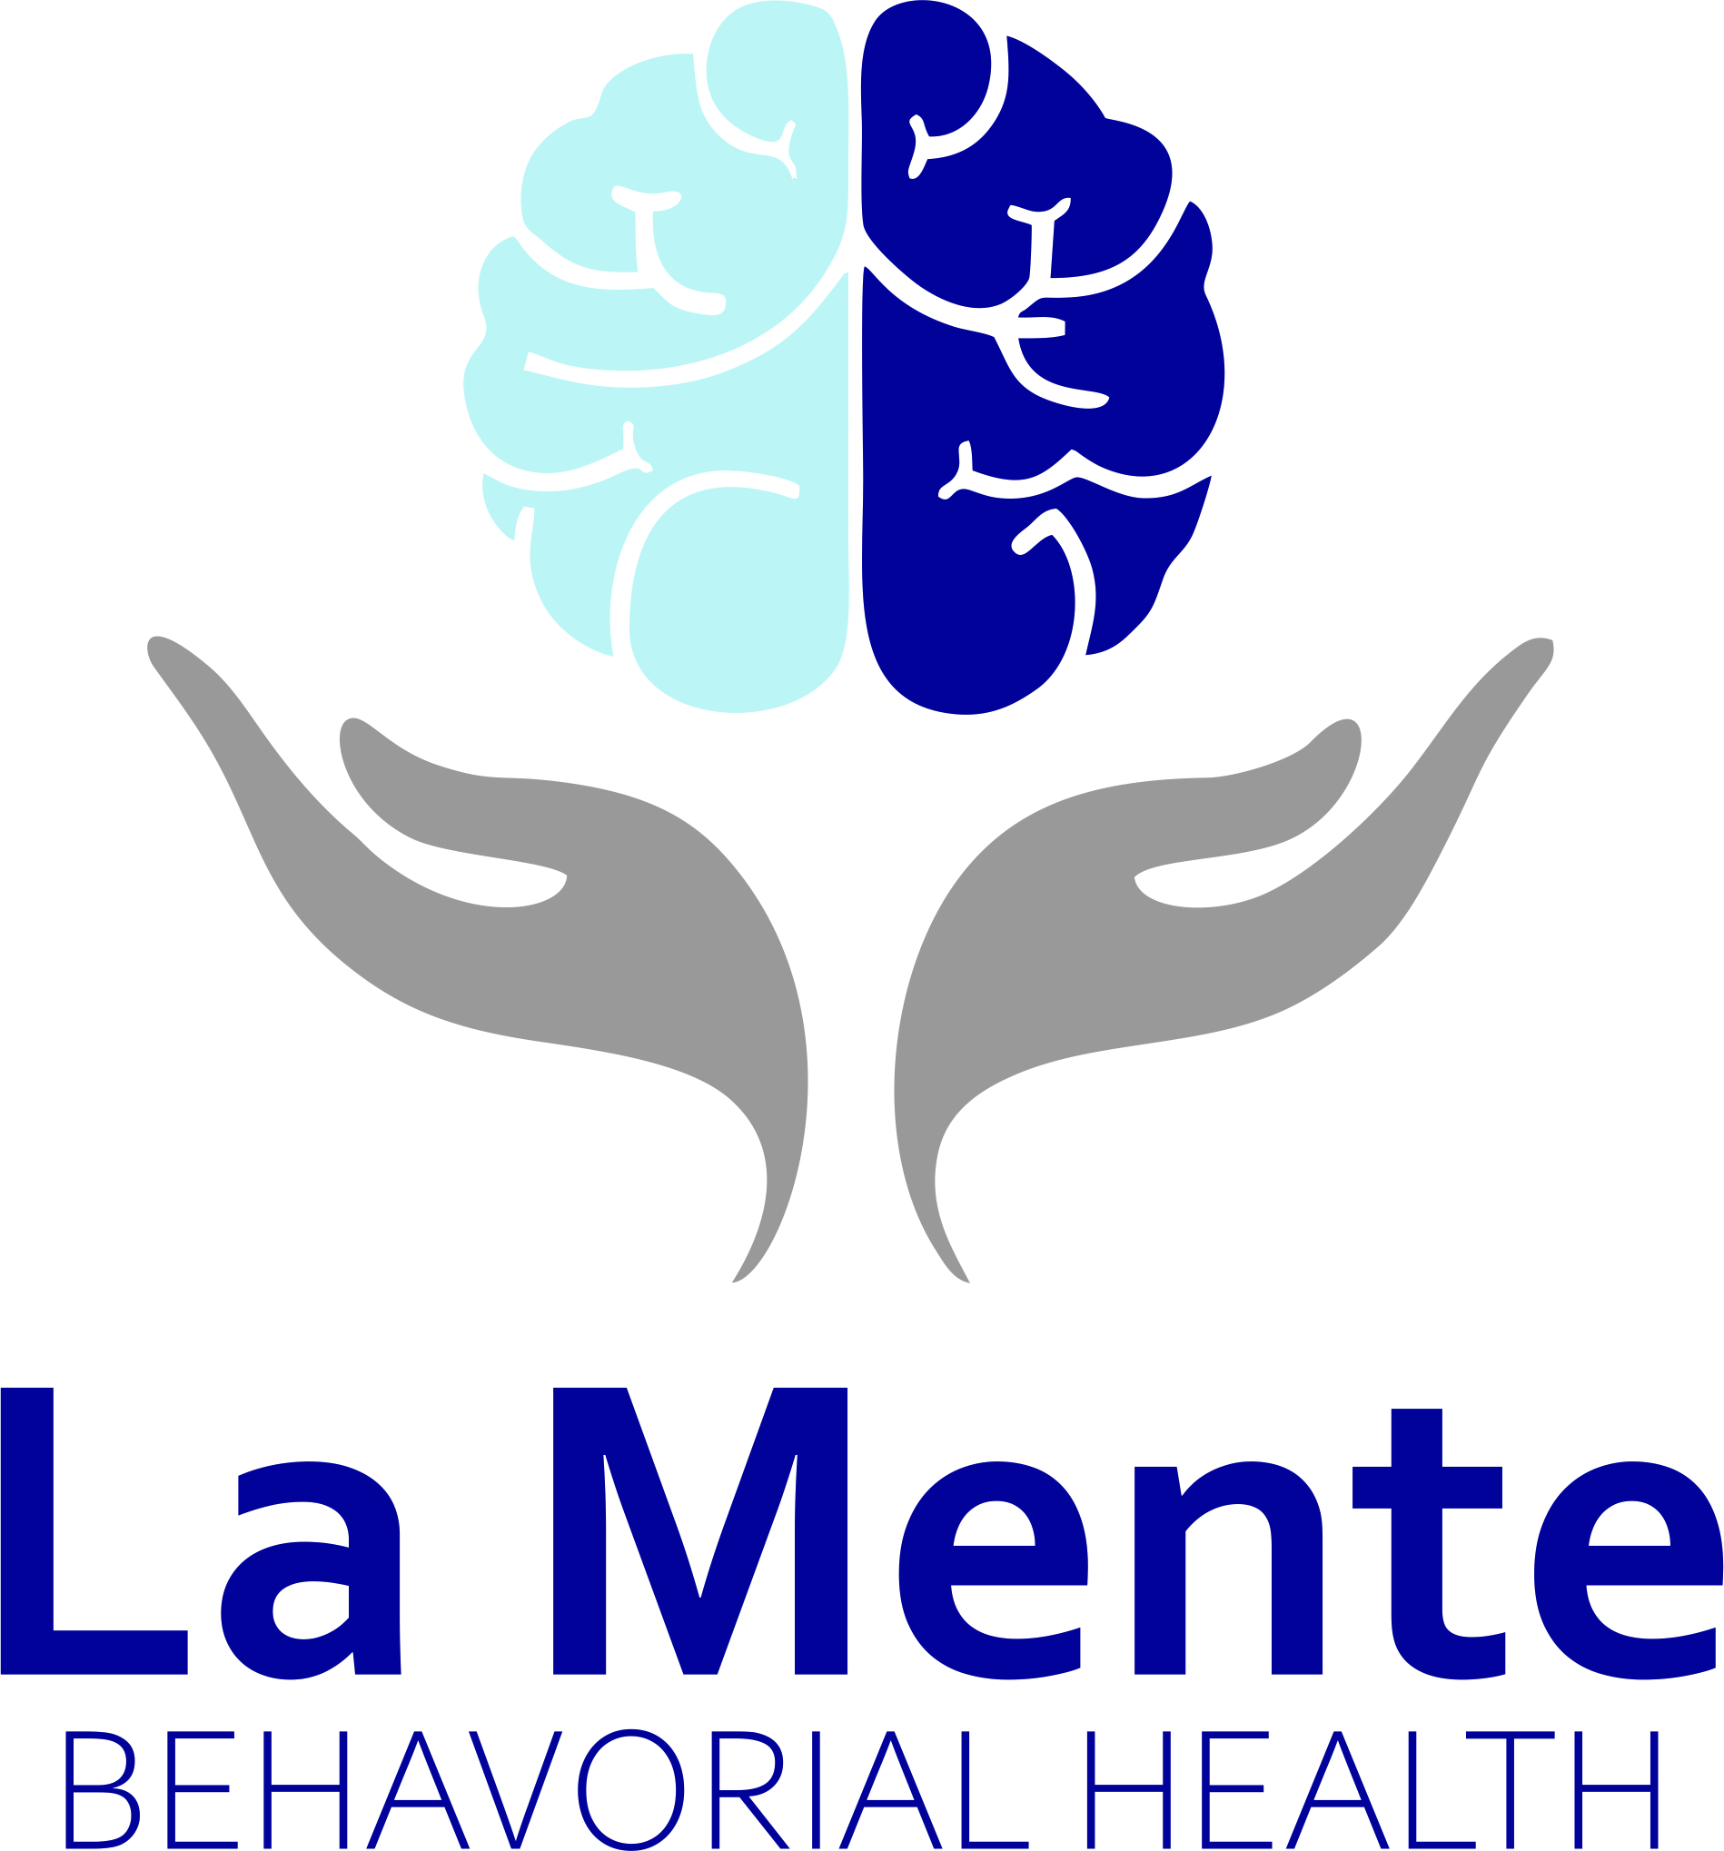

NOTICE OF PRIVACY PRACTICES

ACKNOWLEDGEMENT FORM
It is required by the Health Insurance Portability & Accountability Act of 1996 (HIPAA) to provide confidentiality for all medical and mental health records and other identifiable health information. The HIPPA privacy regulations require, or health care providers and organizations, as well as their business associates, to develop and follow procedures that ensure the confidentiality and security of protected health information (PHI) when it is transferred, received, handled, shared. This applies to all forms of PHI, including paper, oral and electronic, etc. Furthermore, only the minimum health information necessary to conduct business is to be used or shared. The explanation of how La Mente Behavioral Health LLC handles your (PHI) is found on the Notice of the Privacy Practices (NPP). Please acknowledge below your receipt and understanding of the NPP:
You have the right to revoke this consent in writing signed by you at any time. Full disclosure will then cease: however, such revocation is not retroactive.
(Please initial below)
_____I acknowledge that I have read and understand the Notice of Privacy Practices, which explain how my protected health information is used and disclosed.
_____I acknowledge that I can receive a copy of the Notice of Or Privacy Practices at any time upon request.
_____I acknowledge that I can access my medical record upon request, with exception to psychotherapy notes, which are separated from medical records.
_____I acknowledge that I can change my mind on how I want La Mente Behavioral Health LLC to use or share my information other than as described here. If I change my mind, I will let La Mente know in writing.
_____I acknowledge that La Mente Behavioral Health cannot disclose my health information other than what was specified in the notice.
_____I acknowledge that La Mente Behavioral Health reserves the right to change the terms of the notice at any time.

By signing this form, you consent to our use and disclosure of you protected health information (PHI) and potentially anonymous usage I publication. You understand that PHI may be used and disclose for treatment, payment and health care operations. LMBH reserves the right to change the privacy policy as allowed by law.

Print Patient Name:__________________________________ Date:______/_______/______
Parent/LARsignature:___________________________________ Staff/Witness:________________________________

