Instructions for the Healow App

- Your telehealth visit will be similar to a video call. This visit cannot be done if your device does not have access to the microphone and camera.
- Your patient portal should be activated prior to accessing the Healow app
  - If you do not have access to your patient portal, please refer to the patient portal instructions within the Telehealth tab
- Screenshots were taken using an iPhone.
  - Please note that your screen may look different when using an Android device

To-Do List:

Step 1: Follow instructions to create Patient Portal. Ignore this if you already have access to our Patient Portal.

Step 2: Follow instructions to install Healow app.

Step 3: Please have Steps 1 and 2 completed well before your appointment time

Step 4: 15 minutes prior to your appointment, you will need to log back into the Healow app using the username and password you created

Step 5: You will see your Appointment Portion of the wheel is red. Click on the red portion. If this portion is not red, your appointment is not within the next 15 minutes.

- Download the Healow app by E ClinicalWorks on your Smartphone, Tablet, or Laptop with a built-in camera. (Note: Since this is a video call, your device will need to have the ability to access BOTH the microphone and the camera.)

Use the App Store for Apple devices or Google Play for Android devices
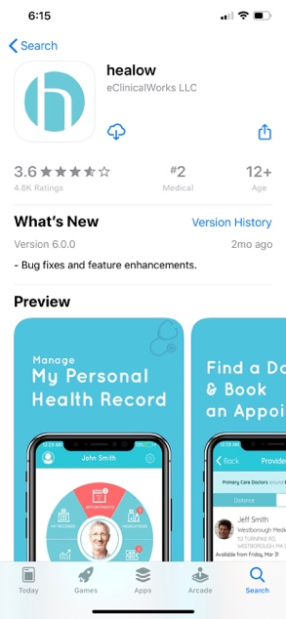

- Click on the App. You will see the screen below. Click “Get Started”

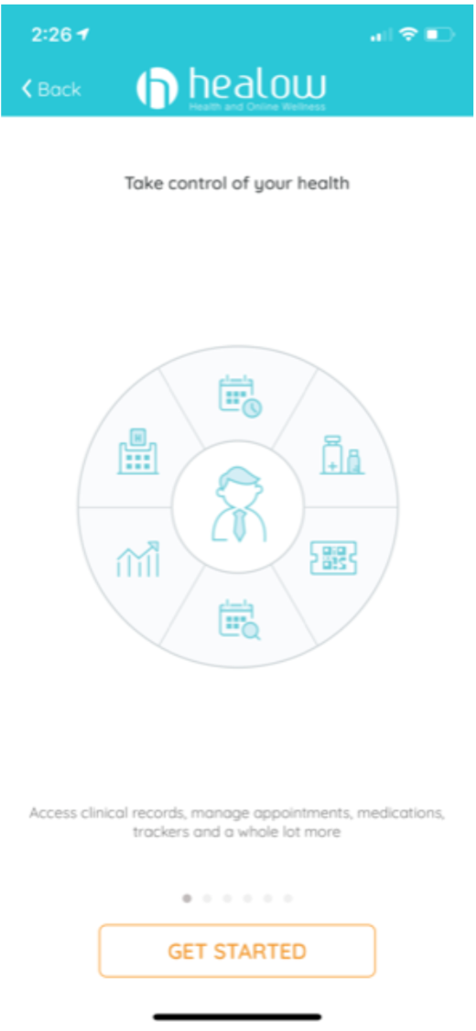

- In the box that says “Enter Practice Code/ Phone No.”, Enter: 6783882184
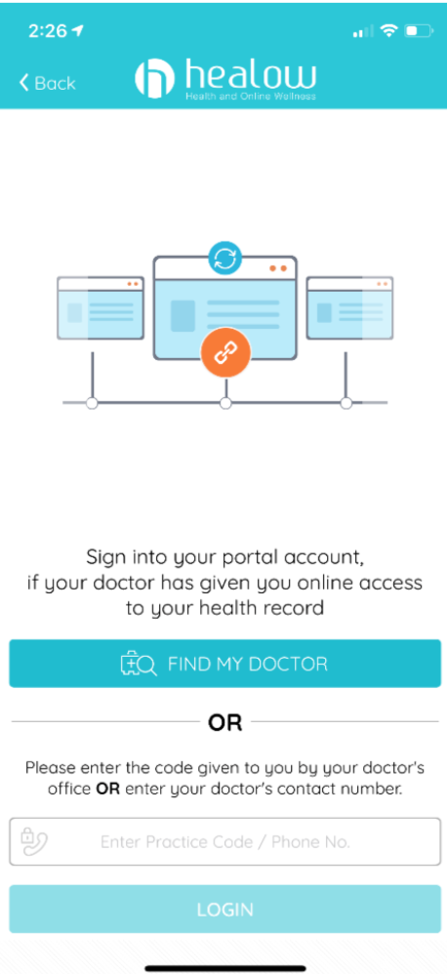

- At this point, you will see a Login Page.
  - Username: same as Patient Portal (ie. the email address you provided to the practice)
  - Password: same as Patient Portal
  - Click “Login”

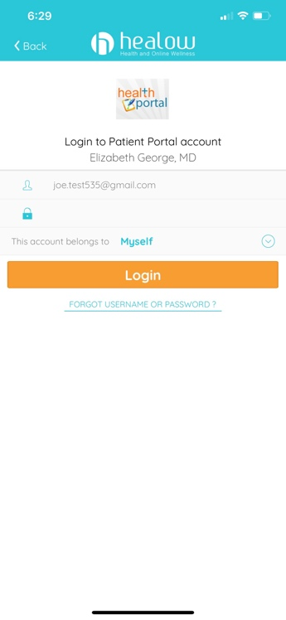

- You may be directed to create a 4-digit PIN.
  - Select 4 numbers
  - Click “confirm”
  - Re-verify the digits on the next screen

- You may also be directed to turn on TouchID.
  - Click “Turn on Touch ID” at the bottom of the screen if desired.
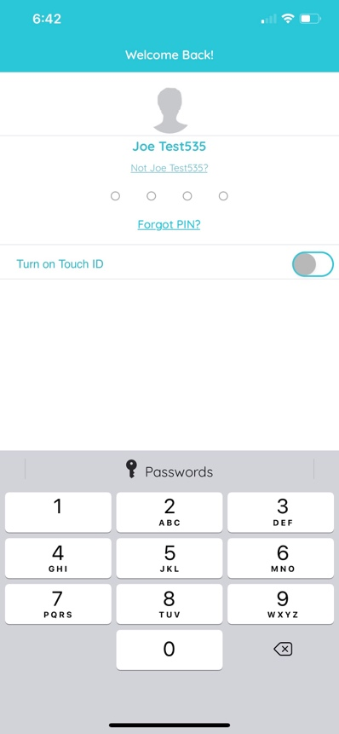

- Once you have agreed, you will prompted to enter your name and DOB.

- At the hello2healow screen, Click “Next”.

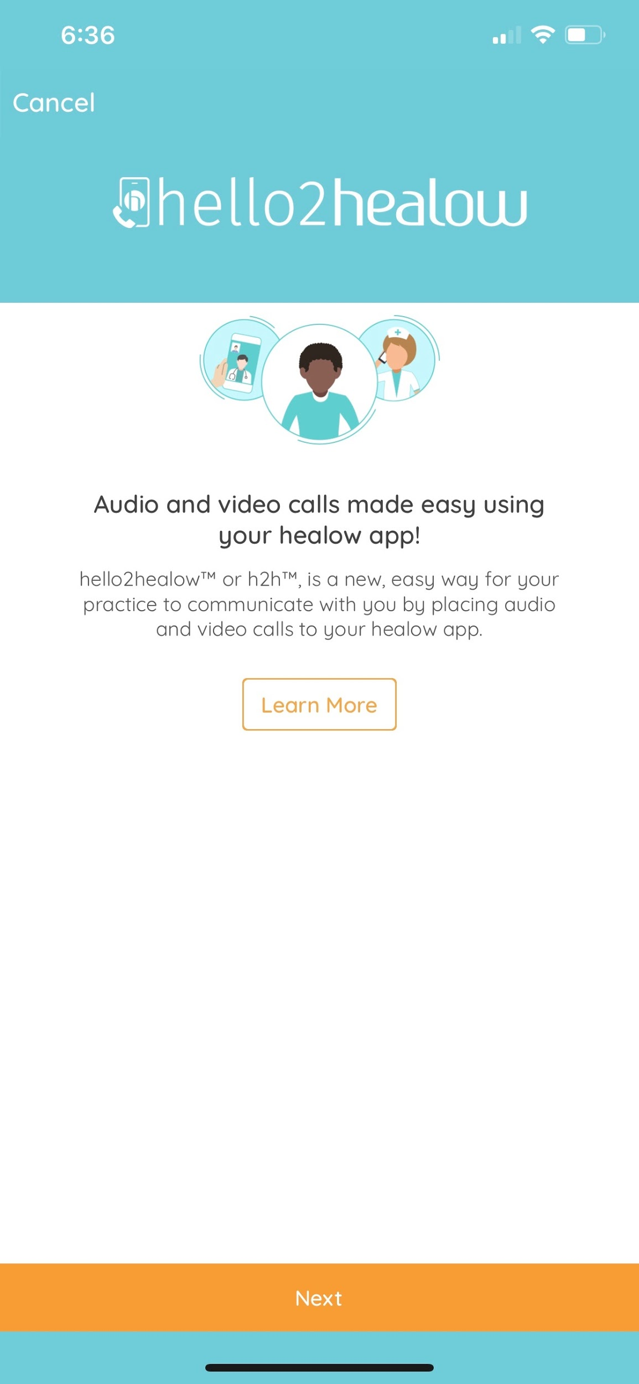

- Read and agree to the Terms of Agreement. Click “Agree & Continue”.
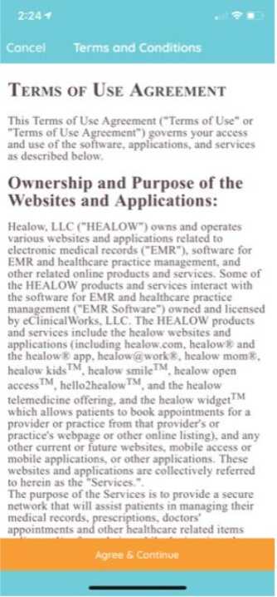

- On the next screen, allow access to camera.
- On the next screen, allow access to microphone
  - WITHOUT ACCESS TO CAMERA AND MICROPHONE, THE TELEHEALTH VISIT CANNOT BE DONE.
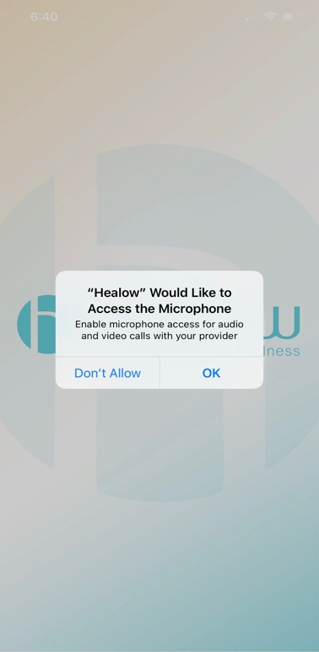

- On the next screen, you may be requested to input the PIN you created. Type in the PIN here.

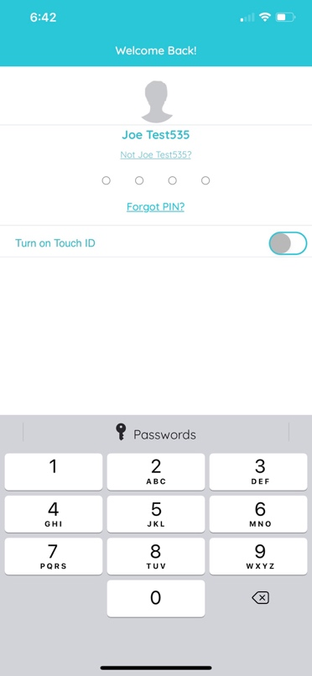

- On the next screen, verify your mobile number. A code will be sent for validation purposes.
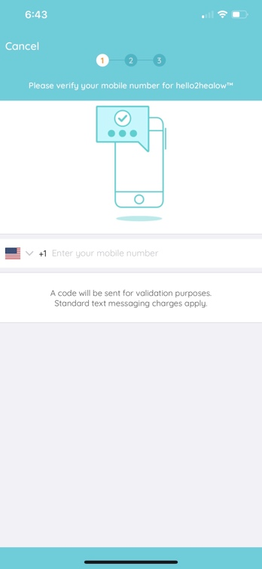

- Click “Verify” and enter your 4-digit verification code that came as a text message.

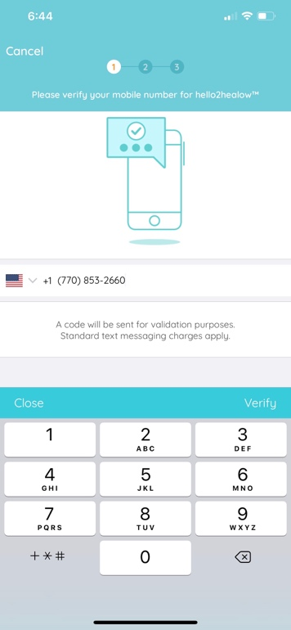

- On the next page, you will see the Enrolled Practices screen. At the bottom, click “Complete Enrollment”.
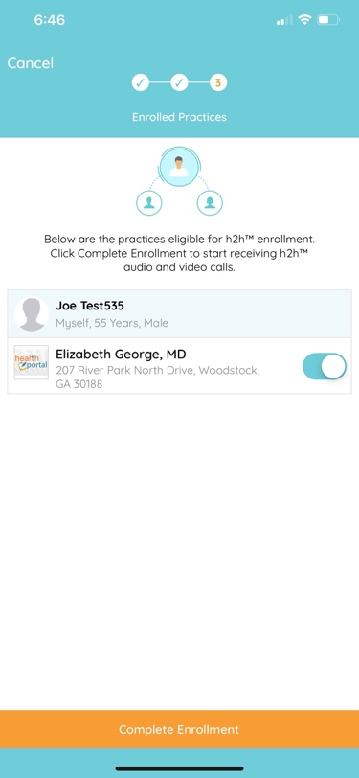

- On the next screen, click “Done”.
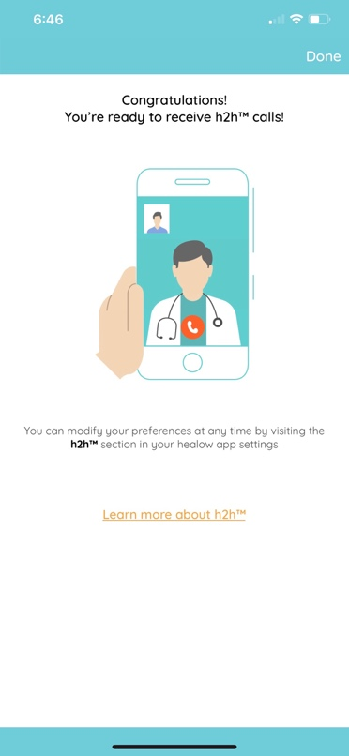

- On the next page, you should have a “1” in your appointment portion of the wheel. This indicates you have one appointment coming up.
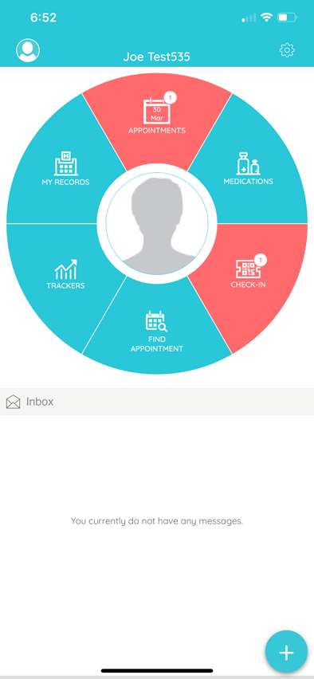

- Click on the appointments portion to review your appointment date and time.

- Enter as much information as you can on the “Vitals” screen
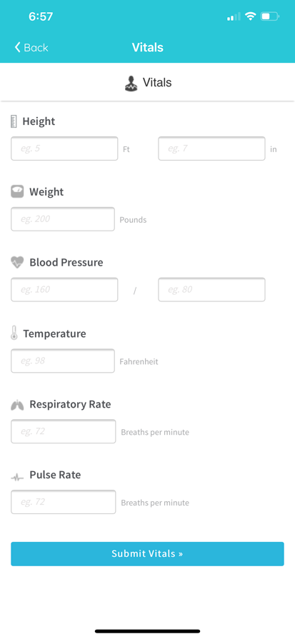

- Click on your appointment. On the right side, click the “Televisit” icon. At the bottom, click “Start Televisit”.

