Patient Portal Instructions: Dr. Elizabeth George

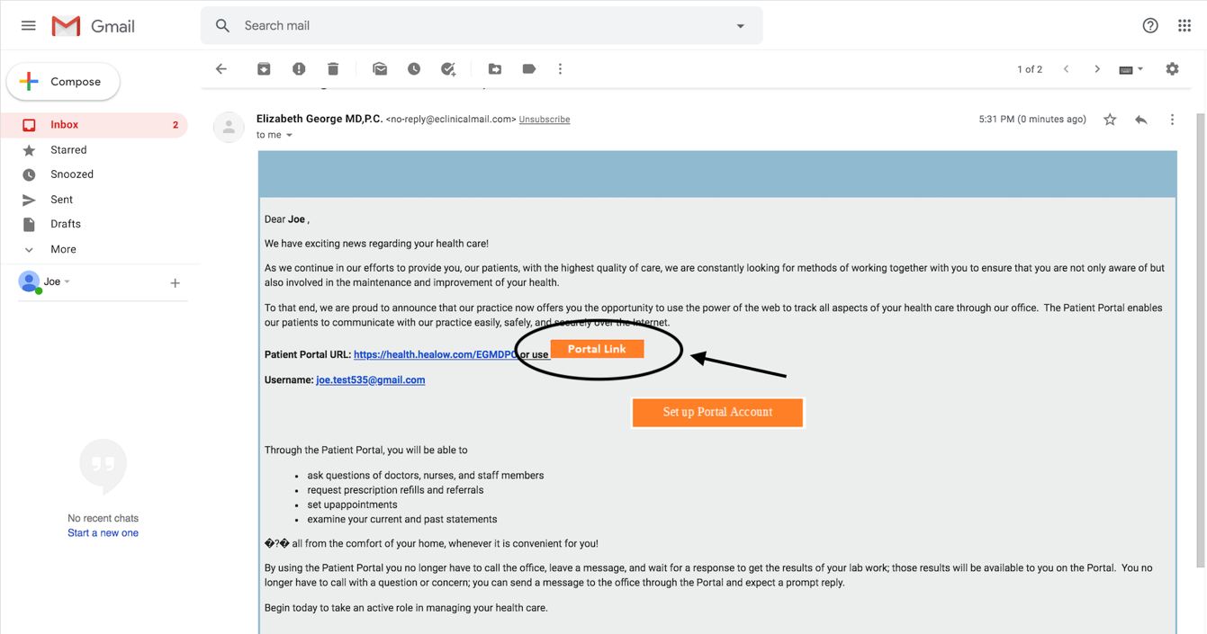
- Activate your patient portal by clicking the “Portal Link” button from the email that you have provided to the practice

- On the main health portal screen, click “Trouble logging in” on the right-hand side of the screen under the area called “Login to Your Account”

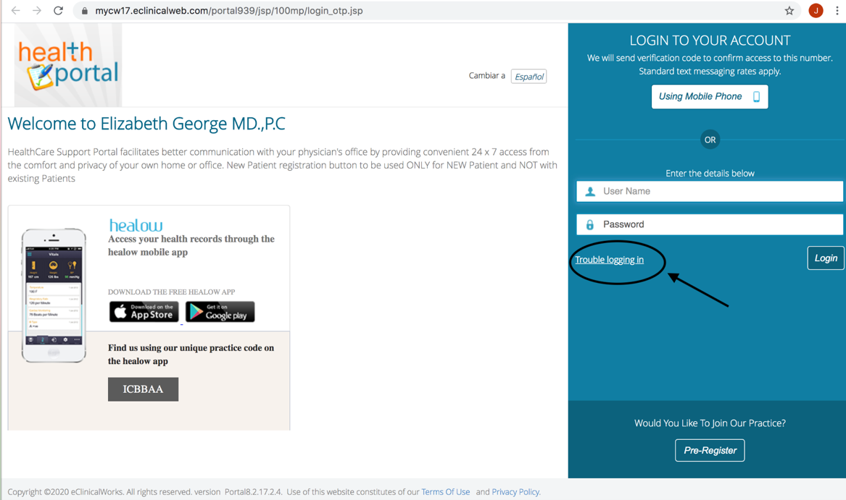

- Choose the “Forgot Password” circle on the Account Recovery Help page, click “Next”

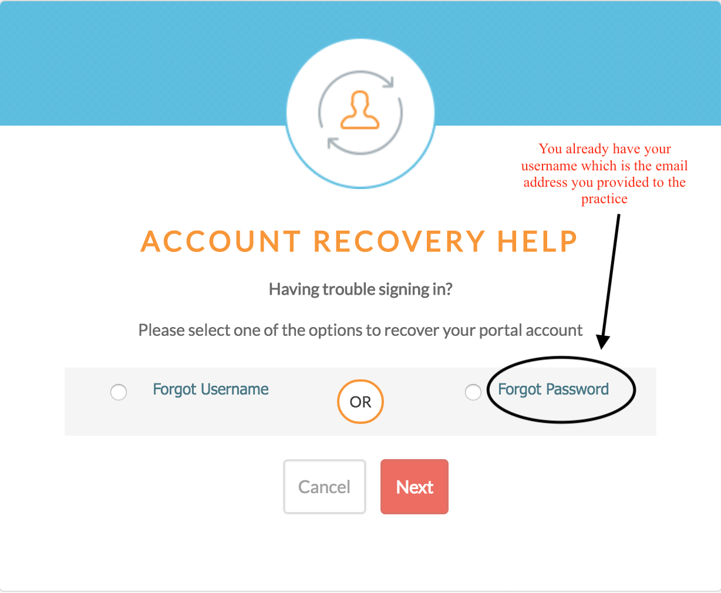

- Type in your username (email you provided to the practice), Click “Submit”

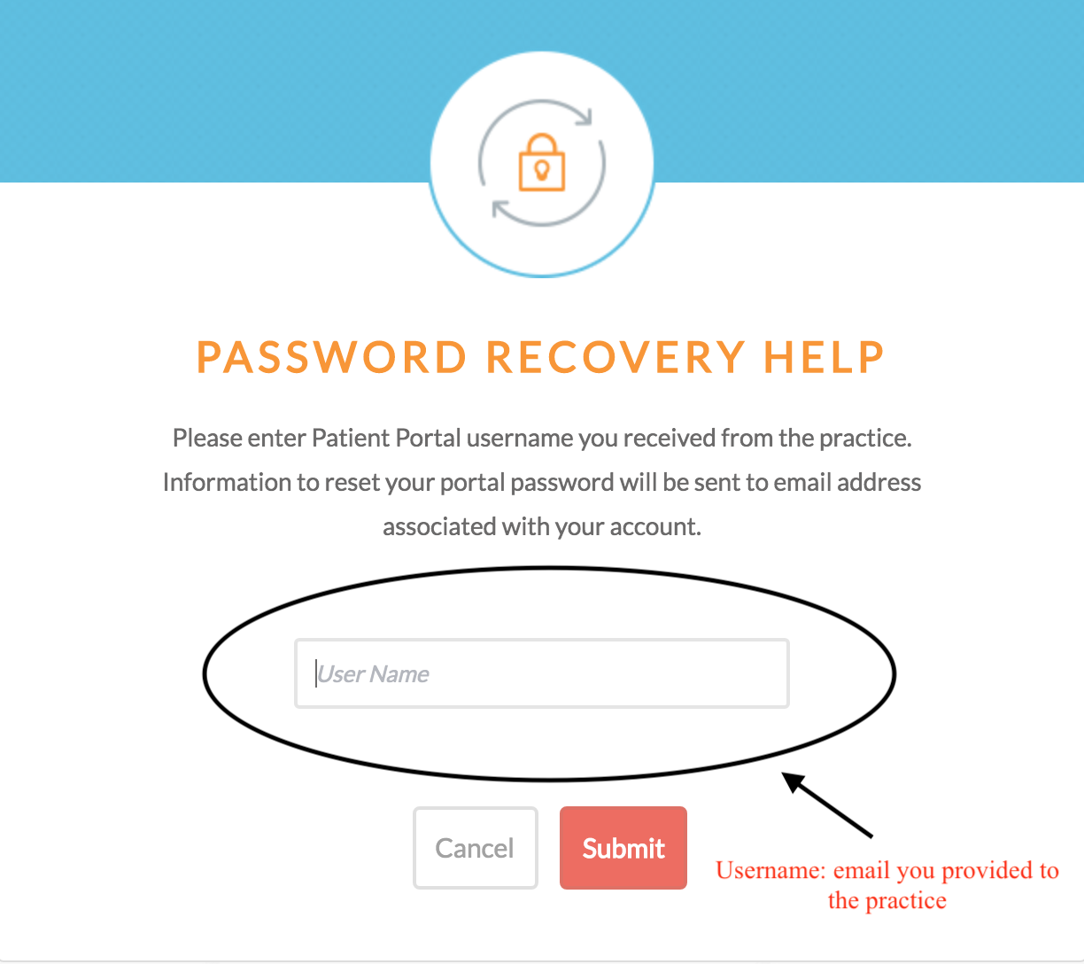

- Go to your email to find instructions to reset your password

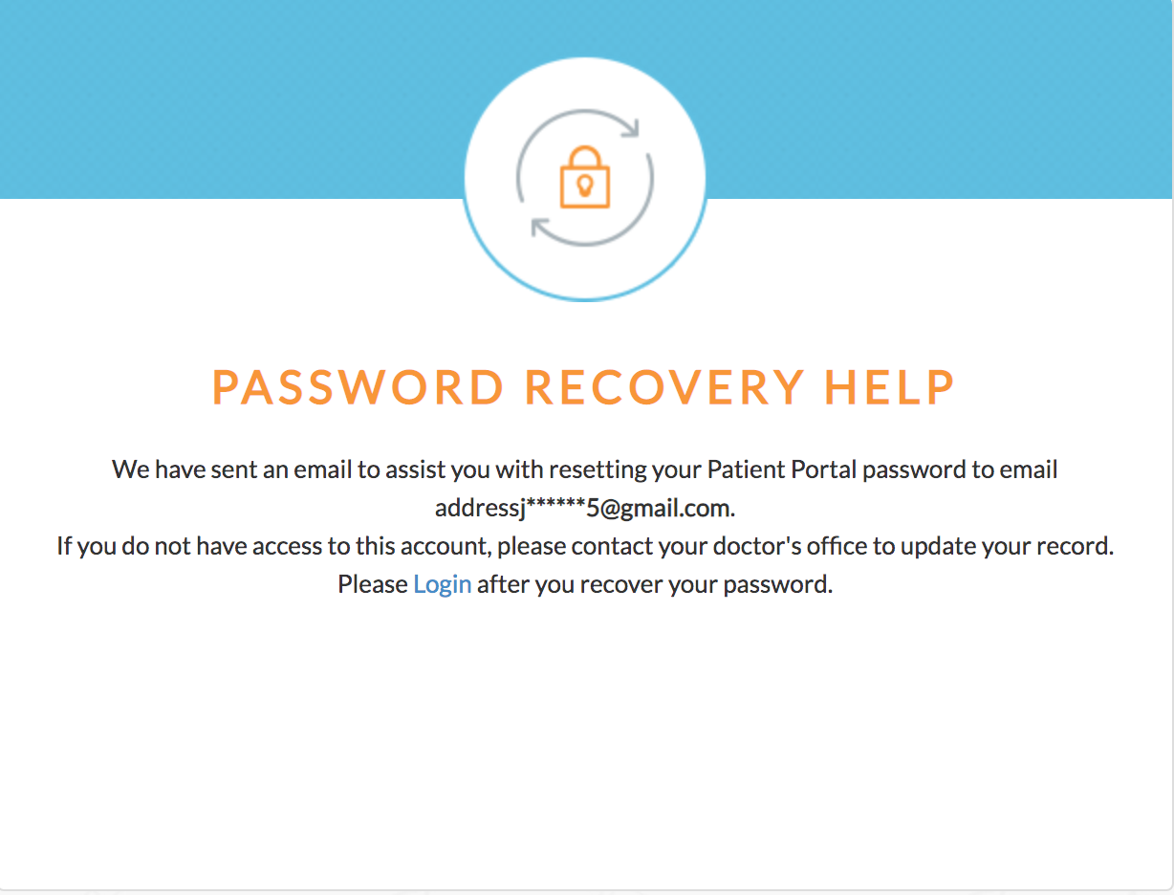

- Click the “Reset My Password” link within the “Recover your password” box

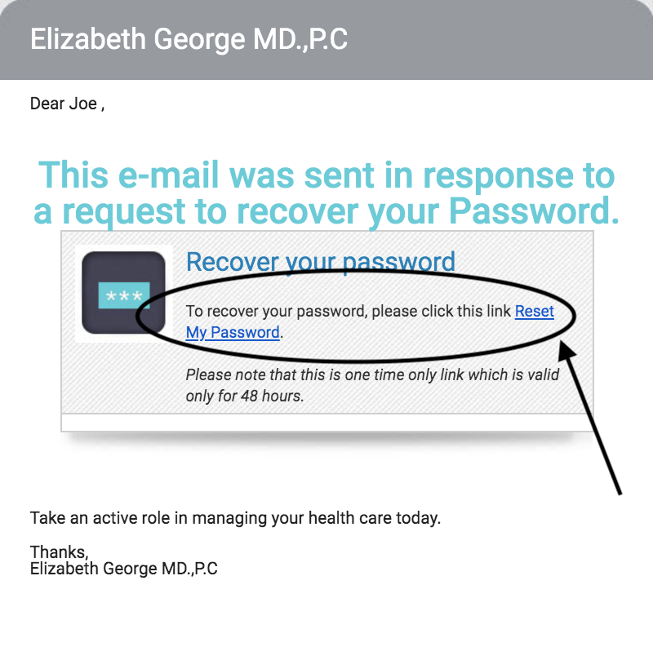

- Enter your email provided to the practice in the first text box and date of birth (DD/MM/YYY) in the second text box, Click “Submit”

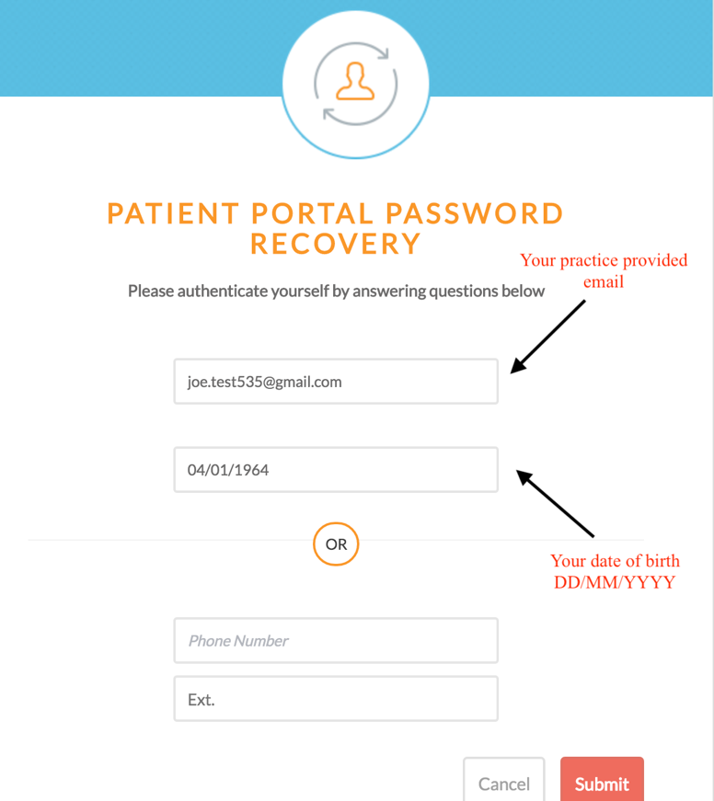

- Reset your password. Please choose a strong password. Click “Next”

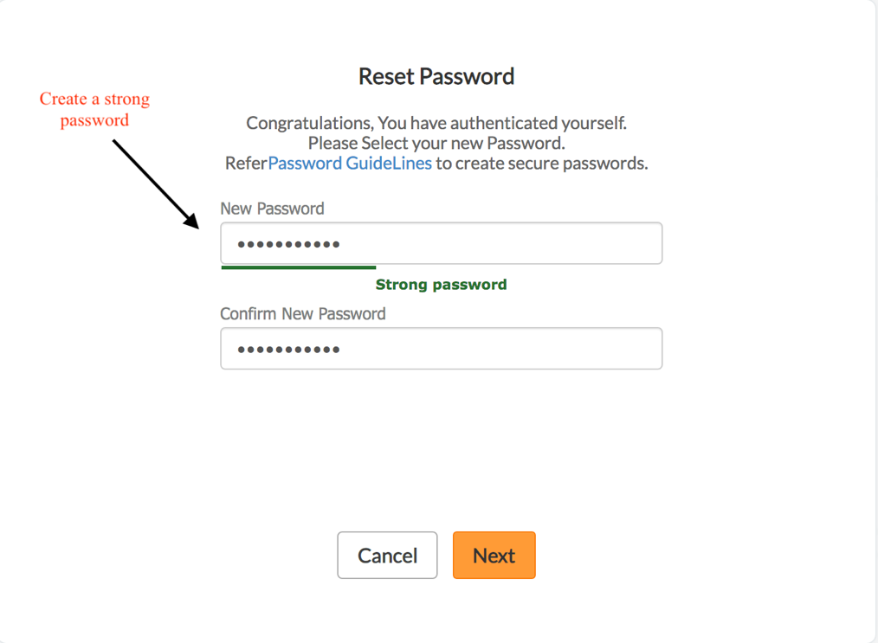

- Choose a security question from the dropdown menu. Click “Next”

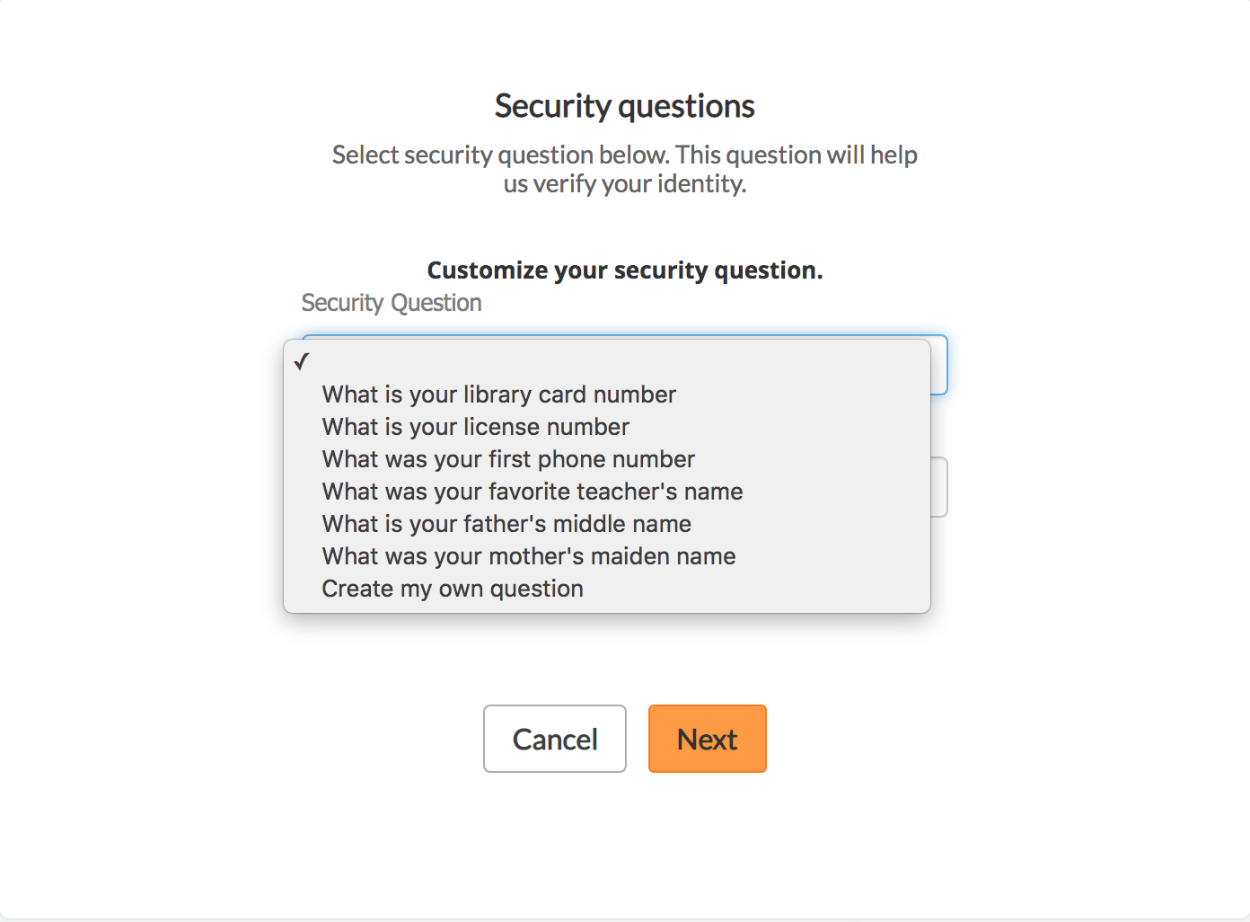

- If you want to customize your security questions, type in the question and answer in the text boxes. Click “Next”

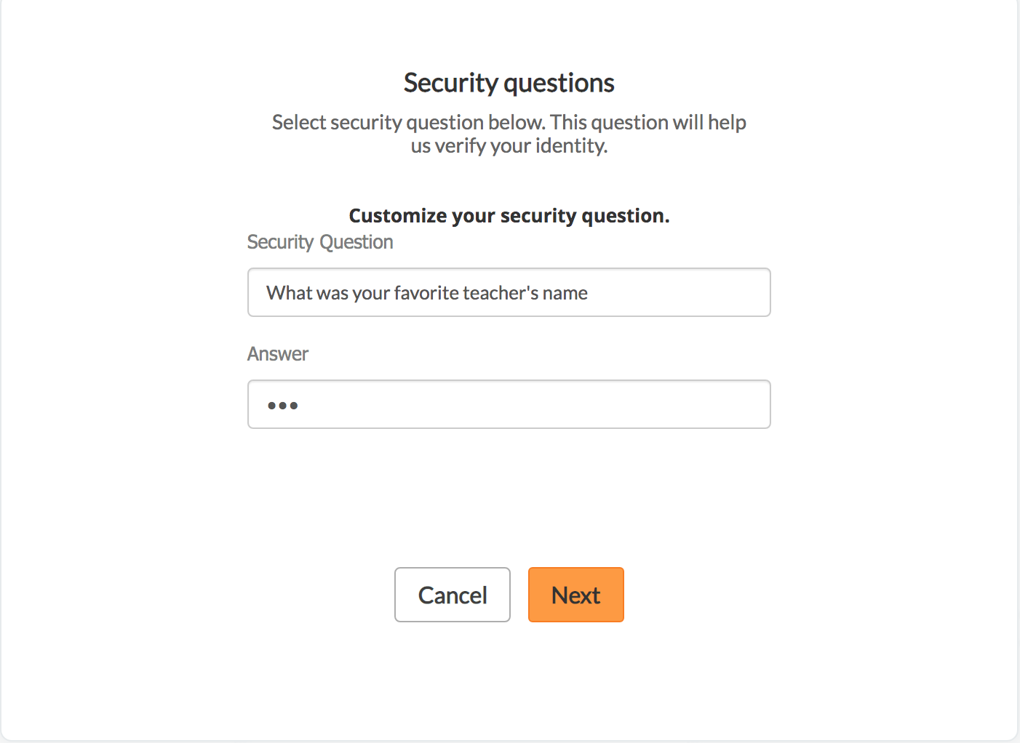

- Read the Consent Form and click “Agree & Next”

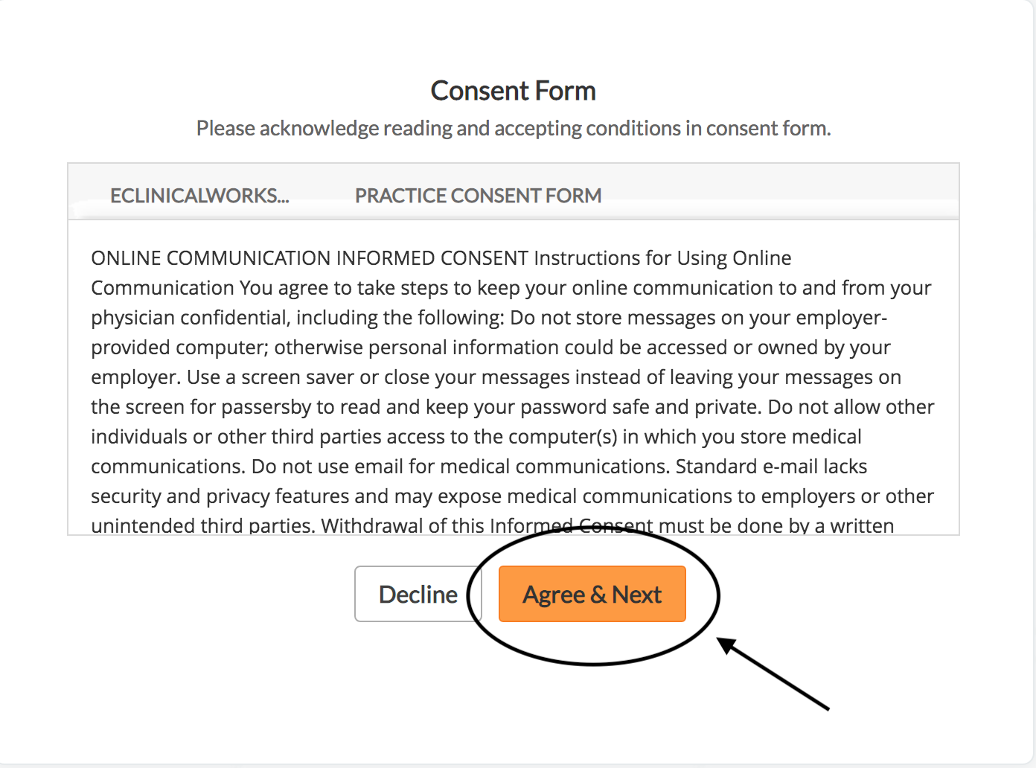

- If you have followed all the above steps correctly, you should see the main dashboard of the portal, which will show your upcoming appointment.

