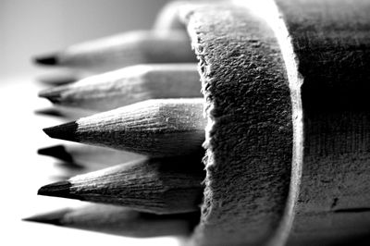
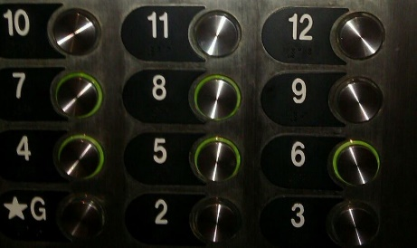
Betwixt and Between: Education for Young Adolescents

Seeking New “Scholarly Work” Submissions!

Overview

A Peer Reviewed Journal of Middle Level Research, Betwixt and Between: Education for Young Adolescents(ISSN-2333-0813) is the official journal of the Pennsylvania Association for Middle Level Education and the Pennsylvania Professors of Middle Level Education.
Inquiries should be addressed to:
Deana Mack
dmmack@geneva.edu

Call for Manuscripts

General Content
Betwixt and Between: Education for Young Adolescents is an open access peer-reviewed journal promoting research in the Commonwealth of Pennsylvania regarding theories and best practices in the education and development of young adolescents. This journal provides for the sharing of formal and informal research related to the improvement of middle level education. Some issues may be thematic as determined by the editors in response to topics of timely interest. Submitted manuscripts should be responsive to this purpose and reflect research or analyses that inform practices in these areas. Submissions are accepted from any source but submissions from teachers/professors/researchers working in Pennsylvania will be given priority in the acceptance and publication process.

Format
All submissions must be prepared using word processing software and saved in Microsoft Word (.doc or .docx) or rich text format (RTF). Manuscripts, must comply with the guidelines in the Publication Manual of the American Psychological Association, current edition. Double space all text, including quotations and references, use 1 inch margins for top and bottom, and use 1.25 inch right and left margins. All text should be Times New Roman 11-point font. Complete references should be placed at the end of the manuscript, using the “hanging indent” function. Additional article publication formatting details are listed on the PA-POMLE and PAMLE web sites.

