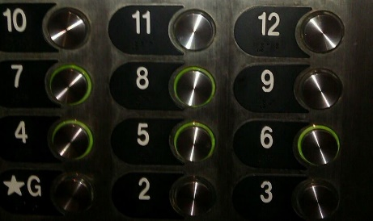
Betwixt and Between: Education for Young Adolescents

Seeking “Schools to Watch Middle Level Principal” Submissions!

A Peer Reviewed Journal of Middle Level Research, Betwixt and Between: Education for Young Adolescents (ISSN-2333-0813) is the official journal of the Pennsylvania Association for Middle Level Education and the Pennsylvania Professors of Middle Level Education.
Inquiries for principal narratives should be addressed to:
Carol Watson
watson@kutztown.edu

Invitation for Middle Level Principal Submissions
You are invited to feature an effective program or best practice at your middle school in a short narrative to be published in the next issue of Betwixt and Between; the professional journal on best practices at the middle level issued through Pennsylvania Professors of Middle Level Education (PaPOMLE) and Pennsylvania Association for Middle Level Education (PAMLE). Ideas for submission include, but are not limited to:

-Facilitating advisory programs
-Implementing community-building practices
-School responses or school needs during a global pandemic
-Involving parents and providing support systems
-Empowering student voice
-Addressing mental health issues and trauma-informed practice
-Partnerships with local middle level teacher education programs
-Innovative practices at the building level (PBL, 21st century skills, Restorative Practice)

Format
All submissions must be prepared using word processing software and saved in Microsoft Word (.doc or .docx) or rich text format (RTF). Manuscripts, limited to 500-750 words, must comply with the guidelines in the Publication Manual of the American Psychological Association, current edition. Double space all text, including quotations and references. All text should be Times New Roman 11-point font. Complete references should be placed at the end of the manuscript.

