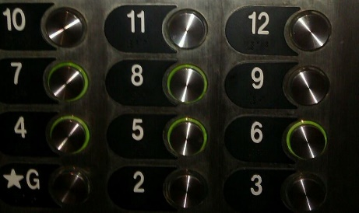
Betwixt and Between: Education for Young Adolescents

Seeking “Middle Level Student” Submissions!

A Peer Reviewed Journal of Middle Level Research, Betwixt and Between: Education for Young Adolescents (ISSN-2333-0813) is the official journal of the Pennsylvania Association for Middle Level Education and the Pennsylvania Professors of Middle Level Education.
Inquiries for student narratives should be addressed to:
Leigh Forbes
forbes001@gannon.edu

Call for Middle Level Student Submissions
Call for Student Submissions
We are currently seeking student narratives on how your school responds well to the unique developmental challenges of teaching middle level students.
Ideas for submissions include:

· What do your teachers do to incorporate hands-on learning?
· How does your school involve parents and the community?
· How does your school provide opportunities for student voice?
· How does your school provide additional help for academics?
· Does your school use rewards for positive behavior such as a School-wide Positive Behavior Program?
· What are innovative ways that your teachers use technology?
· How do your teachers get to know you?
· How do your teachers embrace student culture?
· How do your teachers provide opportunities to foster career development?
. You can discuss all topics or one, two or more.

Format
All submissions must be prepared using word processing software and saved in Microsoft Word (.doc or .docx) or rich text format (RTF). Manuscripts, limited to 500-750 words, must comply with the guidelines in the Publication Manual of the American Psychological Association, current edition. Double space all text, including quotations and references. All text should be Times New Roman 11-point font. Complete references should be placed at the end of the manuscript.

