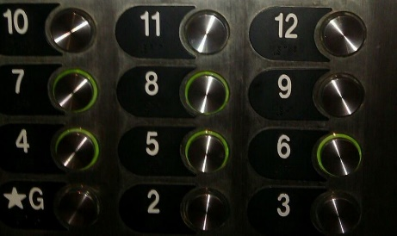
Betwixt and Between: Education for Young Adolescents

Seeking “Middle Level Teacher Candidate” Submissions!

A Peer Reviewed Journal of Middle Level Research, Betwixt and Between: Education for Young Adolescents (ISSN-2333-0813) is the official journal of the Pennsylvania Association for Middle Level Education and the Pennsylvania Professors of Middle Level Education.
Inquiries for teacher candidate narratives should be addressed to:
Leigh Forbes
forbes001@gannon.edu

Call for Middle Level Teacher Candidate Submissions
We are currently seeking narratives on issues involved with learning to become an effective middle level teacher.

Ideas for submission include, but are not limited to:

. Experiences in field placements

. Responses to teaching and collaborating during a global pandemic

. Applying on-campus coursework to real classrooms

. Partnerships with local middle schools

. Innovative practices in teacher education programs

. Reporting engaging CMLA activities

Format
All submissions must be prepared using word processing software and saved in Microsoft Word (.doc or .docx) or rich text format (RTF). Manuscripts, limited to 500-750 words, must comply with the guidelines in the Publication Manual of the American Psychological Association, current edition. Double space all text, including quotations and references. All text should be Times New Roman 11-point font. Complete references should be placed at the end of the manuscript.

