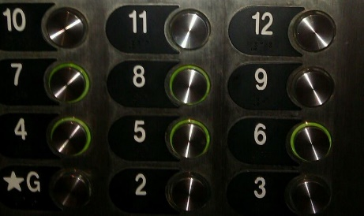
Betwixt and Between: Education for Young Adolescents

Seeking “Teacher Educator” Submissions!

A Peer Reviewed Journal of Middle Level Research, Betwixt and Between: Education for Young Adolescents (ISSN-2333-0813) is the official journal of the Pennsylvania Association for Middle Level Education and the Pennsylvania Professors of Middle Level Education.
Inquiries for teacher educator narratives should be addressed to:
Leigh Forbes
forbes001@gannon.edu

Call for Middle Level Teacher Educator Submissions
Call for Teacher Educator Submissions
We are currently seeking narratives, research, and case studies on best practices in Middle Level teacher preparation
Ideas for submissions could include:

· Student Teaching, Internships, Clinical Experiences
· School-Community Partnerships
· Family Engagement
· Young Adolescent Development
· Advisory/Advocacy
· School Climate and Culture
· Curriculum-Instruction-Assessment
· Cultural Responsiveness/Diversity/Inclusion
· Technology
· Other: (email dmmack@geneva.edu if you want to discuss other possible topics)

Format
All submissions must be prepared using word processing software and saved in Microsoft Word (.doc or .docx) or rich text format (RTF). Manuscripts, limited to 500-750 words, must comply with the guidelines in the Publication Manual of the American Psychological Association, current edition. Double space all text, including quotations and references, use 1 inch margins for top and bottom, and use 1.25 inch right and left margins. All text should be Times New Roman 11-point font. Complete references should be placed at the end of the manuscript, using the “hanging indent” function. Additional article publication formatting details are listed on the PA-POMLE and PAMLE web sites.

