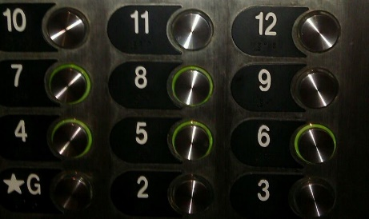Betwixt and Between: Education for Young Adolescents

***Seeking “Teacher” Submissions!***

A Peer Reviewed Journal of Middle Level Research, *Betwixt and Between: Education for Young Adolescents*(ISSN-2333-0813) is the official journal of the Pennsylvania Association for Middle Level Education and the Pennsylvania Professors of Middle Level Education.

Inquiries for teacher narratives should be addressed to:

Leigh Forbes  
[forbes001@gannon.edu](mailto:forbes001@gannon.edu)

Call for Middle Level Teacher Submissions

**We are currently seeking teacher narratives on best practices in the field of middle level education.**

Ideas for submissions may include:

. Your responses to the demands of teaching during a global pandemic

. How you incorporate best practices in middle level teaching

. How you communicate with families

. New strategies you use to teach (case study experience)

·        Teacher reflections on inclusion and collaboration

·        How you incorporate PBIS

·        How you use new technology

. How you include student teachers in your teaching

. How you create a culturally responsive and inclusive classroom

**Format**  
All submissions must be prepared using word processing software and saved in Microsoft Word (.doc or .docx) or rich text format (RTF). Manuscripts, limited to 500-750 words, must comply with the guidelines in the Publication Manual of the American Psychological Association, current edition. Double space all text, including quotations and references, use 1 inch margins for top and bottom, and use 1.25 inch right and left margins. All text should be Times New Roman 11-point font. Complete references should be placed at the end of the manuscript, using the “hanging indent” function. Additional article publication formatting details are listed on the PA-POMLE and PAMLE web sites.