Covid-19 and Preschool

Updated Protocol 5/4/2022

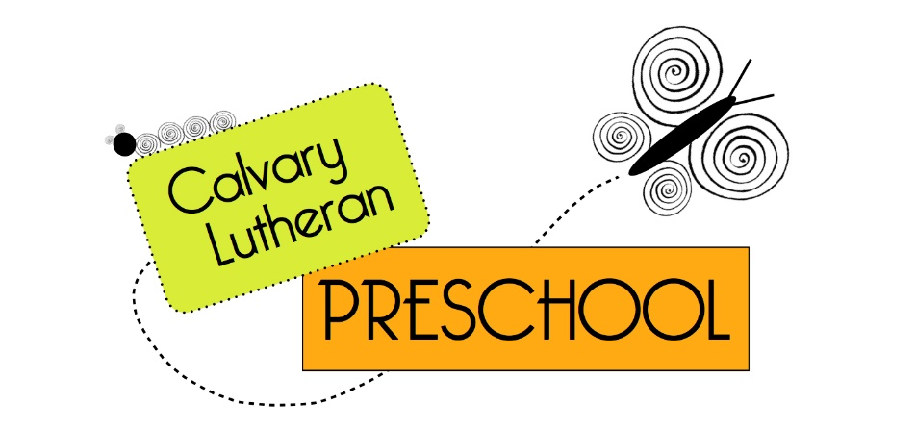Calvary Lutheran Preschool is happy to offer in-person classes for the 2021-22 school year. We will follow ODE Early Learning Division Health and Safety Guidelines for Registered Family Programs. Following the ODE guidelines means some changes in the way we run our program. It is our goal to offer a program that is as safe as possible for children, parents, and teachers. We will always be conservative in our approach to safety.

1. We will be flexible

This year will require flexibility from teachers, parents and students. We may experience:

* Covid-19 potential exposure
* Covid-19 outbreak
* School closure due to Covid-19
* Changes in Covid policy and protocols
* Increased safety measures including, but not limited to: increased social distancing, more independent play, individual supplies (rather than shared), changes in drop off and pick up procedure

We will do everything we can to clearly communicate with you any and all changes due to Covid-19. Our best method of communication is email. Please make sure you have [hillsboroclp@gmail.com](mailto:hillsboroclp@gmail.com) your contact list.

1. Masks are optional, staff will continue to wear masks when around the children. Please be respectful of individual choices.
2. We will eliminate risk where we can

Health checks will be conducted at the door when children arrive. Depending on current guidance, this could include a temperature check with an infrared thermometer and questions of the adult accompanying the child about Covid exposure. We will err on the side of caution so please don’t be offended if we ask you to keep your child home that day.

We will have children wash hands frequently and use hand sanitizer when appropriate.

We will follow all cleaning protocols outlined in the ODE Early Learning Division Guidelines. You are welcome to read these guidelines here: <https://oregonearlylearning.com/COVID-19-Resources/For-Providers>

We will work to improve ventilation in our classrooms including opening windows and using fans/air purifiers where appropriate.

We will spend as much time as possible outdoors. Please dress your child appropriately for the weather and outdoor play.

1. We will follow exclusion protocol as provided by Oregon Early Learning Division We will continue to use a more conservative approach with isolation and wearing masks at all times.

Covid Positive Child Exclusion Protocol: Child is sent home to quarantine for a minimum of 7 days. There is no option to test-to-return before the 7 days.

Child EXPOSED to Covid positive or Covid presumptive case (at preschool or in the community): With the new Early Learning Division guidelines, we will no longer have to guaranine classes or children who are exposed to Covid. Please watch closely for symptoms and with any signs of a cold, please keep your child home.

Fully Vaccinated Teacher exposed to Covid positive or Covid presumptive case (at preschool or in the community): With the new guidelines as stated above, teachers will no longer have to quarantine after being exposed. We will continue to watch closely for any symptoms.

You can find information about exclusion here: <https://oregonearlylearning.com/COVID-19-Resources/For-Providers>

1. We will have a great year!

Covid is going to be with us for a while. We believe that, in spite of Covid, we can have a great school year and that your children will benefit from time with same-age peers and new experiences at school. Thank you for trusting us with your children and for helping keep our kids safe.