Biographical Sketch

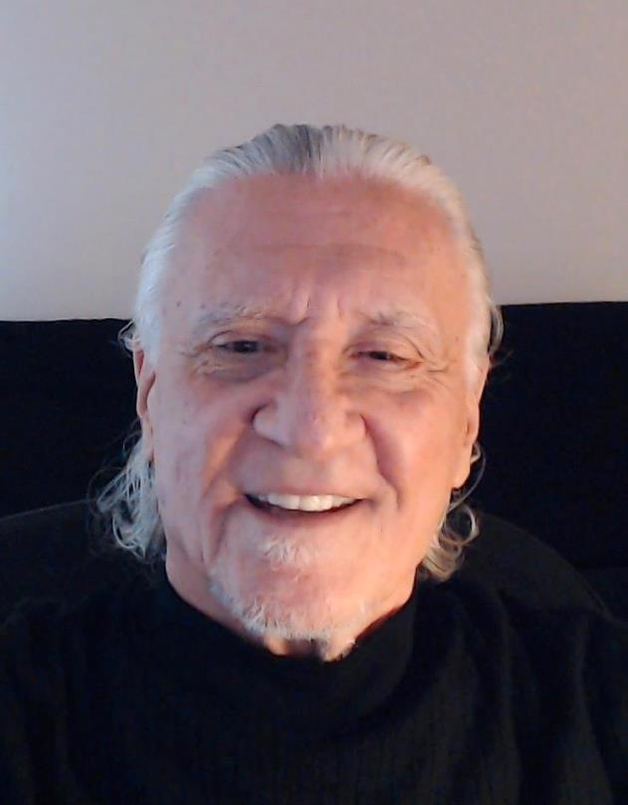

Dr. Bob Wenzel Gross is a researcher, scientist, anomalist, writer, presenter, and educator who began his professional career as a classically trained musician. By nature, Dr. Gross is an accomplished artist who chose music as his preferred medium of expression. However, out of necessity, Bob became a scientist and aggressive researcher. Currently, he is retired and living in the Chicago Area.

In 1970, Robert W. Gross received a Bachelor of Science Degree in Music Education from Duquesne University in Pittsburgh, Pennsylvania. His baccalaureate degree was followed by a Master of Education Degree from Indiana University of Pennsylvania. By 1975, he had enrolled at Penn State University where he studied filmmaking.

As a music educator, Bob taught in Pennsylvania’s public schools and held concurrent adjunct professor positions at Penn State University and Indiana University of Pennsylvania. In 1980, he co-wrote a children’s musical play. The musical play was entered into a national competition sponsored by the Open Court Publishing Company. Open Court awarded the play second prize. Writing the musical play provided Bob with knowledge about human curiosity and mysterious experiences. The award led to Dr. Bob studying musical play writing at Illinois Wesleyan University.

In 1984, Bob earned a Doctor of Education Degree from Penn State University. While at Penn State he studied acoustics, aesthetics, music, and research design, among other subjects. His flawless approach to advanced research was a direct result of The Pennsylvania State University Graduate School awarding his dissertation an excellent rating.

In 1985, Dr. Gross began drafting another children’s musical play. The new play incorporated several contemporary popular topics: UFOs, extraterrestrial intelligence, spaceships, and outer space. To learn more about the UFO/UAP phenomenon, Dr. Gross joined the Pennsylvania Association for the Study of the Unexplained—a nonprofit scientific research organization and clearinghouse for UFO sightings.
During the summer of 1989, Dr. Gross confronted an unidentifiable aerial phenomenon (UAP) that was inches away from him. Throughout this close encounter, he experienced an unusually strong affective response. Bob realized that his intense aesthetic reaction involved a non-arts object. Dr. Gross’s interest regarding links among anomalies, aesthetics, intelligence, and the human brain was ignited.
From 1992 to 1998, Bob served as a member of the National Assessment of Educational Progress Arts Education Consensus Project in Washington, DC. As the project’s multimedia assessment specialist, Dr. Gross was introduced to the research of Dr. Howard Gardner. Dr. Gardner, a psychologist from Harvard University, developed the theory of Multiple Intelligences. In 1999, Dr. Gardner wrote about the possibility of expanding his Multiple Intelligences theory to include existential intelligence. In 2013, after conferring with Dr. Gardner, Dr. Gross instigated an independent research project that explored potential links among musical intelligence, existential intelligence, aesthetic experiences, anomalies, and unexplained phenomena. Through the process of conducting research for his independent study, Dr. Gross was introduced to neuroaesthetics. Neuroaesthetics is a relatively new subfield of neuroscience that merges neuroscience with observed aesthetics.
Dr. Bob Wenzel Gross’s professional experiences embody a depth and breadth of understandings, skills, and habits of mind that translate into an acute awareness of what ought to be. He is an advocate of the creative problem-solving process. During his career, he has pursued a livelihood as a presenter and writer with more than twenty articles published in journals and on blogs. Bob has also delivered lectures at local, state, national, and international conferences.

Dr. Gross specializes in Anomalistics—using the scientific method to evaluate anomalies. He is the author of a blog titled: In Pursuit of Anomalies. Bob has also written a new whitepaper report titled: Relevant and Reliable Evidence Shows the Cornerstone of UFOlogy was a Program Developed by United States Entities. Dr. Gross is also writing content standards for an approach to teaching and learning he calls Interdisciplinary UAP Education. He is also writing an aligned UAP curriculum which engages deep scientific learning through higher order flexible thinking.

Recent scientific studies show that human brains have systems specifically designed for appreciating anomalous phenomena. According to current research, aesthetic systems in the brain help survey and determine how appealing something is—it doesn’t matter if the experience of focus is a UAP, a work of visual art, or a musical performance. Both fine art and non-art objects undergo aesthetic processing. Aesthetic experiences enhance thinking, wellbeing, and health.
Dr. Bob Wenzel Gross has more than 25 years of experience teaching on all levels of instruction. At the higher education level, he was an adjunct professor at Penn State University, Indiana University of Pennsylvania, New Mexico State University, South Texas College, and Grand Canyon University. As a public school teacher he taught in both elementary and secondary schools. In addition, Bob successfully worked for more than 17 years as an educational administrator, change agent, curriculum specialist, troubleshooter, and turnaround specialist. After the tragedy of September 11, 2001, Dr. Gross put his career on hold and joined AmeriCorps to provide community service near Mexico.

Select Related Events

- 1985, joined the Pennsylvania Association for the Study of the Unexplained (PASU), a research unit that conducted investigations of UFOs and other worthy unexplained phenomena.
- 1987, attended National UFO Information Week—a collaborative effort between PASU and the Mutual UFO Network (MUFON) to bring the business of UFO research to the public.
- 1987, observed eyewitnesses provide live testimonies about the 1965 Kecksburg UFO incident.
- 1989, experienced a personal Close Encounter of the First Kind with an unidentified aerial phenomenon (UAP) which led to conducting subsequent research related to such interactions.
- 1997, served on the Cornell University Cinema Advisory Board that premiered the 1997 film, Contact, which was based on a Carl Sagan novel.
- 2006, consulted with the Johnson Space Center in Houston, Texas about recruiting Native Americans for NASA’s Astromaterials Research and Exploration Science (ARES) Project.
- 2007-2010, promoted educational (STEM) involvement in Spaceport America activities and education to develop the skills needed for Spaceport operations.
- 2011, joined MUFON to gain access to their research tools and learn more about how the organization reviewed and studied UFOs.
- 2012, presented “The Kecksburg Incident,” at a UFO Conference in Edinburg, Texas.
- 2012, provided a lecture entitled: “The Kecksburg Case,” at the Texas A & M International University UFO Conference, Laredo, Texas.
- 2013, consulted with Harvard University’s Project Zero and Dr. Howard Gardner related to an independent research study regarding existential intelligence and paranormal activity.
- 2013, delivered a science-based presentation, “Using Science to Explain the Unknown,” at the Amazing Skies Science Education Outreach Conference in Pharr, Texas.
- 2013, participated in a discussion about developing existential intelligence related to anomalous phenomena as a guest on the Jeff Rense Program, a nationally broadcast radio show.
- 2013, assisted with organizing the Out of This World Conference in Edinburg, Texas and presented the lecture: “Science and the Paranormal.”
- 2013, published a book chapter: “A Close Encounter of The Lasting Kind.” In Torres, N., Edinburg 2013 Out of This World Conference & Festival Souvenir Program. RoswellBooks.com.
- 2013, appeared as the keynote speaker and delivered “Science, the Paranormal, and UFOs” at the MUFON State Fall Symposium, Indianapolis, Indiana.
- 2013, conducted a field investigation at the State Theater in South Bend, Indiana.
- 2014, developed a fine art lecture series entitled: “Existential Intelligence and the Arts: A Funerary Art Series” as a docent at Notre Dame’s Snite Museum of Art.
- 2014, conducted a field investigation at the Willows Weep Funeral Home in Indiana.
- 2015, conducted a field investigation at the Whispers Estate in Indiana.
- 2015, conducted a field investigation at the Waverly Hills Sanatorium in Kentucky.
- 2015, proffered the lecture “Haunted Houses and Filmmaking” at the Mid America Filmmakers (MAF) salon gathering in South Bend, Indiana.
- 2016, lectured about science and the paranormal as a guest on the Haunted Michiana TV Show.
- 2016, conducted a field investigation in Randolph County, Indiana and successfully experimented with extended bulb photography techniques that yielded reliable evidence.
- 2018, participated in an interview entitled: “The Truth Behind the UFO Phenomenon and Other Mysteries” for a Citizens for Community Media television show.
- 2018, delivered a PowerPoint presentation at the 2018 International UFO Congress entitled: “Closing the Kecksburg Case Opened Another Mystery: Results of Recent Research.”
- 2018, appointed to the Scientific Coalition for UFOlogy (SCU), an alleged worldwide think-tank that conducted scientific examinations of Unidentified Aerial Phenomena (UAP).
- 2018, wrote an article entitled: An Extraterrestrial Flying Disk Crashed Near Roswell in 1947: Not a UFO. The article was published and trended on The UFO Chronicles.com blog.
- 2018, featured guest on Martin Willis Live Shows: PODCAST UFO LIVE STREAM, “06-12-18 Dr. Bob W. Gross, Possible Kecksburg & Roswell Terrestrial Explanations?”
- 2018, recruited by Robert Powell of the Scientific Coalition for UAP Studies (SCU) to conduct research as a member of the SCU Project on Shapes and UFO Characteristics Team.
- 2018, featured guest on Mack Maloney’s MILITARY X-FILES show about the Roswell mystery.
- 2019, featured guest on Dave Scott’s Spaced Out Radio program.
- 2019, featured guest on Mack Maloney’s MILITARY X-FILES show discussing “The Rise and Fall of the Roswell UFO Incident.”
- 2019, described my 1989 close encounter with a UFO as a featured guest on Mack Maloney’s MILITARY X-FILES broadcast entitled: “Take The Long Way Home.”
- 2020, featured guest on Cameron Brauer’s My Alien Life the Podcast show discussing “In Pursuit of Anomalies.”
- 2020, described my various encounters with anomalies as a featured guest during the Mack Maloney’s MILITARY X-FILES broadcast entitled: “Shootout at the Pillow Factory.”
- 2020, videotaped a discussion regarding MUFON’s Executive Director Rejecting a Suggestion for U.S. Educational Standards Compliance with Jon Kelly on NewsInsideOut.com.
- 2020, created a YouTube Video Channel titled: "Explore the Exceptional with Dr. Gross."
- 2020, featured guest on the Night Dreams Talk Radio with Gary Anderson show entitled: “Dr. Robert Gross on UFOs.”
- 2021, explained the U.S. Government’s recent UAPTF report as a featured guest on the Mack Maloney’s MILITARY X-FILES broadcast entitled: “What Are They Trying To Tell Us?”
- 2021, featured guest on the Disclosure News Network with Dave Emmons broadcast entitled: “Introducing Interdisciplinary UAP Education.”
- 2021, featured guest on PODCAST UFO LIVE with Martin Willis on “10-12-21, Show #476, Dr. Robert Gross, UAP Education a Potentially Bright Future.”
- 2021, began working on vital tasks with the Research Team for The Galileo Project at Harvard University.
- 2021, guest on Untold Radio with Joel Sturgis and Doug Hajicek show titled: “Dr. Bob Wenzel Gross—Skilled Research Scientist Who Discusses UFOs and Other Anomalous Phenomena.”
- 2022, explained The Galileo Project at Harvard University as a featured guest on the Mack Maloney’s MILITARY X-FILES broadcast entitled: “If a Nuke Goes Off in Space, Does it make a Noise?”

