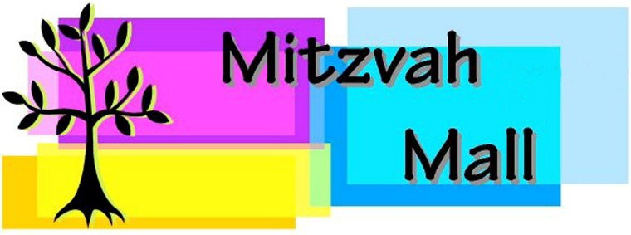

**2025 Mitzvah Mall – Non-Profit Application Form**

Name of organization

Contact Person

Email

LOCAL Address

     City, State and zip code

Phone number

**What is your organization’s mission:**

**(Please make this as short as possible. It will be on the “gift list” so that potential donors understand your mission.)**

**Please list the THREE gift items shoppers could purchase at your booth :**Dollar Amount Gift Description

**less than 60 characters is best; they need to fit on a label**

1. $           2. $     

3. $     

**How will you advertise the Mitzvah Mall to your organization’s members and supporters? Although we do some advertising, we hope you will, too.** (This is VERY important. **Without advertising, there won’t be donors!)**

***Remember- we need $75, fund letter and any other requested documentation before you are confirmed!***

***Thanks again for your interest-We look forward to seeing you at the Mitzvah Mall!***