The South MS Boucherie

# Food Truck Entry Form

# You are invited to The South MS Boucherie

**Saturday, March 25, 2023, from 8 a.m. – 5 p.m.**

# at the Southwest Events Center, 29 MS HWY 48E. Tylertown, MS 39667

Space with hookups- $125

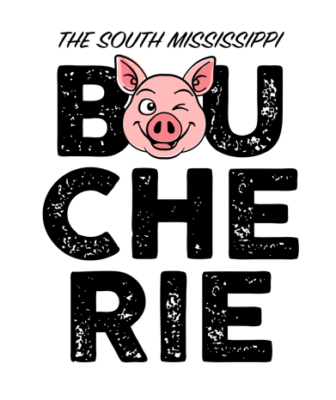

* Make check payable to **The South MS Boucherie**
* Payment must be remitted with application to hold spot.
* Spaces will be assigned based on date of payment received.
* Security will be provided on Friday night.
* Deposits are NON-REFUNDABLE and the event will be held rain or shine.
* Sales tax will be collected at the end of the day - envelopes will be provided and should be returned prior to leaving on Saturday.
* Vendor's MUST NOT close booths early on the day of the event unless approved by Boucherie committee.
* **This is an OUTSIDE event** - **all vendors will be set up OUTSIDE of the arena.**

***NOTE: All vendors are subject to approval by The South MS Boucherie committee.***

For more information, please contact:

**Katie Lynn Craft at 601-876-0511/601-303-2003 or visit www.thesouthmsboucherie.com**

Please remit form and payment to:

**The South MS Boucherie (Attn: Katie Lynn Craft)**

**P.O. Box 311**

**Tylertown, MS 39667**

---------------------------------------------------------*Cut and Return*--------------------------------------------------------NAME:__________________________________________________DATE:__________________

ADDRESS: _______________________________________________________________________

PHONE(S): _________________________CONTACT PERSON: ____________________________

Menu Items (must be approved): _______________________________________________________

$___125.00_____

TOTAL REMITTED $ _____________