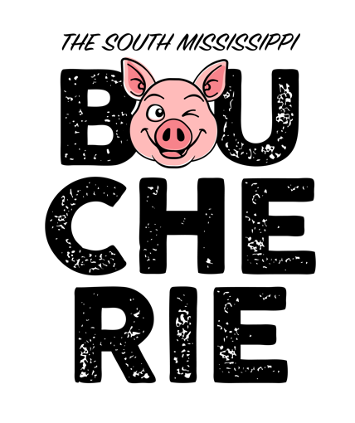

**Southwest Events Center**

**Tylertown, MS 39667**

**March 24-25, 2023**

*Sanctioned by the Memphis Barbecue Network*

**2023 Official Judge’s Application**

_____ YES, I agree to judge **The South MS Boucherie** in Tylertown, Mississippi

I am available to judge at the following times (check all that apply):

_____ Friday, March 24th, 6:00 p.m. to 9:00 p.m.

_____ Saturday, March 25th, 9:30 a.m. to 2:00 p.m.

_____ Saturday, March 25th, 1:00 p.m. to 5:00 p.m. (Finals)

Name: ______________________________________________________________________

_____ Trained _____ Certified (MBN Badge # ___________ )

If you are a judge in training, please circle the categories needed to complete certification:

*(Note: This does not guarantee you a spot in any category)*

Whole Hog Shoulder Ribs

Have you judged FINALS this year? _____YES _____NO If yes, where?______________

Address: ____________________________________________________________________

Cell Number: ________________________ Email: ___________________________________

*Judge’s Memberships must be current prior to contest or your application will not be accepted.*

*Receipt of this application is not a guarantee to judge. A confirmation will be sent to you when your application has been accepted.*

Please return your application to one of the following:

Mail to: Email to:

**Judges Chair tylertownboucherie@yahoo.com**

**The South MS Boucherie**

**PO Box 311**

**Tylertown, MS 39667**