 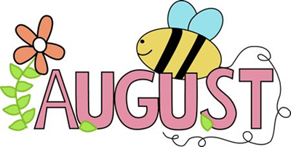 2021
NEWSLETTER-The Farm Fun and Better Me

This month we will be accessing our community as well as Calgary. There is Heritage Park, swimming, bowling, and billiards on the calendar. Remember that these need to be scheduled, so calling to get your name on the list is important.

Heritage Park in Calgary is planned for the beginning of August. Please sign up by the 10th of August to ensure that we can have accurate pricing for everyone as well as rides. It will cost $29.95+tax for admission but the staff get in free. Each person should either pack a lunch or bring money to purchase lunch/snacks. Each person is responsible for purchasing their own souvenirs and carrying them if they want any. The admission also includes rides on the midway, train, and steamboat. There will also be a small cost to cover fuel for vehicles.

Ladies Day Lunch will be a new activity to try. The cost for this is $3 and this is only to cover the cost of food. This is not part of the regular Better Me activities and is not covered under the punch cards for cost.

Gents Afternoon is yet to be determined for the activity but will have a note sent out when activity is chosen. I will keep you posted. This is not part of the regular Better Me activities and is not covered under the punch cards for cost.

September will begin the Better Me Relationship and Employment Studies Monday and Wednesday from 1-3pm. I have some new and exciting ideas for activities that we will do during this time. We will be starting on a new post pandemic adventure together!

ACTIVITY PUNCH CARDS
Just a reminder that some of the activities with Better Me will have a cost involved to cover craft supplies and such. These cards are available through Jackie or Cheryl. The cost is $20, and this is good for about 10 activities (works out to $2 per activity). If you do not have one, the cost will be $3 for the activity that is due at the time of the activity. This is a cost savings of $1 per activity.

Thanks
Cheryl Kilpatrick
Community Program Assistant

UPCOMING EVENTS

August 2- Civic Holiday
Office Closed

August 12-Heritage Park

August 19-Olympic
Games

July 22 Red Lodge Park

August 25 Armchair
Travel Visit Greece

August 26-Pizza Lunch

Please note:
Deadlines for sign up:

Swimming-August 5

Heritage Park-August 10

Ladies Day Lunch:
August 13

Lunch Fundraiser:
August 24

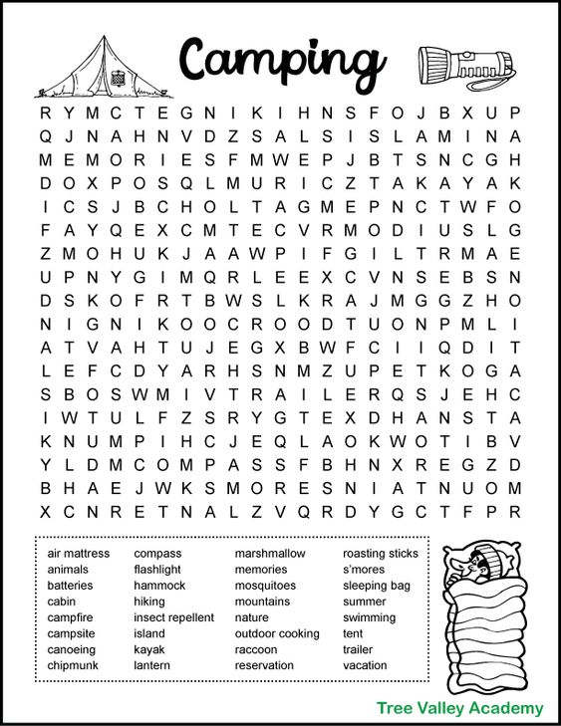

Trivia:

The 1927 Girl Scouts manual featured the first official recipe for S'mores.

The Clayoquot Wilderness Resort in Vancouver Island is the most expensive camping spot in the world. A single night costs $3,900.

There is not a universally held definition of camping. Instead, camping embodies the spirit of escaping everyday life and embracing the outdoors.

The most popular type of shelter among campers is a tent.

The most popular camping gear purchase is a flashlight.

Before tents were used for recreation, they were a basic survival necessity. The first evidence of tent construction can be traced as far back as 40,000 BC.

