The Simple Present
Verb Introduction
A verb in a sentence is an action word.
It indicates what the subject is doing.

(subject) + (verb) + rest of sentence.

I (subject) + walk (verb) + rest of sentence.
I walk to school every day.

This means that walk is the verb.

I is the subject of the sentence doing the action. Walk is the verb.

Note 1:
In the present tense, the verb is conjugated with the subject. A verb in the Simple Present tense explains that an action is happening in the present, right now.
I sing a song.
You sing a song
He sings a song.
She sings a song
We sing a song.
You sing a song
They sing a song
Note2:
Third person singular is conjugated with an “s” at the end of the verb.
The frog jumps.
The girl laughs.
He dances.

Present tense: means that the action takes place in the present. (now)
John plays with the dog.
Mary also plays with the dog.
The little girl plays with the dog.

Exercise 1: Find the subject from the following sentences.

1. The cat jumps over the fence.
2. She writes in her diary every day.
3. I brush my teeth morning and night.
4. You drive the bus every morning.
5. The baby sleeps in the crib.
6. I watch comedy films every Saturday.
7. The teacher speaks loudly.
8. She eats apples every day.
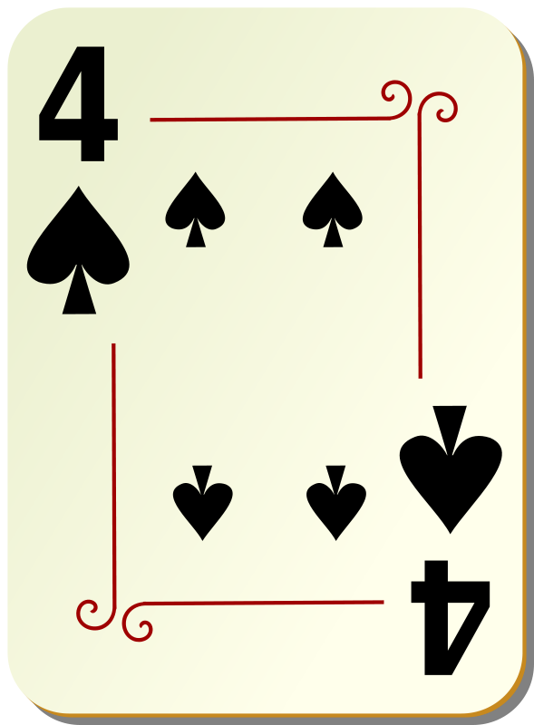
9. Nancy sings opera very well.
10. Jason drives a motorboat.
11. The elephant plays trick with the children
12. The student likes to study.
Exercise 2: Find the verb from the following sentences.
1. The dog runs after the cat.
2. Alice walks to school every day.
3. I play electric guitar really well.
4. She makes good chicken soup.
5. The child reads her favorite story.
6. We go to the movies every week.
7. Paul cleans the yard.

8. Cathy bakes apples pies better than her sister.
9. Alex swims at the gym.
10. Malcom rides his motorcycle to town.
11. She calls her mother long distance.
12. I take piano lessons to improve my musical skills.
Exercise 1: Determine the correct Simple Present tense verb for the subject.
Reference guide: Present tense
I walk
You walk
He walks
She walks
It walks
We walk
You walk
They walk
1. we ________________________ (call, calls )
2. I _________________________ (call, calls)
3. Angela ____________________ (talk, talks)
4. Amy and I _________________ (talk, talks)
5. Mario ____________________ (plan, plans)
6. they ______________________ (plan, plans)
7. you _______________________ (shout, shouts)
8. he ________________________ (shout, shouts)
9. it _________________________ (bark, barks)
10. you ______________________ (jump, jumps)
11. they______________________ (work, works)
12. she ______________________ (work, works)
13. he _______________________ (answer, answers)
14. the frog ___________________ (want, wants)
15. we _______________________ (ask, asks)
16. Jason _____________________ (play, plays)
17. you _____________________ (look, looks)
18. Fred _____________________ (look, looks)
19. Anita ____________________ (share, shares)
20. we ______________________ (share, shares)
21. the child ___________________ (take, takes)
22. I ________________________ (take, takes)
23. the man ___________________ (sit, sits)
24. my friend __________________ (sit, sits)
25. the woman _________________ (cook, cooks)
26. they _____________________ (cook, cooks)
Exercise 2: Complete the sentences using the correct Simple Present tense.
1. She _________________________(enjoy, enjoys) classical music.
2. John _________________________(read, reads) his favorite book.
3. I _________________________ (run, runs) for the bus almost every morning.
4. The opera singer _________________________(like, likes) to practice her voice.
5. Every morning I ________________________(receive, receives) the newspaper.
6. He _________________________ (clean, cleans) the kitchen right after cooking.
7. For breakfast, she _________________________(drink, drinks) black coffee.
8. On weekends, we _________________________ (shop, shops) with our friends.
9. Safia _________________________(want, wants) to visit Spain one day.
10. You ________________________ (live, lives) in a quiet neighborhood.
11. Rosie _________________________ (call, calls) her mother every Friday.
12. Nancy _________________________ (arrive, arrives) late for work every morning.
13. The teenager _________________________ (listen, listens) to rock music.
14. The director _________________________(prepare, prepares) the office meeting.
15. We _________________________(ride, rides) our bikes to town.
16. The bank manager ____________________ (approve, approves) the client’s loan.
17. My friends ____________________ (want, wants) to open a business soon.
18. My mother ____________________(visit, visits) me every weekend.
19. I ____________________ (like, likes) my soup really hot.
20. The band of musicians____________________ (travel, travels) often.
21. Sonia ____________________ (call, calls) to register her appointment.
22. The man ____________________(remember, remembers) where the train station is.
23. The director ____________________(invest, invests) in the stock market.
24. She ____________________ (plant, plants) new flowers in her garden every year.
25. The postman _____________________(deliver, delivers) the mail to the office building.
26. The Mayor of the city ____________________ (plan, plans) to increase taxes again.

Exercise 3: Complete the sentences using the information below.
1. The cat
________________________The cat jumps over the fence.________________________
2. She writes
___________________________________________________________________________
3. I brush
___________________________________________________________________________
4. The bus driver
___________________________________________________________________________
5. The baby
___________________________________________________________________________
6. I watch
___________________________________________________________________________
7. The teacher
___________________________________________________________________________
8. She eats
___________________________________________________________________________
9. With a soprano voice, Nancy sings
___________________________________________________________________________
10. Jason has a green thumb and takes
__________________________________________________________________________________
1. drives the bus to the station.

2. in her diary every day.
3. comedy films every Saturday.
4. sleeps in the crib.
5. care of the garden.
6. jumps over the fence.
7. apples every day.
8. opera very well.
9. gives the lessons to the students.
10. my teeth morning and night.

Answer Page
p.2 Exercise 1: 1.cat 2. She 3. I 4.You 5.baby 6. I 7. teacher 8. She 9.Nancy 10.Jason 11.elephant 12.student.
Exercise 2: 1.runs 2.walks 3.play 4.makes 5.reads 6.go 7.cleans 8.bakes 9.swims 10.rides 11.calls 12.take

p.3 Exercise 1: 1.call 2.call 3.talks 4.talk 5.plans 6.plan 7.shout 8.shouts 9.barks 10.jump 11.work 12.works 13.answers 14.wants 15.ask 16.plays 17.look 18.looks 19.shares 20.share 21.takes 22.take 23.sits 24.sits 25.cooks 26.cook

p.4 Exercise 2: 1.enjoys 2.reads 3.run 4.likes 5.receive 6.cleans 7.drinks 8.shop 9.wants 10.live 11.calls 12.arrives 13.listens 14.prepares 15.ride 16.approves 17.want 18.visits 19.like 20.travel 21.calls 22.remembers 23.invests 24.plants 25.delivers 26.plans

p.5 Exercise 3: 2. She writes in her diary every day. 3. I brush my teeth morning and night. 4. The bus driver drives the bus to the station. 5. The baby sleeps in the crib. 6. I watch comedy films every Saturday. 7. The teacher gives the lessons to the students. 8. She eats apples every day. 9. With a soprano voice, Nancy sings opera very well. 10. Jason has a green thumb and takes care of the garden.

