CRAFTER/VENDOR APPLICATION
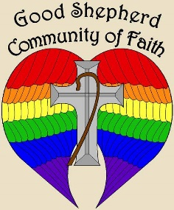
The following is an application for a craft/vendor show to be held at Good Shepherd Community Church, 187 Southside Parkway, Buffalo, NY 14220, on Saturday, October 5, 2019, from 9:00 a.m. until 4:00 p.m. Space will be provided on a first-come, first-served basis. The deadline for application is September 1.

NAME: ______________________________________________________________

PRODUCT: ___________________________________________________________________________

Address: ____________________________________________________________________________

City: __________________________ State: _______________________ Zip: __________________

Phone: _____________________________________________________________________________

Email: _____________________________________________________________________________

Good Shepherd Responsibilities:
- Provide 8’ table and 2 chairs as well as clear identification of table location.
- Allow set-up to begin at 7:00 a.m.
- Have food and beverages available for purchase.
- People available to direct unloading, parking, and other assistance as needed.

Vendor Responsibilities:
- $30.00 fee for space (vendor keeps all profits). A basket/gift to raffle may be required. Vendors will be notified at time of registration.
- Maintain a clean and presentable stand.
- Provide a cordial and friendly experience.
- After unloading product in the parking lot, move car to street parking in order to allow use of the parking lot by attendees.
- No alcoholic beverages.

By signing the bottom of this application, you are agreeing to the “vendor responsibilities” above.

**Submit application along with payment of fee made out to Good Shepherd Community of Faith. Send to Barbara Hulsing, 4325 Two Rod Road, East Aurora, NY 14052 no later than September 1, 2019. For additional information, call Rev. Hulsing at (716) 655-3463 or (716) 574-0164 or email her at barb.hulsing@gmail.com.

Signature: _______________________________________ Date: _______________________

