January 2020 Newsletter
Good Shepherd

Upcoming Events 2020
Jan 18, 2020 Sat active Shooter Training 9:30 AM
Jan 28, 2020 Tues, Self-Care Workshop 6:30-8:00 pm
Feb 25, Tues Self-Care Workshop 6:30-8:00 pm
Feb 29, 2020 Helping Hands for Haiti 9:30am-2:00 pm
March 24, 2020, Tues, Self-Care Workshop 6:30-8:00 pm
All Year 2020, Prayer Circle & Bible Study 6:30-7:30 pm. Every Tuesday, but the 3rd Tuesday of every month
All Year 2020 Exercise 6:30 -7:30 PM

BEASTS & BASKETS

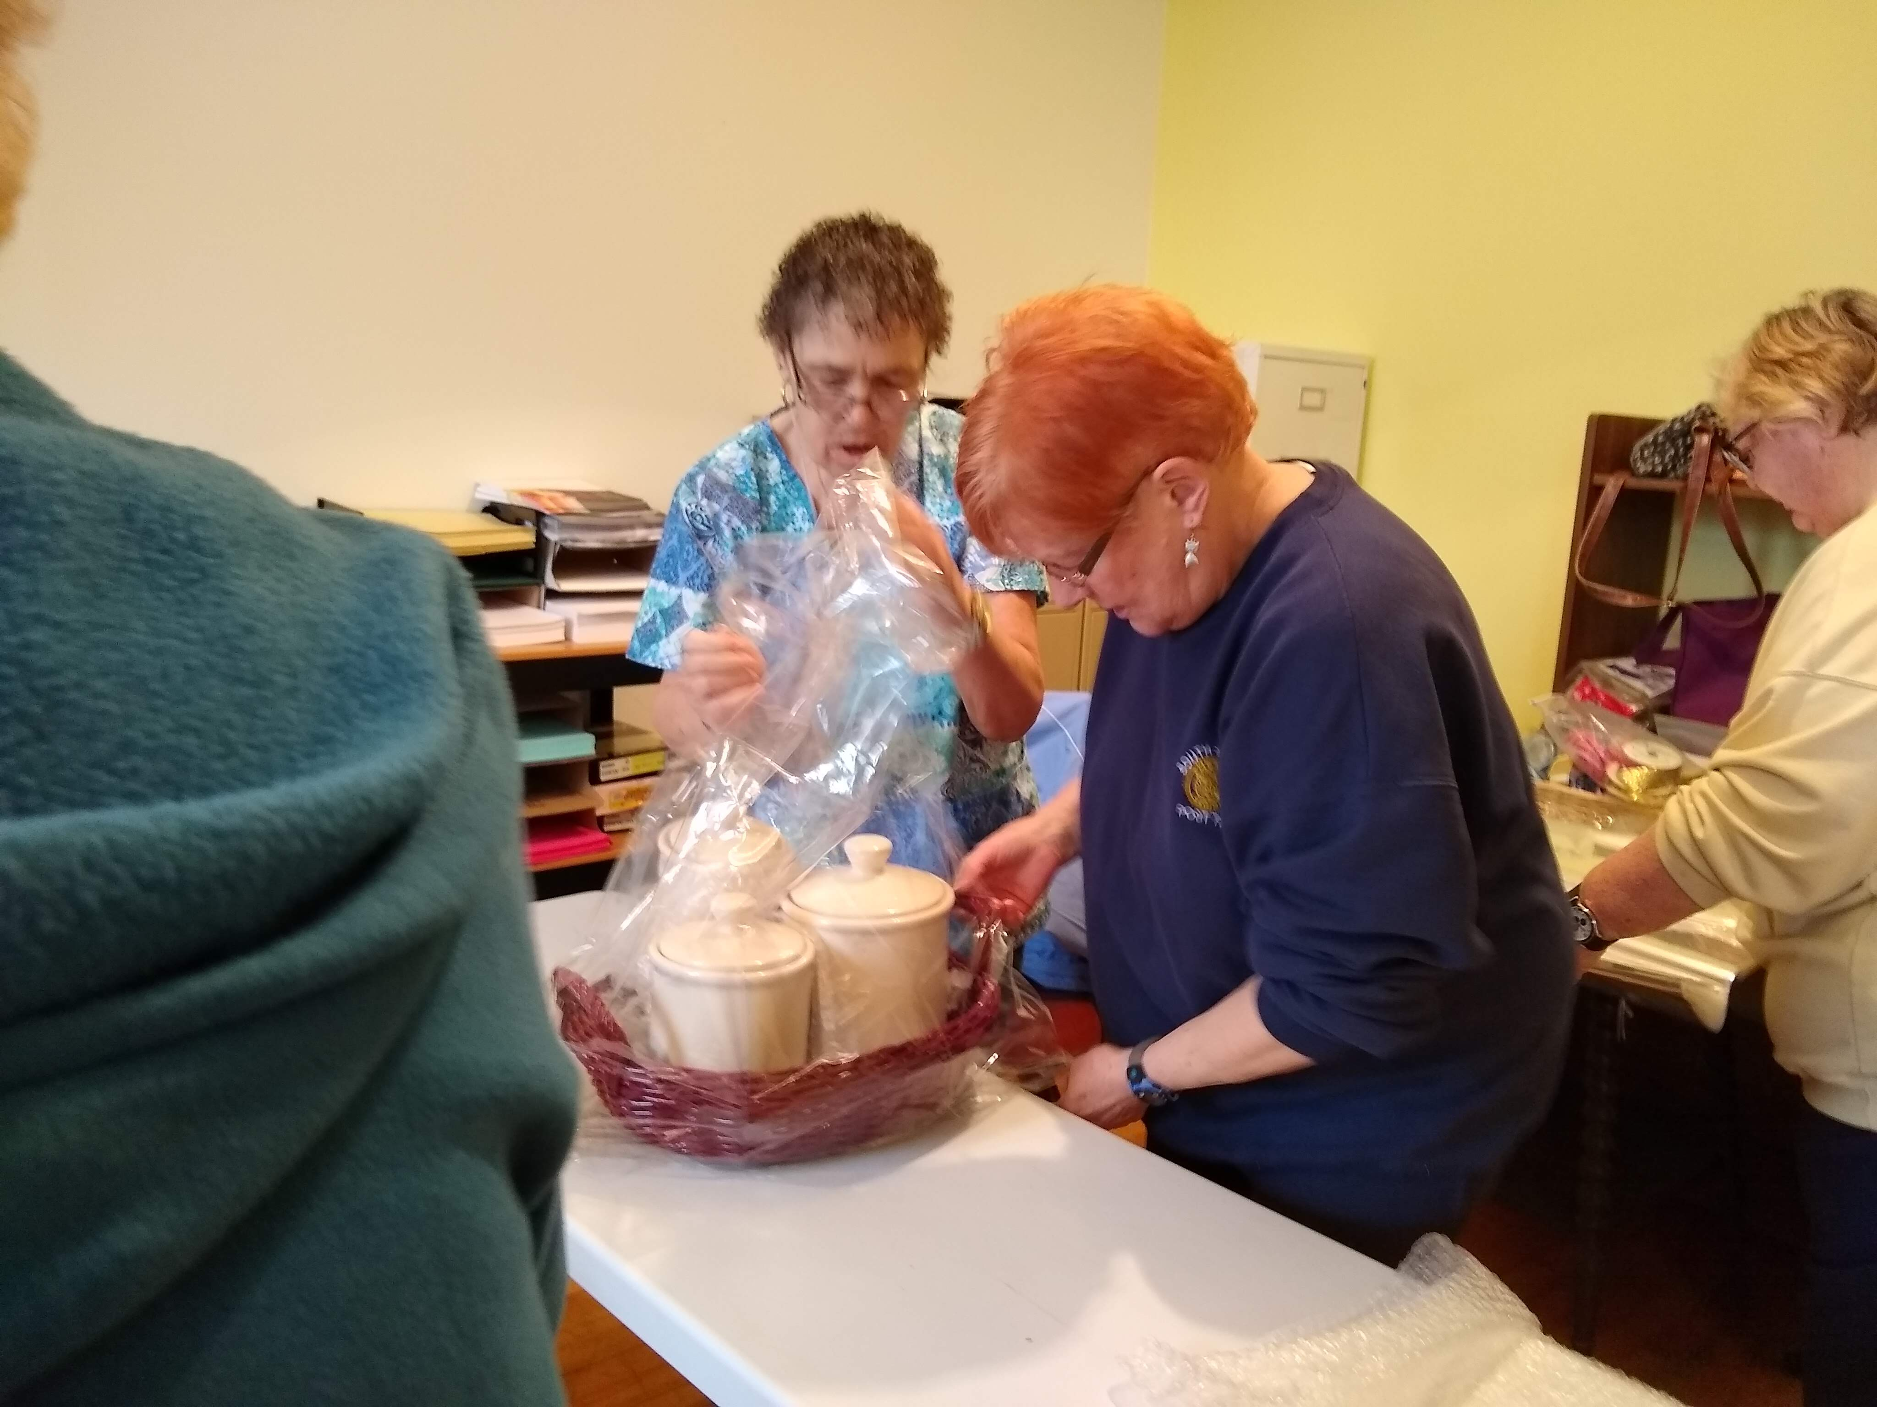
REMEMBER TO DROP OFF YOUR DONATIONS FOR OUR BEASTS & BASKETS! THANK YOU.
THIS FUNDRAISER IS ON MAY 17th, 2020
CALL THE CHURCH OFFICE OR JANICE IF YOU NEED US TO PICK IT UP (716-200-2406)

Community of Faith
187 Southside Parkway, Buffalo, NY 14222
www.gscof.org 716-824-4112 gscofchurch@gmail.com
Published by the Office of Good Shepherd
Dear Friends,
Greetings in the name of our Lord Jesus Christ:
It is with genuine gratitude and Christian delight that I greet you at the start of the New Year. I feel extremely honored and proud to share your fellowship as your pastor and siblings in Christ. As we look back on the year just ended, I would like to thank you all for the outpouring of love, friendship, cooperation and support that you have given to me, thus making the tasks of leadership easier and more pleasant.
God was, as usual, exceptionally generous to us as a church family last year and for that we give Him all the glory and the praise, and we look to the future more confident than ever that we can trust His leadership and benevolence as we face the year ahead. 2020 promises to be a most exciting, even if challenging, year for our country and our church The year will proceed with the usual programs (Bible Study and Prayer, and Wellness programs) and other activities (Beef and Baskets) that keep God’s church going year after year. If we keep in mind that this is God’s church, not ours, and use the talents and means with which He blesses us to reach out to His “other sheep” and bring Him glory, we can be assured of His presence among us and His blessings on our efforts.

In that regard, as we do each year, we will have what, with your cooperation and His blessings, I anticipate will be our most successful evangelistic series ever, in late summer our community event which highlights Mental health issues and Church picnic at the church. Before then, however, it is the hope to see the restoration of the Church building this year for utilization of the entire building to serve the community at large.
Remember this is also an election year, so let us go to the Throne of Grace and pray God’s will be done in the church and the world. God’s plan are good and he gives each one of us insight. The book of Habakkuk tells us plainly what we need to do write the vision, make it plain!
“Then the LORD said to me, “Write my answer plainly on tablets, so that a runner can carry the correct message to others. This vision is for a future time.
It describes the end, and it will be fulfilled. If it seems slow in coming, wait patiently, for it will surely take place. It will not be delayed.” (Habakkuk 2:2-3 NLT)
One thing is sure, that regardless of who leads here on earth, God will still be on the throne of the universe. So, let’s go forward in faith, anticipating many blessings in the year ahead. As I implore you each week, enjoy them and please, pass them on. A Very Happy and Prosperous New Year to All!
In Christ Service! Continued Blessings, Pastor Tanya

Sunday Service
Held at 10:30 a.m., we welcome you each Sunday. We celebrate communion the first Sunday of each month, and all are welcome to receive it. Worship is usually around 1 hour.
Prayer Circle & Bible Study in the Fellowship Hall at Good Shepherd Community from 6:30 – 7:30 PM. It will meet 3 times a month but not on the 3rd Tuesday of each month. All are welcomed to join us. Any question? Email tanyaspencer4@gmail.com.

Wellness Observance For January 2020

Birth Defects Prevention Awareness Month

Blood Donor Month

Cervical Health Awareness Month

Glaucoma Awareness Month

Thyroid Health Awareness Month

Healthy Weight Week Jan. 19th -31st

World Leprosy Day Jan. 27th
Active Shooter Training Saturday, January 18, 2020, 9:30 am -11:00 AM at Good Shepherd Community of Faith
The goal of the training is to keep individuals vigilant in all surroundings and to help provide guidance on what actions to take should you be confronted with an active shooter or other active threat. It will also offer insight on what individuals should watch and listen for in their workplace, at their place of worship, in their schools, or any other place in the community.
This training is provided by Border Community SERVICE of Niagara University and the Buffalo Police Department.
Questions? Leave message at Good Shepherd Community of Faith 716-824-4112.

Chronic Pain Self-Care Workshop Tuesday, January 28, 2020, 6:30-8:00 PM
According to the CDC in 2016 an estimated 20.4% of US adults had chronic pain and 8.0% had high-impact chronic pain.
Tuesday, January 28m 2020, 6:30-8 PM our Self-Care Workshop at Good Shepherd Community of Faith, 187 Southside Parkway, Buffalo, NY, 14220, will be addressing this topic.
Together we will be looking at how chronic pain is not just the physical sensation of pain, but also addition bothersome symptoms such as anxiety, social isolation, depression, fatigue, and misunderstanding. Just to name a few. Join our time of sharing. Questions? Contact Sue. 716-697-1657.
Advanced Directives/End of Life Care Tuesday, February 25th, at 6:30 pm
On February 25th, at 6:30 pm. Good Shepherd Community of Faith will be presenting a conversation about Health Care proxy, Advanced directives, MOLST Forms and Living Wills. We look forward to seeing you there! HOSPICE NIAGARA will be presenting the information.
Here is the information available to hand out:
An advance healthcare directive, also known as living will, personal directive, advance directive, medical directive or advance decision, is a legal document in which a person specifies what actions should be taken for their health if they are no longer able to make decisions for themselves because of illness or incapacity.
A living will is one form of advance directive, leaving instructions for treatment. Another form is a specific type of power of attorney or health care proxy, in which the person authorizes someone (an agent) to make decisions on their behalf when they are incapacitated. People are often encouraged to complete both documents to provide comprehensive guidance regarding their care, although they may be combined into a single form.
MOLST forms will also be explained and available at this event.

Come join us for some Gentle Exercise
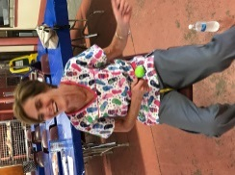
Grab your sneakers. Grab your water bottle. That’s all you need to come and join some gentle movements with us at Good Shepherd Community of Faith. Our classes are led by Samantha Curtis, certified group fitness instructor or arthritis exercise led by Cheryl Wilczak. Together, we engage our bodies and minds in gentle exercise and laughter. Most exercises can be done seated. Participants are encouraged to move at their own pace. All are welcome. There is no charge.
For more information contact Sue at 716-697-1657 or bsuea@yahoo.com. Ongoing classes will be held Thursdays, 6:30-7:30 pm all year.

FEAR/ANXIETY/WORRY Tuesday, March 24, 2020. 6:30-8pm
Our monthly Self-Care Workshop for March will focus on FEAR/ANXIETY/WORRY. Can you relate? What causes us to worry or be fearful? How do we best handle these stress provoking feelings in such a stress-filled life?
Join us in this time of interactive fellowship. Tuesday, March 24, 2020. 6:30-8pm. Good Shepherd Community of Faith. 187 Southside Parkway. Buffalo.
All welcome. Light refreshments. Questions? Contact Sue 716-697-1657.

CHRONIC PAIN/FIBROMYALGIA SUPPORT GROUPS Good Shepherd Community of Faith will be offering chronic pain, including fibromyalgia, support groups. These groups will be an opportunity for sufferers to share their journeys as well as what works for them and what does not. We will truly SUPPORT one another with our caring presence. Also, up-to-date information will be provided, and guest speakers, knowledgeable in the field of chronic pain/fibromyalgia, will be invited occasionally. We will discuss causes, the latest studies and their findings, and comfort-providing practices.
One group will meet on the first and third Thursdays of each month, beginning February 6, 2020, at 1:00 p.m. Meetings will run about 1-1/2 hours. The other will be held the second Saturday of each month, at 10:00 a.m., beginning February 8. Groups will be led by Rev. Dr. Barbara Hulsing and Sue Allen, Retired RN.
For further information about the support groups, contact Barbara at 716-574-0164 or barb.hulsing@gmail.com.

Helping Hands for Haiti February 29, 2020 Saturday 9:00 am – 2:00 pm
Come. Join us as we gather to sew, to assemble, to fill, to find purpose and joy in providing for others.
Infant & mother mortality rates in Haiti are amount the highest in the Western Hemisphere. Birthing bags are saving lives.
Our semi-annual HELPING HANDS FOR HAITI will be held Saturday, February 29, 2020. 9am – 2pm.at Good Shepherd Community of Faith. 187 Southside Parkway, Buffalo.
All are welcome to this time of fellowship. Light lunch provided. Questions contact Sue. 716-697-1657. For more information contact Sue 716-697-1657 or bsuea@yahoo.com
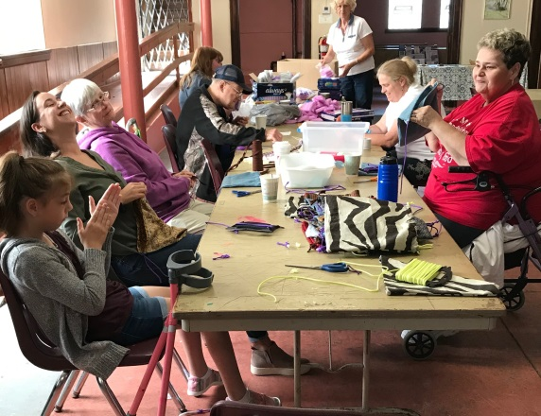

Stretcher Bearer Wellness Ministry
News-letter article
January 2020
“My soul weeps because of grief.
Strengthen me according to Your word.” (Psalm 119:28)
According to the CDC (2016) an estimated 20.4% of US adults had chronic pain and 8.0% had high-impact chronic pain.
I think these statistics are wrong!!! What do you think??
I don’t have to look far to see around me friends, family and folks in our congregation and community that (in my humble opinion) are struggling with pain. Not just temporary pain that will be gone in a few days. I am talking about that pain that just won’t go away!!
When pain lingers it becomes much more then a physical ailment. Additional bothersome symptoms may include: anxiety, social isolation, depression, fatigue, misunderstanding, loss of independence, grief, even spiritual dis-stress! The list goes on and on.
Ones pain does not only impact the individual but also those around them. Family and friends may many it is difficult to understand another’s physical pain. How do we as a family of faith respond those with chronic pain? Are we caring? Compassionate? Faithful in all that God’s plan is for us?
Our next upcoming Self-Care Workshop on Tuesday, January 28m 2020, 6:30-8 PM our Self-Care Workshop will be addressing this topic. This time together is meant for not only persons who deal with pain, but everyone.
Please consider joining our time of fellowship. And do bring a friend along.
Blessings for health and wholeness for 2020,
Sue

