Autumn 2019 Newsletter
Good Shepherd Community of Faith

Upcoming Events 2019
Sept 8, 2019, Sunday, Church Picnic at East Aurora 10:30
Sept 11, 2019 Wed, Panera Fundraiser 4-8 PM
Sept 14, 2019 Sat, Helping Hands for Haiti 9 am – 2 pm
Sept 17, 2019 Tues, Prayer Circle & Bible Study begins. 6:30-7:30 pm
Sept 24, 2019, Tues, Decluttering: Body, Mind & Spirit 6:30-8:00 pm
Oct 5, 2019, Sat, Vendor & Crafter Fair 9 am-4 pm
Oct 5, 2019 Sat Flu Shots 10 am – 4 pm
Oct 19, 2019 Sat PASTOR INSTALLATION 12:00
Oct 22, 2019 Tues Self-Care Workshop for Emergencies 6:00-8:00 pm
Nov 12, 2019, Tues Narcan Training 6:00-8:00 pm

Sunday Service
Held at 10:30 a.m., we welcome you each Sunday. We celebrate communion the first Sunday of each month, and all are welcome to receive it. Worship is usually around 1 hour.

187 Southside Parkway, Buffalo, NY 14222
www.gscof.org 716-824-4112 gscofchurch@gmail.com
Published by the Staff of Good Shepherd
Dear Friends,
We thought we would get you caught up on the latest events at our church………

NEW PASTOR INSTALLATION. ALL ARE WELCOMED!
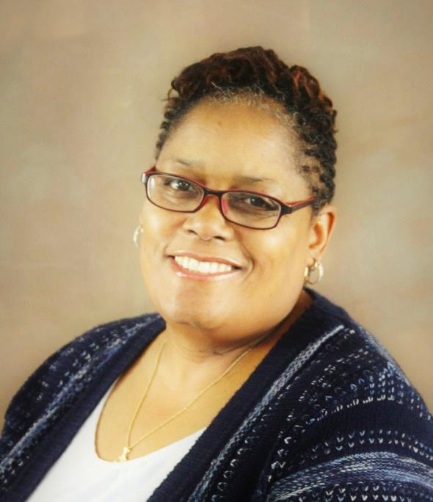
The Installation Service for Reverend Tanya Spencer will be held Saturday, October 19th at 12:00 PM - all are invited to this special occasion in the life of our church!

Prayer Circle & Bible Study begins on Tuesdays, September 17th, in the Fellowship Hall at Good Shepherd Community from 6:30 – 7:30 PM. It will meet 3 times a month but not on the 4th Tuesday of each month. All are welcomed to join us. Any question? Email tanyaspencer4@gmail.com.

Our new Pastor at Good Shepherd Community of Faith
In the spring of 2019, we began an era with a new pastor presiding over our small but mighty congregation at Good Shepherd. After over two years of guidance of our parish from retired, transitional Pastor, Reverend Faith Schaut, we celebrated with a wonderful Easter Service with both Reverend Faith and Reverend Tanya.
Tanya Spencer was born in Buffalo, New York. She attended Evangelistic Temple Community Church and Free Spirit Missionary Baptist Church in Buffalo. Tanya is a mother of three children: Phylicia, Daryl Jr., and Rashad and five grandchildren.
Christ has called her to a unique life. A life where she is told to have an eschatological hope while living an “everlasting life.” She sought clarity to these apprehensions by obtaining a Business Administration degree at Houghton College, Houghton, New York. She pursued her quest at Roberts Wesleyan College, Rochester New York with a Master of Strategic Leadership. She was aroused to demolish denominational segregation when she completed her Master of Divinity at Northeastern Seminary, Rochester, New York. She knows Christ is alive and speaks to her through the Holy Spirit, she has felt His presence all her life.
Tanya has built a reputation for developing business strategies, nurturing new business models, and developing leaders. Her expertise as an License Practical Nurse, Practice Manager for Buffalo Pediatrics Associates, Adjunct Instructor for the University of Buffalo Educational Opportunity Center, Congregation Care Coordinator and Sunday School Instructor for St. Stephen-Bethlehem United Church of Christ, Free Methodist Women’s Ministry, American Baptist Church, Genesis Conference, Pioneer Area Churches (PAC), American Baptist Minister’s Council, Buffalo-Niagara Clergy Women are instrumental to her call. Tanya also has experience in finance/business, has helped to build and inspire personal relationships, Associate Pastor at Chaffee Community Baptist Church, Board of Mission for American Baptist Church (ABC-NYS). Tanya has a gift for figuring out how people who are different can work together productively. She constantly applies Psalm 23 to promote peace to life situation that stimulates a positive outcome.
One thing is clear for Tanya, Christ has called her to follow and serve Him. God has given her a heart and passion for people who are disillusioned with traditional church, who have had negative church experiences, and who are looking for God outside of the organized Church. Tanya’s passion is to meet and to share with people the love of Christ in ways that are relevant, authentic and true to the spirit of the Gospel.

PANERA BREAD FUNDRAISER FOR GOOD SHEPHERD SHOULD BE A WINNER! JOIN US…..Sept 11th, Wednesday 4-8 pm.
Good Shepherd Community of Faith is having its first Fundraiser at Panera Bread at McKinley Mall - 3701 McKinley Pkwy, Buffalo, NY 14219. Catch up with church family and friends there. You must bring FLYER so when you buy your meal so Good Shepherd will get a percent of the profit. It will not change the price of your meal. Plus, the best part: No dirty dishes. FLYERS ARE INCLUDED IN THIS NEWSLETTER.

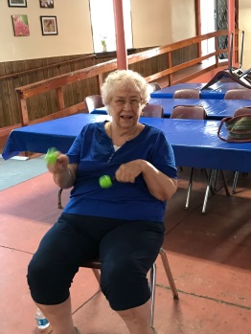
Come join us for some Gentle Exercise
The Arthritis Foundation Exercise Program is nationally certified and especially for persons with arthritis. However, all are welcome to participate. Our time together will include exercises for range-of-motion, endurance, strength building and flexibility set in a fun format. Exercises can be done seated or standing, and participants are encouraged to exercise at their own pace. Classes last for 1 hour. Our instructors are Cheryl, who is trained by the Arthritis Foundation. Ongoing classes will be held Thursdays. - 6:30-7:30 pm all year. Free Will Offering.

Don’t forget our first Vendors & Craft Fair on Saturday, October 5^{th 2019}
Applications are available for all vendors and crafters who like to gather at the fairs and farmer markets. The applications are due September 1st. The chairman of Good Shepherd’s first Vendor & Craft Fair is fellow vendor, Barb Hulsing, who sells jewelry and with her experience, this has been a fun collaboration. There will be basket raffles as well as a bake sale by the Women Ministry Board. The fun begins 9 AM, pronto, and ends at 4 PM. Please stop in and if you would like an application to be a vendor, Barb can answer your questions at barb.hulsing@gmail.com or call her at (716) 574-0164. POSTERS ARE ENCLOSED. PLEASE HANG UP IN YOUR COMMUNITY.

Do you know what to do in an emergency? What if a child were choking…. Your spouse was exhibiting signs of a stroke…You were the first at the scene of a car accident….or a loved one was bleeding? Would YOU be able to handle these emergency situations? Self-Care Workshop - October 22, 2019 Tuesday, 6:00 PM - 8:00 PM. Presented by Debbie Kampff, RN; American Red Cross/American Heart instructor for greater than 40 years; certified life guard; EMT trainer, will be our guest presenter. This program is open to ALL and there is no charge. Please register by calling Sue @ 716-697-1657.
*Don’t forget* that on Sunday, Sept 8th is the Church Picnic at the East Aurora Fireman's Field, 299 Pine Street, East Aurora. There will be a short service of prayers and hymns followed by a picnic lunch. Bring a dish to pass if you’re able. Meat and beverages will be provided. 10:30 am.

Stretcher Bearer Wellness Ministry
STRETCHER BEARER NEWS LETTER ARTICLE
AUGUST / SEPTEMBER 2019
“TIDY UP”
“Do not store up for yourselves treasures on earth, where moths and vermin destroy, and where thieves break in and steal .But store up for yourselves treasures in heaven, where moths and vermin do not destroy, and where thieves do not break in and steal. For where your treasure is, there your heart will be also.” Matthew 6: 19-21 NIV
Many of you have probably watched episodes of Marie Kondo’s series being aired on Netflix titled “Tidy Up”. Ms. Kondo teaches us how to sort through our many, many belongings and gradually part with those that we need to let go of. Her theory is simple: does this item bring you joy? If not, it’s time to let go.
I am sure we can all recognize that just maybe we tend to gather possessions. Clothes, books, dishes, toys, papers, souvenirs. This list of possessions that clutters our space goes on and on. Often leading to STRESS!! And Illness!!
It’s easy to see the impact clutter has on our physical well-being. But how about our emotional well-being? Spiritual well-being?
We will kick off our fall season with our Self-Care Workshop on September 24, 2019, 6:30-8pm, titled: “DECLUTTERING. BODY, MIND & SPIRIT”
Join us for this time of learning, sharing, fellowship together.
Light refreshments are always available. Remember to brings a friend or two.
And be sure to keep an eye out for lots more opportunities to promote health and wealthness of body, mind and spirit by joining together at our faith community.
Blessings,
Sue
GOOD SHEPHERD COMMUNITY OF FAITH WOULD LIKE TO WISH HAPPY BIRTHDAY AND HAPPY ANNIVERSARY TO THOSE CELEBRATING IN THE MONTHS OF SEPTEMBER, OCTOBER & NOVEMBER! GOD BLESS YOU.

Helping Hands for Haiti
Whoever you are, and wherever you are in your faith journey, you are warmly invited to make Good Shepherd your church home
Is a family member in the hospital or in need of pastoral care? Please leave a message at the church office or call Reverend Tanya Spencer directly at 716-783-4443.
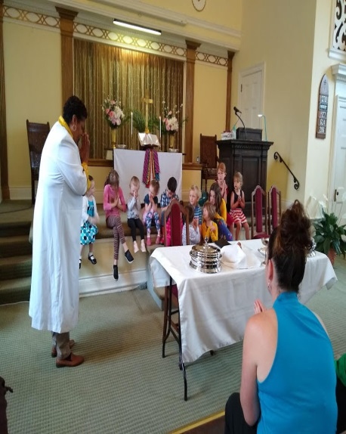

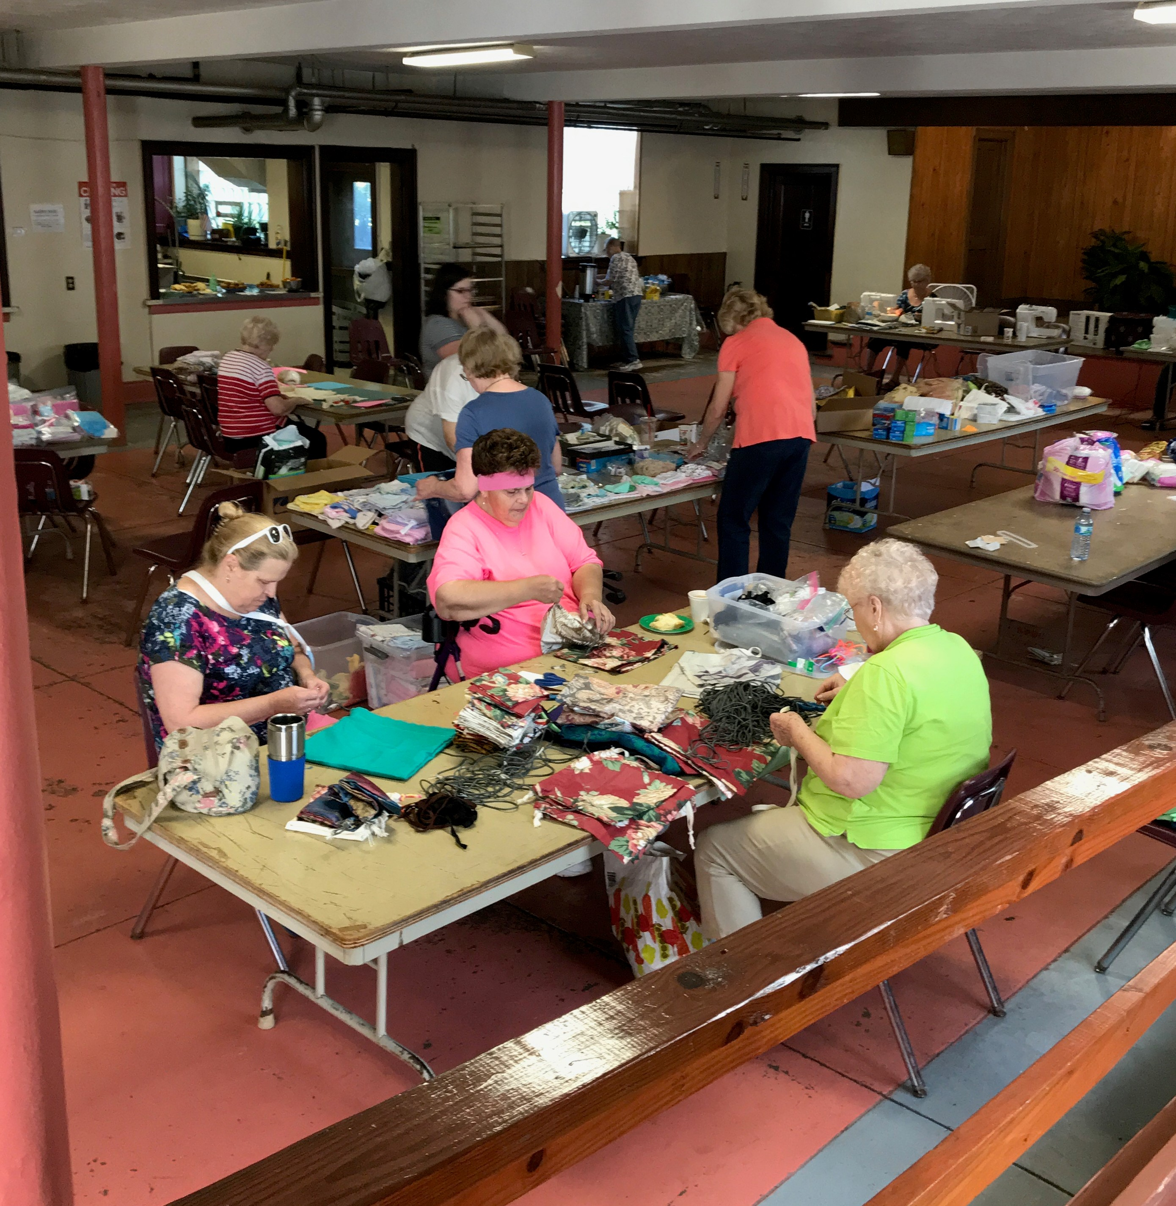
INTRODUCING OUR NEW MINISTRY TEAM BOARD MEMBER, Mark Turner & New CongrEGATION MEMBER, Michelle EscabI. 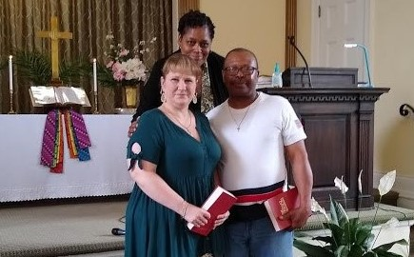

Workshop: Sept 14, 2019

Saturday 9:00 am – 2:00 pm
Clean delivery kits (birthing bags) can make a big difference for the mothers and infants of Haiti. What a joy to gather together: gather needed supplies; sew and assemble draw-string bags; fill the bags; prepare them to be transported and distributed to our midwives in Haiti.
A light lunch will be provided. No sewing skills needed.
Supplies especially needed at this time includes: small infant caps; receiving blankets; small bars of soap; small box of maxi pads or larger packs with individually wrapped pads and small bottles of hand sanitizer. For more information contact Sue 716-697-1657: bsuea@yahoo.com

