Is a shotgun an appropriate firearm for Zoos?

## 

Shotguns are certainly versatile firearms capable of firing a wide range of cartridge types from birdshot & buckshot all the way up to solid slugs but are they suitable for use in an emergency response within a zoo environment?

To begin answering this question we would need to set the parameters we would expect the shotgun to meet to prove its effectiveness both in accuracy and ballistic capability.

To determine a shotguns effective range, we need to consider the maximum distance the firearm, with its chosen cartridge, is consistently accurate enough to ensure a humane kill. At Zoodart we consider a four-inch (10cm) circle or kill zone to be the ideal representative target size which would cover the average size of all Cat. 1 zoo species vital organs ensuring a humane dispatch. Any firearm type not capable of hitting this size target should not be considered accurate enough for use at the range it was fired from. Similarly, the chosen firearm and cartridge combination needs to be able to deliver enough energy at the maximum accuracy range to ensure a humane dispatch.

The two most popular “zoo” shotgun cartridges are undoubtably 00 Buckshot and the 1oz Solid slug.

* 12ga 00 Buckshot consists of 9 pellets each weighing approx. 54 grains with a diameter of .33” or 8.38mm. These pellets have a muzzle velocity of approx. 1325 ft/sec. The 9 pellets generate 1548 ft/lbs of combined energy. Each single pellet generates 172 ft/lbs of energy.
* A 12ga solid slug weighs 1oz or 437.5 grains and has a muzzle velocity of approx. 1620ft/sec. generating 2488 ft/lbs of energy.

If we look at the shot pattern characteristics of a 12ga shotgun at various ranges with various chokes, we would be able to determine at what range the pellets would not consistently hit our required 4”/10cm vital area.

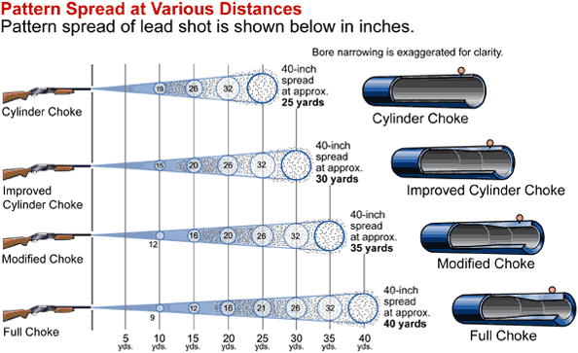

So, from an accuracy stand point, as per the diagram above, at 10yds the respective chokes only achieve a pattern of between 9”-19”. Nowhere near our 4”/10cm requirement. With all our practical testing on the range using a variety of shotguns we can concur that to ensure that all the pellets remain within the vital area shot distances need to be limited to a max. distance of 5m with shotshells and 10m with solid slugs.

I know that some people would argue that it just takes one pellet to hit the vital area however when dealing with dangerous species in an emergency within the public domain are you happy to gamble that one pellet may hit its intended target? Even if you could guarantee that at least one pellet makes it remember that one pellet is only going to deliver 172 ft/lbs of energy.

|  |  |  |
| --- | --- | --- |
| **Slug @** | **Velocity / FPS.** | **Energy / FT.LBS.** |
| **50 yds.** | 1,161 | 1,310 |
| **100 yds.** | 953 | 882 |

Please see the chart below and you will notice that 172 ft/lbs of energy makes up only 17.2% of the minimum legal requirement to shoot at Muntjac in the U.K. and a slug at 50yds, if you hit your target generates below the minimum requirement for Red, Sika & Fallow deer.

As a direct comparison, lets look at the legal minimum requirements for the humane shooting of deer in the U.K. as well as the legal minimum for all African dangerous game species based on energy, it is interesting to note that the shotgun with a slug comes up short regarding energy for every species other than the smallest deer species and nowhere near the requirements for dangerous species.

|  |  |  |  |  |
| --- | --- | --- | --- | --- |
| **Species** | **Min. bullet weight** | **Calibre** | **Min. muzzle energy**  **ft/lbs** | **12ga**  **Shotgun**  **Slug** |
| **Red / Fallow / Sika Deer** |  |  |  |  |
| England & Wales | – | Not less than .240 inches | 1,700 ft/lbs | 50yds  1,310 ft/lbs |
| Scotland | 100 grains | – | 1,750 ft/lbs (min. muzzle velocity 2,450 feet per second) | 50yds  1,310 ft/lbs |
| N Ireland | 100 grains | Not less than .236 inches | 1,700 ft/lbs | 50yds  1,310 ft/lbs |
| **Roe Deer** |  |  |  |  |
| England & Wales | – | Not less than .240 inches | 1,700 ft/lbs | 50yds  1,310 ft/lbs |
| Scotland | 50 grains | – | 1,000 ft/lbs (min muzzle velocity 2,450 feet per second) | 50yds  1,310 ft/lbs |
| **Chinese Water Deer & Muntjac** |  |  |  |  |
| England & Wales | 50 grains | Not less than .220 inches | 1,000 ft/lbs | 50yds  1,310 ft/lbs |
| **African Dangerous Game** | - | Not less than .375 inches | 4,661 ft/lb | 50yds  1,310 ft/lbs |

Another factor, which is a new topic of discussion on its own, but I will simply mention it, is that shotgun pellets and shotgun solid slugs are not copper jacketed to aid in weight and shape retention or in fact designed for controlled expansion thereby ensuring consistent penetration and energy transfer making them both vastly inferior to rifle bullets.

### So, based on the fact that a shotgun delivers substantially less required energy when compared to the minimum requirements for legally dispatching species like Lion, Leopard, Buffalo, Elephant, Rhino and Hippo throughout Africa and it does so with very fragile projectiles that are inherently inaccurate, how can we have them as a weapon of choice within zoos during a Cat.1 animal escape?

It simply does not make sense yet is common practise in zoos in the U.K. Please note that in accordance with the Health and Safety Executive and Secretary of State legislation zoos are obligated to provide:

* Formal training by a suitably qualified person
* Periodic refresher training
* Appropriate firearms

‘Particular attention should be paid to employees’ ability to make the right decision in the presence of the public and the training should reflect this’. (HSE)

### So as a zoo professional ask yourself:

**Is my zoo providing adequate training by a suitably qualified person?** If you are using shotguns, then that answer would have to be “no” because they should have the experience and knowledge to point out what has been mentioned above! You, your staff and public may have been put at risk by using an inappropriate firearm…who is then liable when it goes wrong?

**Is my zoo providing the firearms staff with “appropriate” firearms?** If your response protocol for Cat.1 species like lion, tiger etc. involves a shotgun or other small to medium calibre rifles ie: .243 – .308/30-06 then once again that would have to be a “no”.

Trevor Mckenzie – Lead Instructor, Zoodart.