Meet the Lebanon Cookbook Collective Founders.
Laurie Bennett
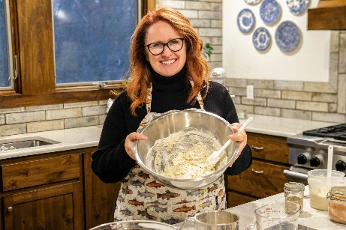
Laurie Bennett founded the Lebanon Cookbook Collective after making a simple but meaningful New Year’s resolution in 2026: to cook more meals from the cookbooks she loved collecting. Laurie is the owner of Bread and Bloom at The Farme, a farmstand and gift shop where she grows seasonal flowers, bakes artisan sourdough bread, and curates culinary and home gifts for every occasion. Deeply rooted in her love for Christ, family, and food, Laurie believes the table is one of the most powerful places to build community.
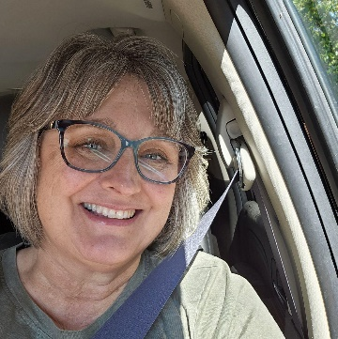
June Buckles
June Buckles discovered her love for cooking around the age of 11, when her mother would call home from work and guide her through preparing dinner over the phone. Her favorite cookbook is actually a magazine, Taste of Home. She recently opened the blueberry Buckle, a retreat space centered around sewing, crafting and creative gatherings. Known for her kindness and gentle spirit, June brings creativity, encouragement, and heartfelt hospitality to everything she does.

Ali Mitchell
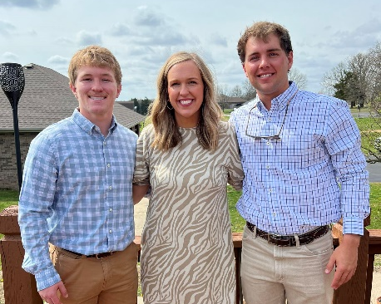
Ali Mitchell lives in the close-knit community of Lebanon, where she owns and operates Hairy’s Salon. She and her family live on a small farm filled with life, from chickens to horses, creating a home rooted in simplicity and hospitality. Ali also owns a vacation property near her home where her attention to detail keeps visitors coming back to Lebanon. Whether gathering friends around the table or preparing a home-cooked meal, Ali finds joy in creating spaces where people feel comfortable, cared for, and connected.
Cathy Qualls
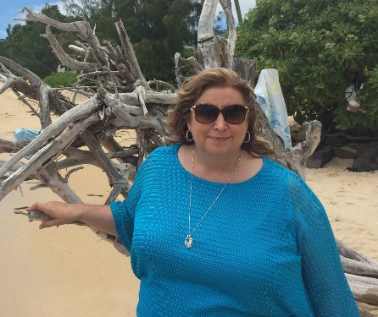
Cathy Qualls, alongside her husband Randy Qualls, with her children and grandchildren, has spent much of her married life opening her doors and heart to the Lebanon community for the past 33 years. Known for her gracious hospitality and servant’s spirit, Cathy has long been someone who brings people together and makes everyone feel welcomed, valued, and at home. Cathy faithfully serves on numerous Christian and civic organization boards throughout Lebanon, including serving as President of Elevate Lebanon.

