Non-chemical weed control methods:
Note: early identification each growing season of all invasive species prior to seed head formation is key to the success of controls regardless of type (chemical, biocontrols, or mechanical.)
If you see this… | It is: | Do this | At this time | Notes
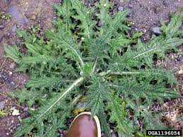 | Bull thistle rosette  - Deeply lobed, spiny leaves  - No flowers or seed heads present at this stage (see below for how to treat flowering plants.) | - Cut completely through root 3”-4” below soil level.  - Turn over and leave in place (or bag if preferred.)  - Bagging is not necessary.  - Once cleared, seed area of infestation with native plants.*  - Feed seeded areas with clean (weed seed free) compost. | Spring  Late Fall | - Leaving plants to die in place may discourage  future growth.  - Weevils have been extensively tested by CO Dept of Agriculture.
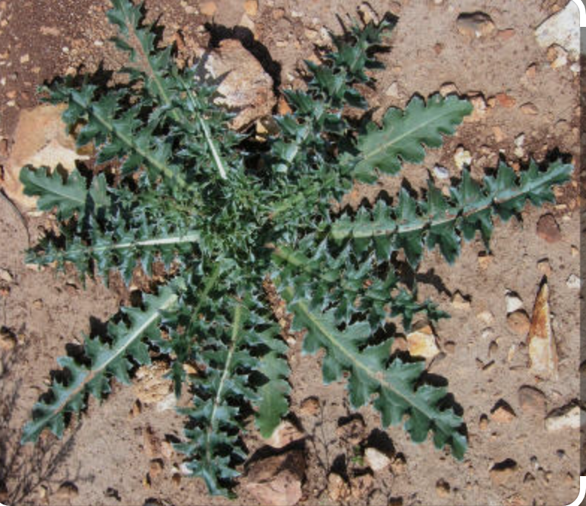 | Musk thistle rosette  - Leaves somewhat lobed, wavy white outlined margins  - Prominent, light green mid –vein  - No flowers or seed heads present at this stage (see below for how to treat flowering plants.) | - Biological control is achieved through introduction of species-specific weevils  - Weevils can be requested through Crowley Open Space Committee. |  | - Weevils by subscription through the CO Dept of Agriculture at: https://ag.colorado.gov/conservation/biocontrol.  - This is a biennial thistle that reproduces through seed only. Does not produce seed heads in year one, so early identification can assist in full eradication.
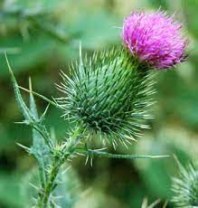 | Bull thistle flower  - Vase-shaped flower head  - Purple flower  - Golf ball sized flower head  - Deeply lobed, spiny leaves  - Biennial (last 2 years) | - Cut & bag all open or partially open flower heads. Dispose of them.  - Cut root 3”-4” below soil level.  - Turn over de-headed plant & leave in place (or bag if preferred.)  - Seed area of infestation with native plants.*  - Feed seeded areas with clean (weed seed free) compost. | Summer/Fall  Late Fall | - It’s important to bag/dispose of even partially opened flower heads as they may contain viable seeds.  - Depleting seeds already in soil may take several seasons.  - Leaving de-headed plants to die in place may discourage future growth.
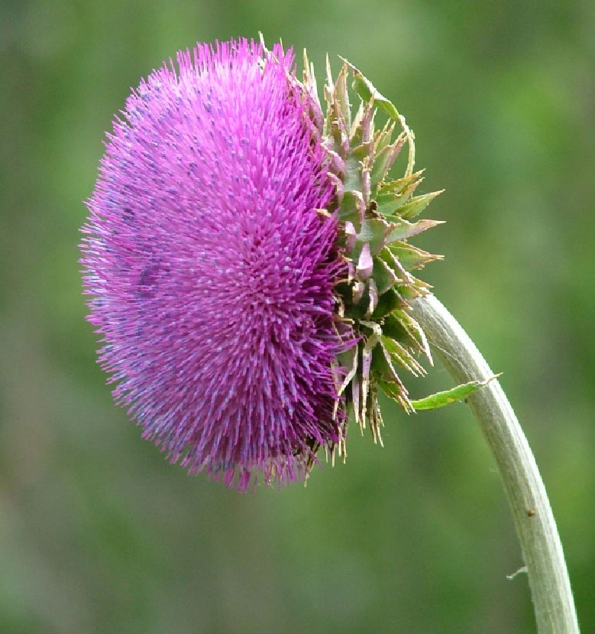 | Musk thistle flower  - Flattened flower head  - Purple-ish flower  - Golf ball sized flower head  - 1 flower head per stem  - Biennial (last 2 years) | - Biological control is achieved through introduction of species-specific weevils  - Weevils can be requested through Crowley Open Space Committee.
 | NOTE : | - The above thistles are invasive & are treated in the same way.  - Canada thistle (on other side) has a different treatment regime.  - Other thistles found on Crowley Ranch are native and can be left alone.  - Contact the Crowley Open Space Committee for more info.  - For more pics & help identifying thistles go to https://tinyurl.com/4j7p9tsv |  | Suggested tools:  - Radius Garden Root Slayer Shovel  - Pruning Shears  * Use only seed mixes guaranteed not to contain invasive seed. NRSC/SJCD in Pagosa is a reliable, publicly available source.
If you see this… | It is: | Do this | At this time | Notes
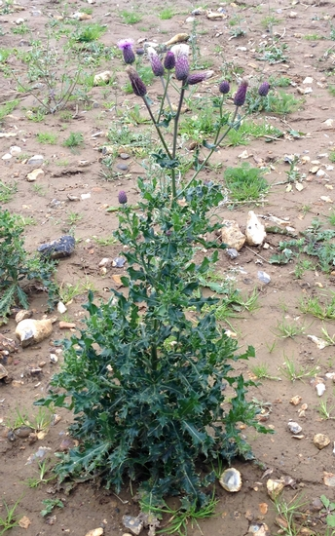 | Canada thistle plant  - Pink or purple flowers (rarely white.)  - Flowers the size of tip of thumb  - Multiple flowers per stem  - Highly invasive, tenacious perennial. | - Do NOT pull plant or cut below soil.  - Clip plant just above ground level multiple times throughout growing season to suppress seed propagation and starve roots.  - Do NOT disturb roots when clipping plant above ground.  - Cover affected area with dark plastic tarp (called solarization) for 4-12 weeks  - Solarization is the most effective method for 100% eradication.  - Seed area of infestation with native plants.*  - Feed seeded areas with clean (weed seed free) compost. | Summer  Fall | - Propagates mostly via roots. Pulling plant or cutting below soil leaves roots and results in accelerated spread.  - Solarization: place dark plastic tarp over plant bed for 4-12 weeks. 4 weeks when underlying plants are new infestation, 12 weeks when infestation is 2 or more years old.  - Rust fungus tested for 10 years only attacks Canada thistle per CDA studies spanning 3 decades.  - Control of Canada thistle may take several years.
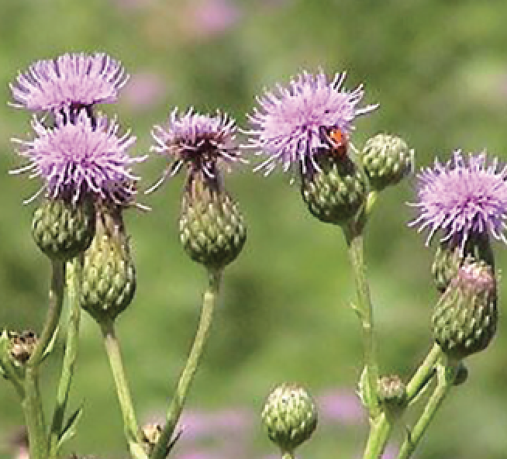 | Canada thistle flower | - Can also be contained (not eradicated) by rust fungus available from Open Space Committee.  - If you intend to use rust fungus, please contact the Crowley Open Space Committee for best practices information. | ??? | - Rust fungus biocontrol can be requested by subscription through the CO Dept of Agriculture at: https://ag.colorado.gov/conservation/biocontrol.
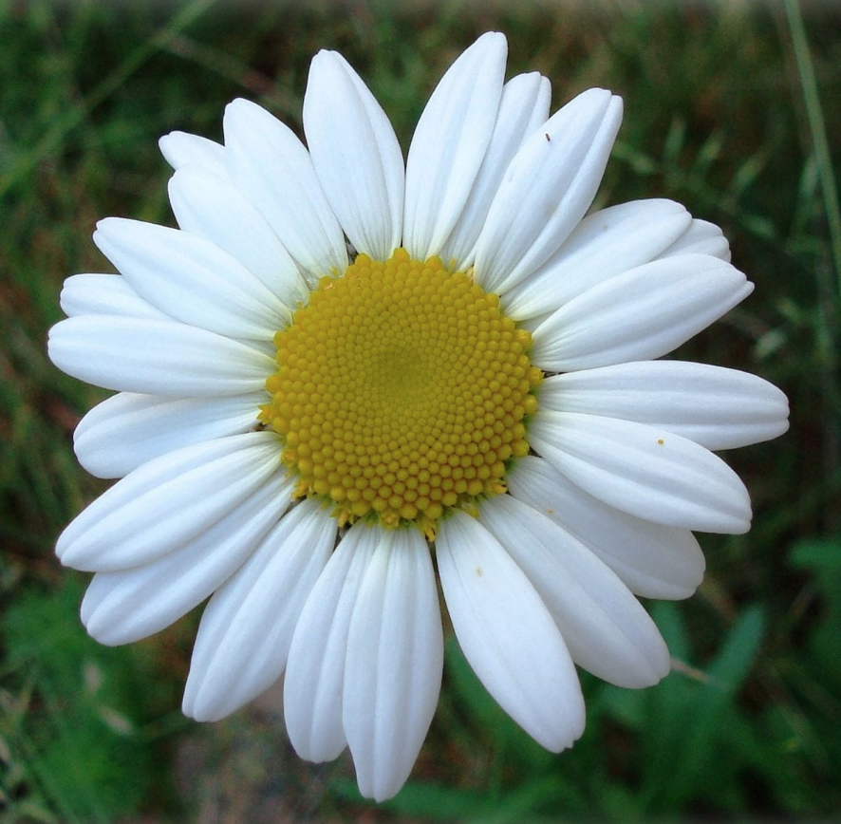 | Oxeye Daisy  - Yellow center surrounded by white petals, slight notch at tip  - Flower 1.5”-2” | - Do NOT pull plant or cut below soil.  - Clip plant & flower/ seedhead above ground to suppress seed propagation and starve roots.  - Cover affected area with dark plastic tarp (called solarization) for 4-12 weeks  - Solarization is the most effective method for 100% eradication.  - Seed area of infestation with native plants.*  - Feed seeded areas with clean (weed seed free) compost. |  | - Distinguished from Shasta daisy by leaf shape:  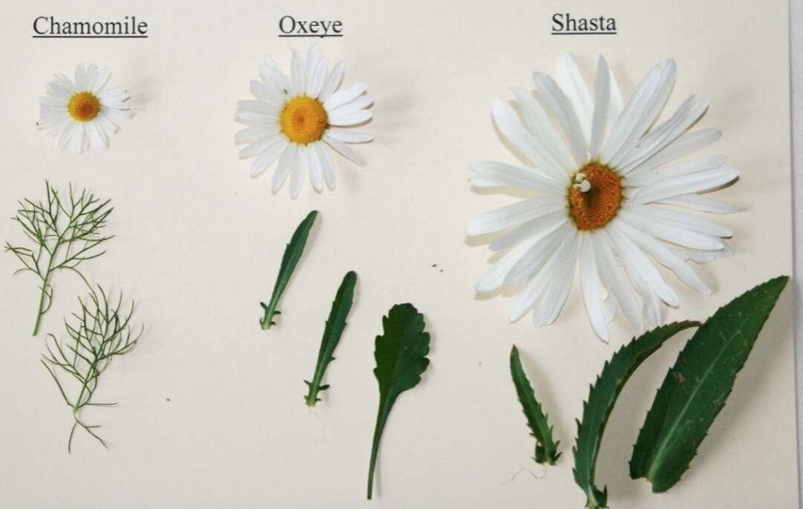
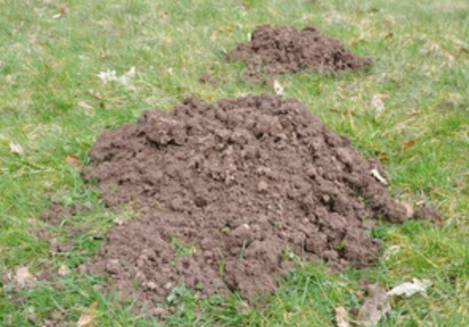 | Disturbed earth | - Seed with native grasses / wildflowers.*  - Cover with certified weed free compost and water. |  | - Many invasive weeds find a foothold in disturbed earth.  - Seeding with native plants helps suppress invasive species.
 | NOTE : | - Other native thistles found on Crowley Ranch can be left alone.  - Contact the Crowley Open Space Committee for more information  - For more pics & help identifying thistles go to https://tinyurl.com/4j7p9tsv |  | * Use only seed mixes guaranteed not to contain invasive seed. NRSC/SJCD in Pagosa is a reliable, publicly available source.

Chemical weed control methods
If you see this… | It is: | Do this | At this time | Notes
 | Bull thistle rosette  - Deeply lobed, spiny leaves  - No flowers or seed heads present at this stage (see below for how to treat flowering plants.) | - Follow all safety instructions on herbicide labels.  - Spray within confines of your property.  - Avoid overspray by applying in low wind conditions only.  - The chemical Milestone considered effective for use on these weeds by the USDA. | Spring | - The makers of glyphosate (Roundup, etc) have lost multiple civil lawsuits in US Appeals courts totaling over $10 billion claiming it causes non-Hodgkins Lymphoma.  - Colorado law requires disclosure of any pesticides used on your property during real estate sales. Use of glyphosate may effect property values and impact real estate transactions.
Musk thistle rosette
- Leaves somewhat lobed, wavy white outlined margins
- Prominent, light green mid –vein
- No flowers or seed heads present at this stage (see below for how to treat flowering plants.)
 | Bull thistle flower  - Vase-shaped flower head  - Purple flower  - Golf ball sized flower head  - Biennial (last 2 years) | - Follow all safety instructions on herbicide labels.  - Spray within confines of your property.  - Avoid overspray by applying in low wind conditions only.  - The chemical Milestone considered effective for use on these weeds by the USDA. | Best to spray before flower/seed formation
Musk thistle flower
- Flattened flower head
- Purple-ish flower
- Golf ball sized flower head
- 1 flower head per stem
- Biennial (last 2 years)

NOTE : | - The above thistles are invasive & are treated in the same way.  - Canada thistle (on other side) has a different treatment regime | - Other thistles found on Crowley Ranch are native and can be left alone.  - Contact the Crowley Open Space Committee for more info.  - For more pics & help identifying thistles go to https://tinyurl.com/4j7p9tsv |  | * Use only seed mixes guaranteed not to contain invasive seed. NRSC/SJCD in Pagosa is a reliable, publicly available source.
If you see this… | It is: | Do this | At this time | Notes
 | Canada thistle plant  - Pink or purple flowers (rarely white.)  - Flowers the size of tip of thumb  - Multiple flowers per stem  - Highly invasive, tenacious perennial. | - Follow all safety instructions on herbicide labels.  - Spray within confines of your property.  - Avoid overspray by applying in low wind conditions only.  - The chemical Milestone considered effective for use on these weeds by the USDA. Do not use near desirable trees or near water (lakes, streams, etc.) | Late Spring  Fall | IMPORTANT:  - Fall application is the most effective for control of Canada thistle.  - Herbicide choice is important. Milestone is the suggested herbicide.  - Application in late spring may serve to knock back the plant, but it will re-grow.  - It takes multiple seasons to control Canada thistle.
 | Canada thistle flower
 | Oxeye Daisy | - Follow all safety instructions on herbicide labels.  - Spray within confines of your property.  - Avoid overspray by applying in low wind conditions only.  - The chemical Milestone considered effective for use on these weeds by the USDA. Do not use near desirable trees or near water (lakes, streams, etc.) | See notes | - Apply when plants are actively growing and in pre-bud stage of development.
 | Disturbed earth | - Seed with native grasses / wildflowers.*  - Cover with certified weed free compost and water. |  | - Many invasive weeds find a foothold in disturbed earth.  - Seeding with native plants helps suppress invasive species.
 | NOTE : | - Other native thistles found on Crowley Ranch can be left alone.  - Contact the Crowley Open Space Committee for more information  - For more pics & help identifying thistles go to https://tinyurl.com/4j7p9tsv |  | * Use only seed mixes guaranteed not to contain invasive seed. NRSC/SJCD in Pagosa is a reliable, publicly available source.

