**KPRA Meeting Agenda**

**Saturday, May 20, 2023**

**10:00 a.m. (CT)**

**Crazy Mule Restaurant – Greensburg, KS**

BOARD - Leon Winfrey, Austin Hawkins, Coy Christian, Matt Dockendorf, Jarek Van Petten, Lucas Philips, Kari Boone, DelRey Welsh, Jacob Benham, Peyton Freeman, Troy Boone, Joe Macoubrie, Burton James, Kashly Van Petten, Coleman Kirby, Klee Jones, Jennifer Baker, Mike Greenleaf, Bud Jennings, Justin Russell, Tim Gleason, Ashley Macoubrie

Meeting called to order: Leon called meeting to order with a prayer at 10:10 a.m.

Review of minutes – posted to the website “Business” page, and e-mailed. David Craig did respond to the email to address the original tie vote in the 40/40 and OTR cattle decision followed by the re-vote.

REPORTS

Secretary Reports

2022 Financials and Bank Statements available for review.

Current 2023 Financial Report attached.

PayPal transfer from March 15th of $3,827.66 not logged in QB along *current PayPay balance of $2,857.10* and online memberships purchased yesterday. Square transfer $432.53

General Account Balance - $40,706.29

TC Dawson Memorial Account – $4215.00

Mary sent $1000.00 in March to add.

CD – $20,069.04

Finals Funds - $166.66

Membership is at 333, late year at this time it was 281.

Heather gave a quick review of the financial report. Kashly moves to approve, Tim seconds.

NEW BUSINESS

1. 2023 Sponsorship Update

Agco Hesston - $3,500

Mariah Fund Grant - $5,000

Drive to Zero is not sponsoring us in 2023

Leon has contacted most of last years sponsor and they will be back on this year. Invenergy is playing with the idea of doing a larger sponsorship, they like to do community support and are growing in the area. Hoping for a long term sponsorship.

1. 2023 Finalist Jacket – Do not have samples yet, attached are detail on the two choices.

Will hold off on making a decision until we get them.

1. Buckles – Quote from Bob Berg. Austin moves to order the Bob Berg buckles. Kashly seconds the motion. Passes.
2. 2023 Finals Information – Leon asked if everyone is good with keeping the schedule the same. The board would like to move Tie Down and Breakaway to the last events to run cattle.

Personnel – Pick up men, Do we want to stay with 3 or should we cut back to 2. Tim asked how Bud and Mike feel about it. Leon has talked with DelRey Welsh about making KPRA chaps for the pick-up men at finals. Jennifer said we should order three so that we always have enough. Austin moves to order three sets of pick-up men chaps, Kari seconded the motion. Austin feels we should have rough stock representation before we decide to cut back to two.

Same with judge, do we want to stay with 4 or should we move back to 3? We plan to move to 3 judges for the 2023 finals. Austin moves and Troy seconds.

Announcers – Leon thinks Monte does a good job and he really likes announcing the KPRA for finals and will do it for the same price last year. Troy mentioned that Troy Goodrich would like to put in a quote for the KPRA finals. Troy will visit with him tonight and see if he would like to put in bid. Austin mentioned getting Caleb back as the co-announcer for the same price.

Chute Boss – Cody Whitney has done it the last couple years. Alex Phelps asked about doing it. Kashly thinks that Alex would be good because he knows the timed events and rough stock. Austin thinks that Alex might be to nice, Jarek doesn’t think it would be a problem for him. Leon will contact Alex.

Hotel rooms – Kashly feels like we offer two nights and if they want to stay Thursday night, they have to cover it. Stock contractors are the exception. Ashley said maybe we can give an incentive to stay in your trailer.

Timers and secretary – ahsley suggested a nice back or backpack with engraving.

Big Screen – Leon has talked to several big screen people, Leon would like to have one in the same corner as last year but there is no power in that corner. But Patrick said there is a 50 amp breaker somewhere around there. Leon is working to get us on the Cowgirl channel and we can get a big screen from Lisa Bailey. Cost will be roughly the same as last year.

Concert – Albert is out so we are on our own. Leon talked to Steve Deges with Roundup and they are willing to partner on a concert. Austin knows a gal, Kaitlyn Kilain, from his hometown that is getting started in Nashville. She is available the weekend of finals, she quoted $1000 for an acoustic set or $3000 with a band. Leon thought we could have her on Saturday night and have a $500 local group for Friday. Incorporate the concert with the buckle ceremony. Possibly have Wes Cossman again. Ashley knows a guy with a band in Alva, so she will contact him. Ashley mentioned doing the scholarships during the awards ceremony. Heather mentioned a goat roping and Kashly though that would be a good fundraiser and LD Meier might be willing to put it on. Troy thought we could have it prior to the start of the rodeo and stop for the rodeo and continue after the rodeo. Kari asked if we could set up to replay the rodeo during the awards ceremony. Leon said there are several TV’s in the beer garden but they need a certain cable. Leon will check with Lisa with the big screen.

Finals Entries will be Monday, Sept. 10th following the Sayre, OK. Heather requested all sponsorship money be submitted by the finals entries.

Sponsor/Committee Hospitality Tent.

ADJOURN

Motion to adjourn by Austin moves, Kari seconds 11:35 a.m. cst.

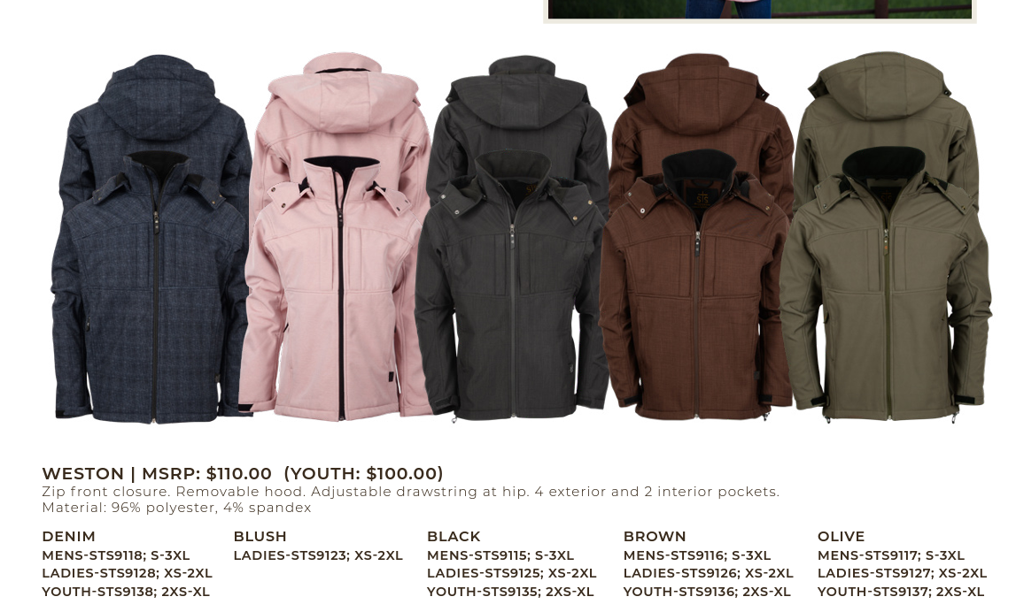

**KPRA Price $55.00 plus embroidery**

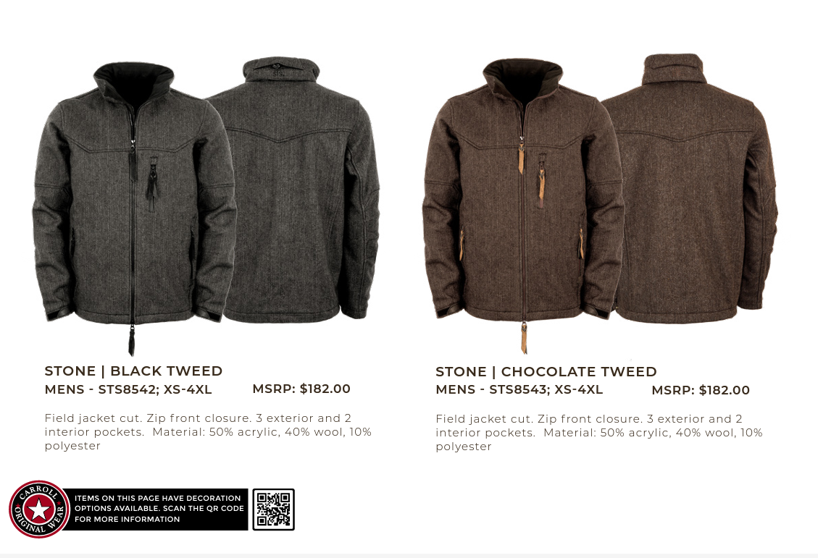

**KPRA Price $91 plus embroidery**