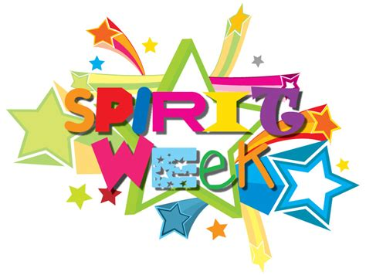
October 1st- 5th
Spirit week is here, bring your creativity to Fields Prep…

Monday: Crazy sock day
(wear mix-match or colorful socks)

Tuesday: Crazy hair day
(show your swag with a funky hairstyle)

Wednesday: Team day
(wear jersey or team colors)

Thursday: Wacky Tacky Wednesday
(Dress any way you want, not to impress)

Friday: Pajama day
(Roll out of bed and head to school, it’s Pj day)

