November
2018 | 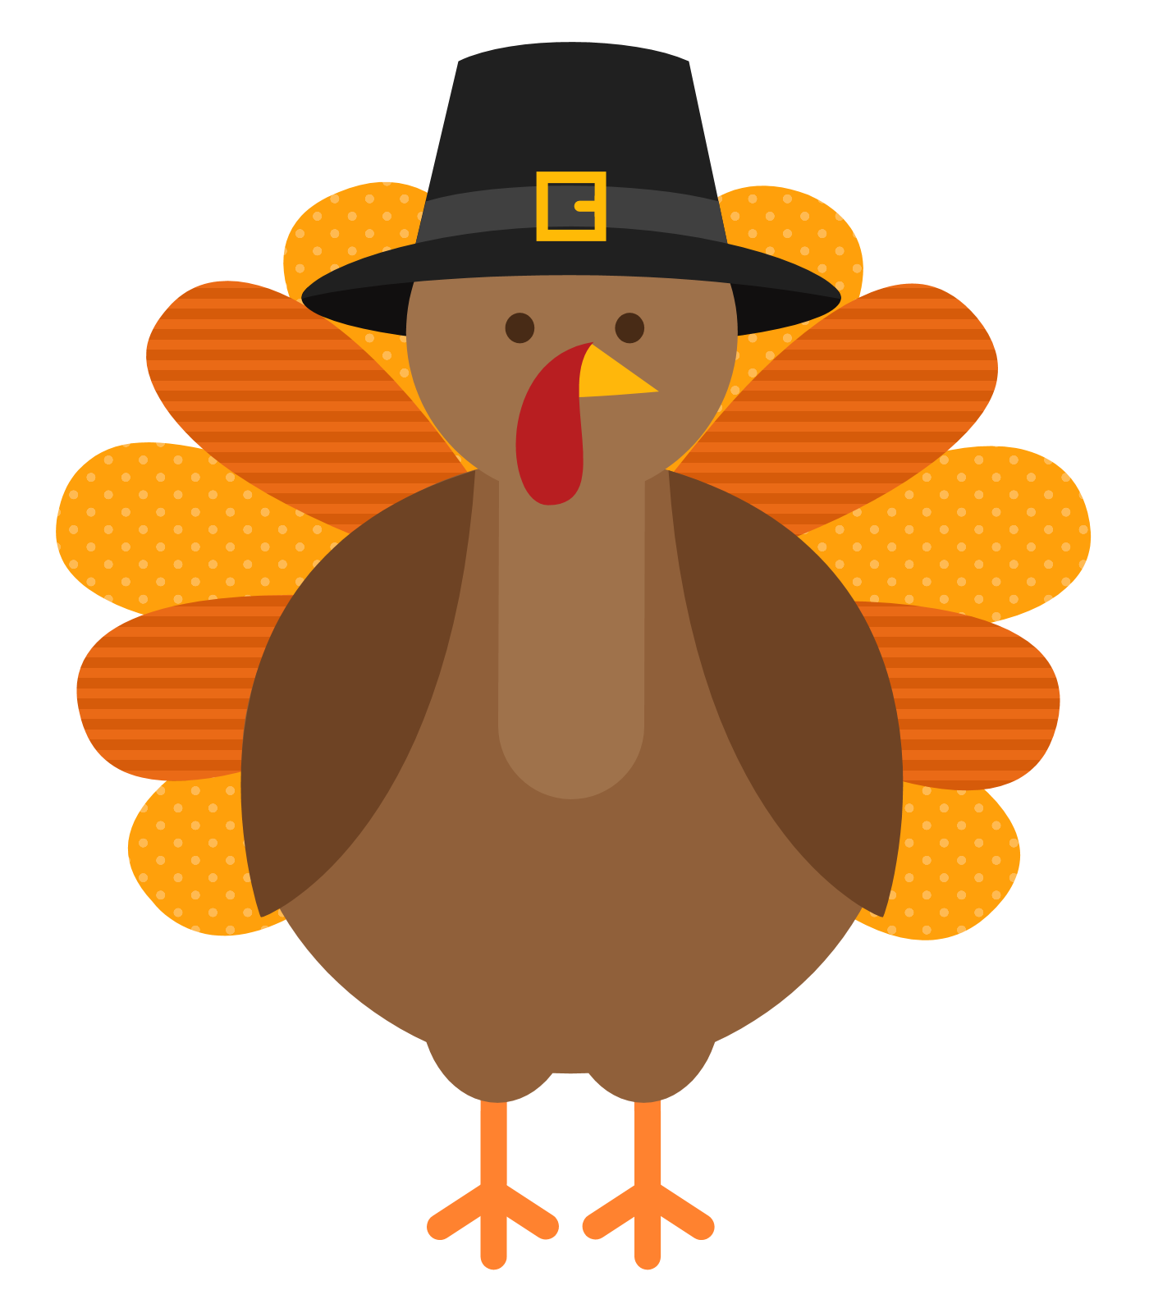
Sunday | Monday | Tuesday | Wednesday | Thursday | Friday | Saturday
 |  |  |  | 1 | 2 | 3
 |  |  |  |  | Homework Due
4 | 5 | 6 | 7 | 8 | 9 | 10
 |  |  | Show and Share |  | Homework Due
11 | 12 | 13 | 14 | 15 | 16 | 17
 | Closed VETERANS DAY | Parent Teacher Conferences | Parent Teacher Conferences | Parent Teacher Conferences | Homework Due
18 | 19 | 20 | 21 | 22 | 23 | 24
 | Native American  Pilgrims Activity | I am thankful for assignment | “Friends/ Family lunch-giving” (Bring in a dish)  Homework Due | CLOSED THANKSGIVING | CLOSED THANKSGIVING BREAK
25 | 26 | 27 | 28 | 29 | 30
 | National Cake Day |  |  |  | Homework Due

Sight Words:  It, So, In, Me  Number of the month: 3 | Shape of the month:  Rhombus/ Diamond  Color of the month:  Brown/Café | Letter of the month:  Gg, Hh, Ii  Theme of the month:  After the harvest | Weather Closings and Delays: Tune in to WJZ.com or channel 13. Check our website, Facebook or Instagram page for updates! | Reminder: Every child needs their own fitted sheet and blanket. Please sent a coat daily for outdoor play. | Keep in mind, any medication to be administered to children will need a doctor’s note.

