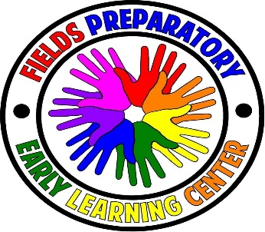
Fields Preparatory Early Learning Center Inc.
2022 Center Closings
January
1/17/22 Martin Luther King Jr. Day
February
02/21/22 - Presidents Day
March
No closings
April
4/18/22 Easter Monday
May
05/30/22 Memorial Day
June
06/20/22 Juneteenth
July
07/04/22 Independence Day
August
08/22/22- 08/24/22 (Re-open 08/25/22) Summer Break
September
9/5/22 Labor Day
October
10/10/22 Columbus Day
November
11/11/22 Veterans Day
11/24/22 Thanksgiving Break
11/25/22 Thanksgiving Break
December
12/23/22 Closing at 1:00 pm
Closed 12/26/22 - 12/30/22 Winter Break

