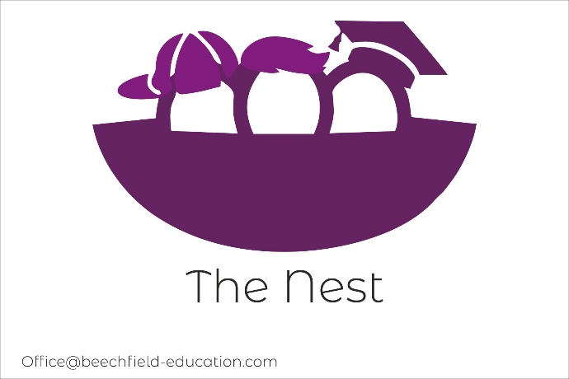

The Nest -Accessibility Plan

Aims of the Accessibility Plan

This plan outlines how the school aims to increase access to education for pupils with disabilities in the three areas required by the planning duties in the Equality Act 2010 (i.e. the curriculum, physical environment and information).
A person is regarded as having a disability under the Act where they have a physical or mental impairment that has a substantial and long-term adverse effect on their ability to carry out normal day-to-day activities.
This plan aims to:

- Increase the extent to which pupils with disabilities can participate in the curriculum.
- Improve the physical environment of the school to enable pupils with disabilities to take better advantage of education, benefits, facilities and services provided.
- Improve the availability of accessible information to pupils with disabilities.

The above aims will be delivered within a reasonable timeframe, and in ways which are determined after taking into account pupils’ disabilities and the views of parents and pupils. In the preparation of an accessibility strategy, the LA must have regard to the need to allocate adequate resources in the implementation of this strategy.
The Senior Leadership Team also recognises its responsibilities towards employees with disabilities and will:

- Monitor recruitment procedures to ensure that individuals with disabilities are provided with equal opportunities
- Provide appropriate support and provision for employees with disabilities to ensure that they can carry out their work effectively without barriers.
- Undertake reasonable adjustments to enable staff to access the workplace.

The plan will be resourced, implemented, reviewed and revised in consultation with:

- Pupils’ parents.
- The Governing Body and other relevant members of staff

This plan is reviewed every year to take into account the changing needs of the school and its pupils. The plan is also reviewed where the school has undergone a refurbishment.

The accessibility audit

  - The Senior Leadership Team will undertake an annual Accessibility Audit.

  - The audit will cover the following three areas:

    - Access to the curriculum – the Senior Leadership Team will assess the extent to which pupils with disabilities can access the curriculum on an equal basis with their peers.

    - Access to the physical environment – the Senior Leadership Team will assess the extent to which pupils with disabilities can access the physical environment on an equal basis with their peers.
    - Access to information – the Senior Leadership Team will assess the extent to which pupils with disabilities can access information on an equal basis with their peers.

  - When conducting the audit, the Senior Leadership Team will consider all kinds of disabilities and impairments, including, but not limited to, the following:

    - Ambulatory disabilities – this includes pupils who use a wheelchair or mobility aid
    - Dexterity disabilities – this includes those whose everyday manual handling of objects and fixtures may be impaired
    - Visual disabilities – this includes those with visual impairments and sensitivities
    - Auditory disabilities – this includes those with hearing impairments and sensitivities
    - Comprehension – this includes hidden disabilities, such as autism and dyslexia

  - The findings from the audit will be used to identify short-, medium- and long-term actions to address specific gaps and improve access.

  - All actions will be carried out in a reasonable timeframe, and after taking into account pupils’ disabilities and the preferences of their parents.

  - The actions that will be undertaken are detailed in the following sections of this document.

Planning duty 1- Curriculum

 | Issue | What | Who | When | Outcome | Review
Short term | Increase access to the curriculum for pupils with a disability | Support from curriculum lead, additional training for staff | Curriculum manager and Senior Leadership Team | Ongoing | All Pupils to access the curriculum | Annually
Short term | Individual needs and engagement of pupils | To deploy Teaching Assistants.  Review resources, both staffing and physical space. | Deputy head of school and curriculum manager | Ongoing | Pupils needs are appropriately met through effective deployment of skilled support staff.  Both staffing and physical space are used for maximum impact, providing  the highest quality provision | Annually
Medium term | Monitoring of data to ensure all pupils are accessing the full curriculum entitlement needed to ensure progress. | Ensure data is shared with and understood by all relevant parties.  Ensure termly pupil progress meetings take place and all  data analysed. | Curriculum manager and Senior Leadership Team | Ongoing | Where pupils are not making expected progress, they are quickly identified, and appropriate targets set, and support is given | Annually

Medium term | Evaluation of how the curriculum is meeting the learning needs of SEND pupils | Audit of curriculum | Curriculum manager and Senior Leadership Team | Ongoing | Management and teaching staff are aware of the accessibility gaps in the curriculum | Annually
Medium term | ICT access for pupils | To continue to recognise that ICT can promote accessibility and so the school remains proactive in seeking best practice. | Senior leadership Team | Ongoing | Appropriate use of ICT allows all pupils to access the curriculum independently. | Annually
Long term | Official examinations to be held on the school premises. | To be able to take exams in the school | Senior leadership Team | 2024 | Progression routes and access to official examinations | Annually

Planning duty 2- Physical environment

 | Issue | What | Who | When | Outcome | Review
Medium term | The school’s physical environment is not accessible to physically disabled pupils. | Move to a premises that have disabled access. | Managing Directors | Ongoing | A Material change application has been submitted to the DFE. | 2024
Medium term | Learning environment of pupils with visual impairments is not accessible | Incorporation of appropriate colour schemes | Building Contractors | 2023 | Learning environment is accessible to pupils with visual impairments | Annually

Long term | Access to lessons for pupils with a hearing impairment | Microphones and sound system to be put in each classroom. | Building contractors | 2024 | Any referrals for children with hearing impairments can be accepted. | September 2024

Planning duty 3- Information

 | Issue | What | Who | When | Outcome | Review
Short term | School information is not understood in written form by parents with English as an additional language. | Different forms of information will be created to allow access. This will be done on a case by case basis depending on their individual needs. | Senior Leadership Team | Ongoing | Parents with EAL will be able to access the information that we share. | Annually
Medium term | Written information is not accessible to children and parents with visual impairments. | Provide written information in alternative formats suitable for the individual needs of each parents. | Senior Leadership Team | 2024 | School is aware of local services for converting written information into alternative formats so that written information is fully accessible to children and parents with visual impairments. | Annually

Long term | No school website | To set up a school website. | Management | 2024 | Website is fully accessible | Annually

