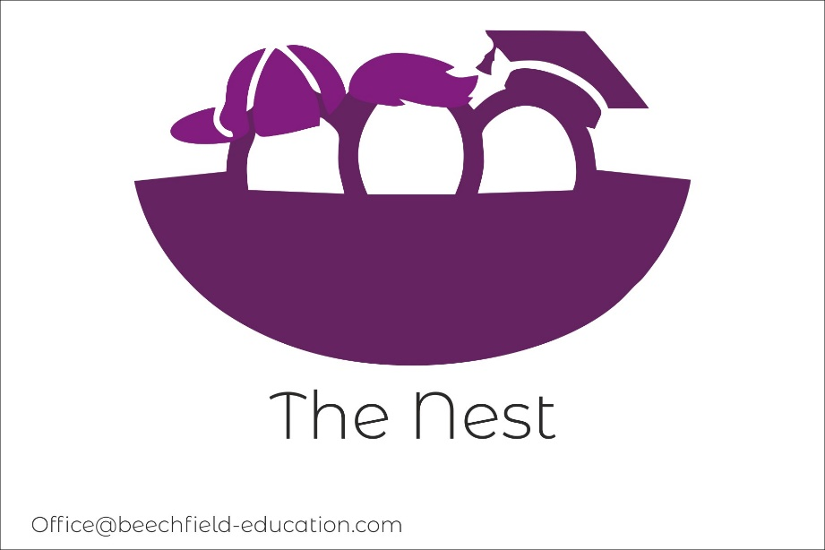

The Nest: Pupil Admissions Policy

Introduction and Aims
The aim of the Beechfield School is to provide a safe, nurturing, fun, and creative environment for children from key stage 2 to key stage 4 with SEMH needs to access a broad and balanced curriculum. The school will help each child to reach their potential, through a tailored curriculum, which encompasses enrichment and physical activities.. At our school there will be an appropriate balance between - supporting children to access and make progress within a suitable curriculum, which is differentiated for their needs; Whilst ensuring we are also prioritising the developmental and life skills and focussing on building children’s self-esteem and confidence. We believe this will create a holistic education plan for the children.
Children do not require a diagnosis to attend The Beechfield school, however there will evidence to suggest a mainstream education environment is not suitable for their individual needs.
A child could begin with The Beechfield School at any point in the school year. In all cases, the head of school, Liam Barlow will liaise closely with the current school to understand the needs of the child and gather information on strategies the school have implemented to support the child. The head of school will also liaise closely with parents/carers and child to develop a transition plan that will enable the child to successfully begin and feel safe within our school. If the child is not attending a school, the head of school will only liaise with the parents/carers and any other external agency, if it is deemed appropriate to do so at this stage.
- Referrals for an alternative provision pace at the Beechfield School are received directly from the child’s existing school. The application in this instance would come directly to the head of school from either the head teacher or SENCO team. If the child has an EHCP in place the team in the local authority would be involved and this arrangement would be discussed with the team and the Beechfield school would be added as part of the child’s EHCP.

- If a child has an EHCP and the request is for a child to come on role and have a school place at the Beechhfield School, the flow chart below details the process between school and the local authority for this to happen. This is called the consultation process.
In all cases, please contact the head of school Liam Barlow, liam@beechfield-education.com for more information.

Please see below for the consultation process and admissions flow chart:

Once a placement has been agreed with the Local Authority, the following process will begin:

