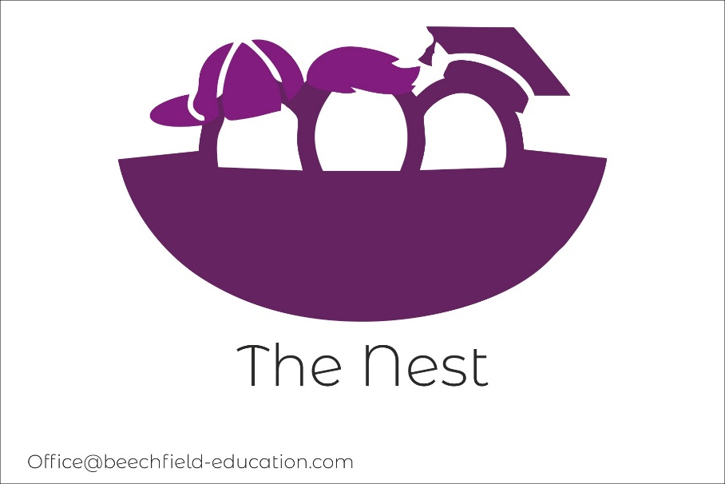

The Nest: Curriculum Policy

Aims
It is the aim of our school that every member of the school community feels valued and respected, and that each person is treated fairly and well. We are a caring community, whose values are built on mutual trust and respect for all. It aims to promote an environment where everyone feels happy, safe, and secure and able to learn. Through the school’s core values, staff show consistent high standards which are inherent throughout the school in both behaviour and teaching and learning at the Nest, which in turn will encourage the students to have high expectations of themselves. At the Nest we aim to give our students appropriate experiences to develop into confident and responsible citizens.
Core Values
- Respect
- Fairness
- Compassion
- Caring
These values underpin everything we do at the nest which will have a positive impact in our students.
Impact of our values
- Develop resilience
- Develop confidence
- Develop courage
- Feel valued
- Develop empathy
- Work hard
- Be more focussed
These shape our curriculum, employ the vision, aims and values of the school as well as responding to the particular needs of our community and children.

The Beechfield School seeks to promote a curriculum that is accessible to all pupils, one that directs them towards key social, emotional, and academic skills appropriate to their needs, development, and ambitions. Our curriculum will enable them to experience personal development and achieve academic success.
At The Beechfield School, all children have access to a broad, balanced, relevant and holistic education, that supports and challenges them appropriately. Through careful planning, work is sequenced towards supporting children to gain confidence in the knowledge they acquire and progress to the next stage of learning, meeting the individual needs of each pupil. Staff at The Beechfield School support pupils to develop a positive attitude to learning through the creation of a consistently safe, nurturing, playful environment, where they feel valued and supported to learn and challenge themselves. This includes opportunities to experience a sense of personal achievement in each school day.
The Beechfield School supports children who find mainstream school a challenge, and in response display challenging behaviour. Access to our curriculum is underpinned by our delivery of lessons and interaction with students through the PACE model (Playfulness, acceptance, curiosity and empathy). We aim to build a consistent, trusting relationship with children, based on respect for the child and acceptance of their needs, throughout the learning experience.
Our learning, through activities, accelerated and stealth learning, as well as targeted support, including individual projects where appropriate, meet the national curriculum objectives where appropriate in conjunction with creative and stealth learning styles, to foster better engagement with the acquisition and development of key skills and knowledge at each Key Stage.

INCLUSIVE EDUCATION

At The Beechfield School, we endeavour to deliver an inclusive curriculum that responds best to each pupil’s needs and aspirations. These include: more able pupils; pupils with low prior attainment; pupils from disadvantaged backgrounds; pupils with SEN; Pupils with English as an additional language (EAL).
SEN: Lessons are planned to support pupils with SEN, so that they can study English and Maths based on the National Curriculum, and all other subjects wherever possible, and ensure there are no barriers to every pupil achieving. Support is available on a 1:1 basis where appropriate to foster better engagement.

More able: We encourage those who are more able, to stretch their learning and deepening of their understanding through further experiential elements. They also have the opportunity to complete extension activities where appropriate in lesson time or at home.
EAL: Lessons will be planned so that teaching opportunities help pupils to develop their English, and to support pupils to take part in all subjects.
Pupils from disadvantaged backgrounds: We make sure that all children, irrespective of family income, have access to the same opportunities as children who may not face financial hardship. Therefore, all pupils are provided with the same learning equipment, including equipment needed for sport and cooking, to provide all children with a better chance of equality of opportunity. Students on FSM will receive their food paid for by the school. All students, irrespective of income will have their trips and off-site visits paid for.
Pupils with low prior attainment: Lessons will be planned to identify and support students to close the gaps in their knowledge and learning. We will work closely with students to identify any contributing factors to the low prior attainment such as low attendance at school, unidentified SEN, etc.

OUR INTENTIONS AT THE NEST:
At The Beechfield School, our aim is to deliver measurable outcomes that demonstrate:
- Increased ability to make and maintain positive relationships with staff and peers.
- Improved self-regulation (managing own emotions and behaviour)
- Decreased anxiety around uncertainty and change
- Increased independence around decision making and positive life choices
- An increased level of achievement both academically and personally.

HOW DO WE IMPLEMENT THIS?

Our curriculum
At The Beechfield School, all students will have access to learn, develop, and embed their knowledge in numeracy and literacy. These areas will be assessed within 6 weeks of arriving at The Beechfield School, with flexibility to cover the curriculum areas according to pupil’s ages, stage of development, ability and interest. PHSE and PE lessons are taught each week to develop their mental and physical wellbeing, at age/development appropriate levels.
Staff meet on a regular basis to review curriculum subjects and develop planning, to ensure we are meeting the needs of all students. Where necessary, lesson plans and opportunities for learning will be adapted and modified to allow students to be successful and meets their SEMH needs, which will support an increased level of engagement with their learning.
Our curriculum manager will meet with staff twice a term to monitor staff planning and provide support which ensures pupils will have access to a broad and balanced curriculum, experiencing all areas of learning. The Head of the Beechfield School and the curriculum manager will complete lesson observations each term to ensure effective teaching and learning is taking place with meaningful engagement taking place, as well as effective and consistent marking and feedback to pupils, to ensure students understand how to progress.
A day at The Beechfield School
- The school day starts with a ‘How are you?’ introduction and welcome into school. Children/parents/guardians/carers have the opportunity to speak to members of staff with concerns or worries prior to the start of learning.
- The next sessions focus is on 45 minutes of wellbeing time, which will include walking the therapy dog, Lego, Mindfulness activities etc. •
- There will be 2 lessons which will focus on learning core or one of the chosen subjects such as history.
- Lunch
- 1 lesson on either a core or subject such as French.
- 1 hour reward activity. This 1-hour reward activity will never be used as a sanction. If a student cannot engage in that activity, e.g., due to a safeguarding concern for that child/other child, another activity will be provided for that child.
The structure of the day is key to maximising pupil engagement and achievement within our setting as a special school for children with SEMH.

The curriculum follows the Key stage 3 National Curriculum, which is adapted and tailored to suit individual learning. All work is differentiated to the ability of the student; we understand that students may have learning gaps due to various reasons, such as poor attendance at their previous school lack of engagement or inadequate support for their individual needs. There are lots of opportunities within the curriculum for students to revisit or learn the level of topics within the KS1 and KS2 curriculum.
At the Nest we have 3 pathways that students can follow and can move between and within each one.
For YR7 AND 8
- The first pathway is a formal curriculum where students study and have experiences of a variety of subjects.
- A 1:1 pathway where students who need extra SEMH support have a specific programme which will focus on these needs.
- A practical programme where students study core subjects and practical subjects such as gardening, art, music, dance, drama.
Yr9
Students will follow core subjects plus a chosen workshop experience and a variety of Unit awards such as driving theory and a variety of employment encounters.
All students will follow a progressive careers programme which will be a discrete lesson as well as being taught throughout the curriculum.
The White Rose curriculum is followed for Maths and offers opportunities for differentiated teaching using the lower and higher attainment tasks and key concepts.
Students at the Nest have access to a broad, balanced, and enriching curriculum which covers the subject areas as outlined below. There are also opportunities for students to take part in dance, music and drama through external workshops where appropriate.
There are opportunities for students to participate in extra- curricular activities and the following areas are offered such as:
- Football
- Art and Design

Key Stage 3 curriculum:
ENGLISH | MATHS | SCIENCE
RELIGIOUS EDUCATION | PSHE and RSHE | FRENCH
DESIGN AND TECHNOLOGY | PHYSICAL EDUCATION | HISTORY
GEOGRAPHY | Computing | Citizenship
Art | Careers | Music/dance/drama

Key Stage 4 curriculum:
At KS4 students will be offered one of three pathways:
1.) The first one is a formal curriculum where students will attend the Nest for 5 days. They will follow a variety of subjects which will include core subjects plus their chosen subject and a vocational workshop
2.) The second one is a vocational curriculum where students will study core subjects for 3 days a week at the Nest with two days at their chosen Alternative Provider such as motor vehicle or construction.
3.) The third one is where students will follow a staff to student ratio of 1:1 which will be mainly at the Bridge Centre and offsite learning. These students will study English and Maths, PSHE/RSE, PE/Activities, Careers, Citizenship and their option choices.
All students will have an individualised timetable to suit their needs and abilities and to make progress towards their SEMH and SEND targets.
Students at the Nest will have access to functional Skills from (Entry Level 1 to Functional skills level 2) for Maths, English, Science and ICT and computing. We are keen to promote life skills in all children to help prepare them for life after school, therefore, Staff will also teach the AQA unit awards, which covers a whole range of interest areas such as gardening, cooking and art, languages etc. Once the activity has been completed, they will receive a recognised certificate, this will support to develop their strengths and interests ready for positive post 16 options.
As part of our curriculum at KS4 we will also be offering workshops in woodwork and hospitality and catering in collaboration with local providers. We feel that offering a vocational route is essential for our students to develop their own interests and employability skills.
We also strive to provide employment encounters, by developing links with local businesses.
Other subject areas within the KS4 curriculum are:
Physical education | Citizenship | Religious education
Careers | AQA Unit Awards | PSHE and RSHE

As we are a school supporting children who have SEMH, PHSE lessons will form an integral part of their learning and development. PHSE lessons will follow age-appropriate topics or be modified to deal with current issues that may need to be addressed by the current cohort.
WHAT IMPACT DO WE AIM TO SEE?
With support, pupils should:

- Demonstrate how to be adaptable, solve problems in different situations, work independently and as a team member.
- Begin and develop a set of moral values such as honesty, sincerity, personal responsibility, and to understand the importance of these values through experience.
- With support, guidance, and modelled behaviour from staff, in an environment of high nurture and expectations, each child will learn and demonstrate how to behave in an acceptable and responsible way and become responsible for their own actions.
- Learn how to communicate their knowledge, feelings, and thoughts in an appropriate and safe way.
- Know how to stay healthy and safe.
- Be prepared for the next stage of learning and post16.

ASSESSMENT
At The Beechfield School, all pupils will have a ‘settling in’ period of 6 weeks, whereby staff will assess through observation of interaction with learning, attainment data from school, what level the student is currently working at socially, academically, and emotionally.
Baseline levels for English reading and comprehension and maths and science are assessed formally within the first 6 weeks of a pupil beginning at the Nest. The levels are recorded on our online system and the staff will then work with the pupil and staff team to monitor progress of subjects using the I Can Statements.

Students will also complete an ELSA assessment within the first 6 weeks, this will help to develop a 6-week targeted support programme, which focusses on their SEMH needs. The assessment will be repeated after the 6 weeks and staff will monitor and record the progress and plan for future interventions.

This information will inform the creation of their personal curriculum targets to support their individual academic and SEMH needs. Pupils may arrive after long absences from school or sporadic school attendance, meaning there are gaps in learning. Conversely, some students may be working at expected levels of attainment but may have experienced barriers to learning. A pupil’s progress will be tracked against the I can statements’, based on the outcomes of our observations, marking and engagement with learning.
Students will be taught on a 1:1 or small group basis depending on the activity or needs of the pupils, with work differentiated to support, stretch, and challenge appropriately.
Academic and SEMH targets will be outlined clearly on an IEP, which will be reviewed and shared with parents/guardians/carers, and the pupil where appropriate, in half termly review meetings. Within each half term, pupils will be given between 2 and 3 specific targets relating to their SEMH and academic needs and aspirations, that will be working towards fulfilling the broader targets on their IEP. These individual targets will be discussed discreetly with each pupil on a 1:1 basis and will be revisited with them where appropriate. This will support students to progress academically, and of the have a positive impact on their SEMH development.

