TeamApp Information
This document will act as a quick reference guide to items you can configure within TeamApp to get the most out of the platform for our use cases.

Notifications

View current and past notifications. On the main home screen of the app there is a bell symbol in the top right corner. Click on this to view new unread as well as historical notifications.
  - 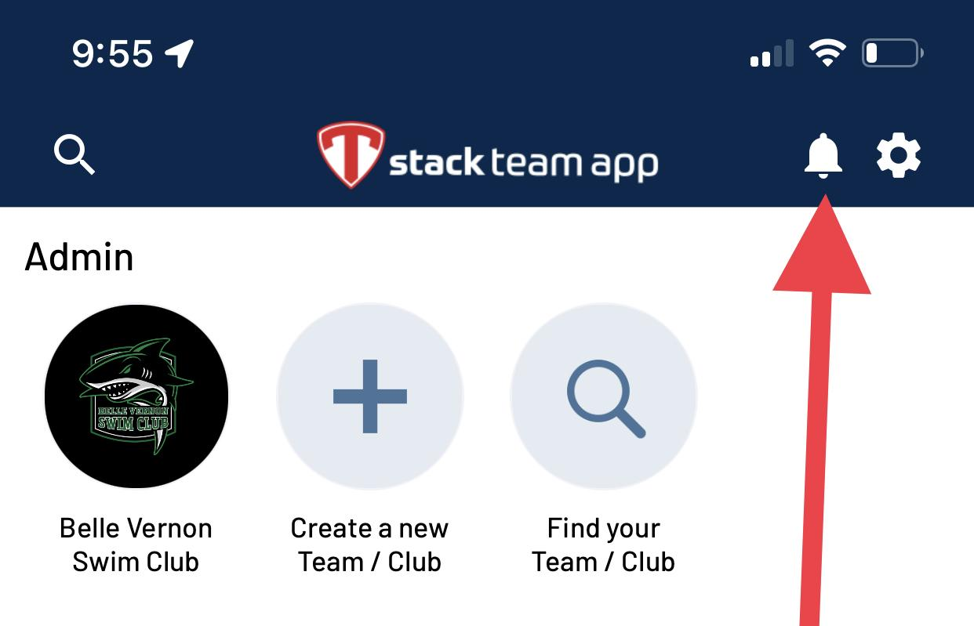
- Why am I not receiving notifications or seeing all the information I require?

- How do I turn on or off chat room notifications?
  - Any chat with a strike through the bell symbol will NOT get notifications.In the example below the “Lost and Found” chat is an example of one that will not get notifications when someone else replies to the chat.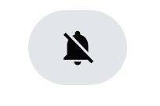

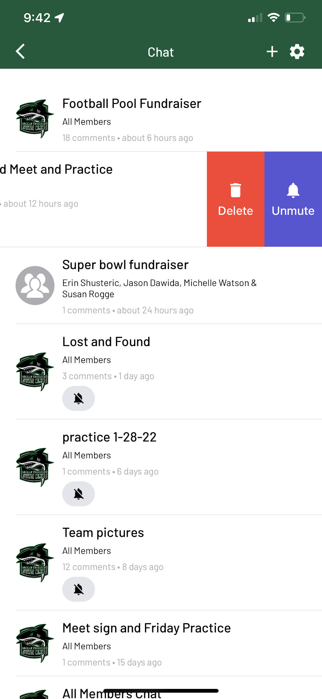

Schedule vs. Special Events
- We currently utilize the Schedule to track swim meets primarily.
- The Special Events section is used for activities such as pizza parties, team photos, parent meetings, etc as they come up.

Schedule View
By default the view provided in the schedule window is a calendar view (First Image). Click on the three horizontal lines in top left to switch to line item view. This view tends to be simpler to navigate (Second Image).
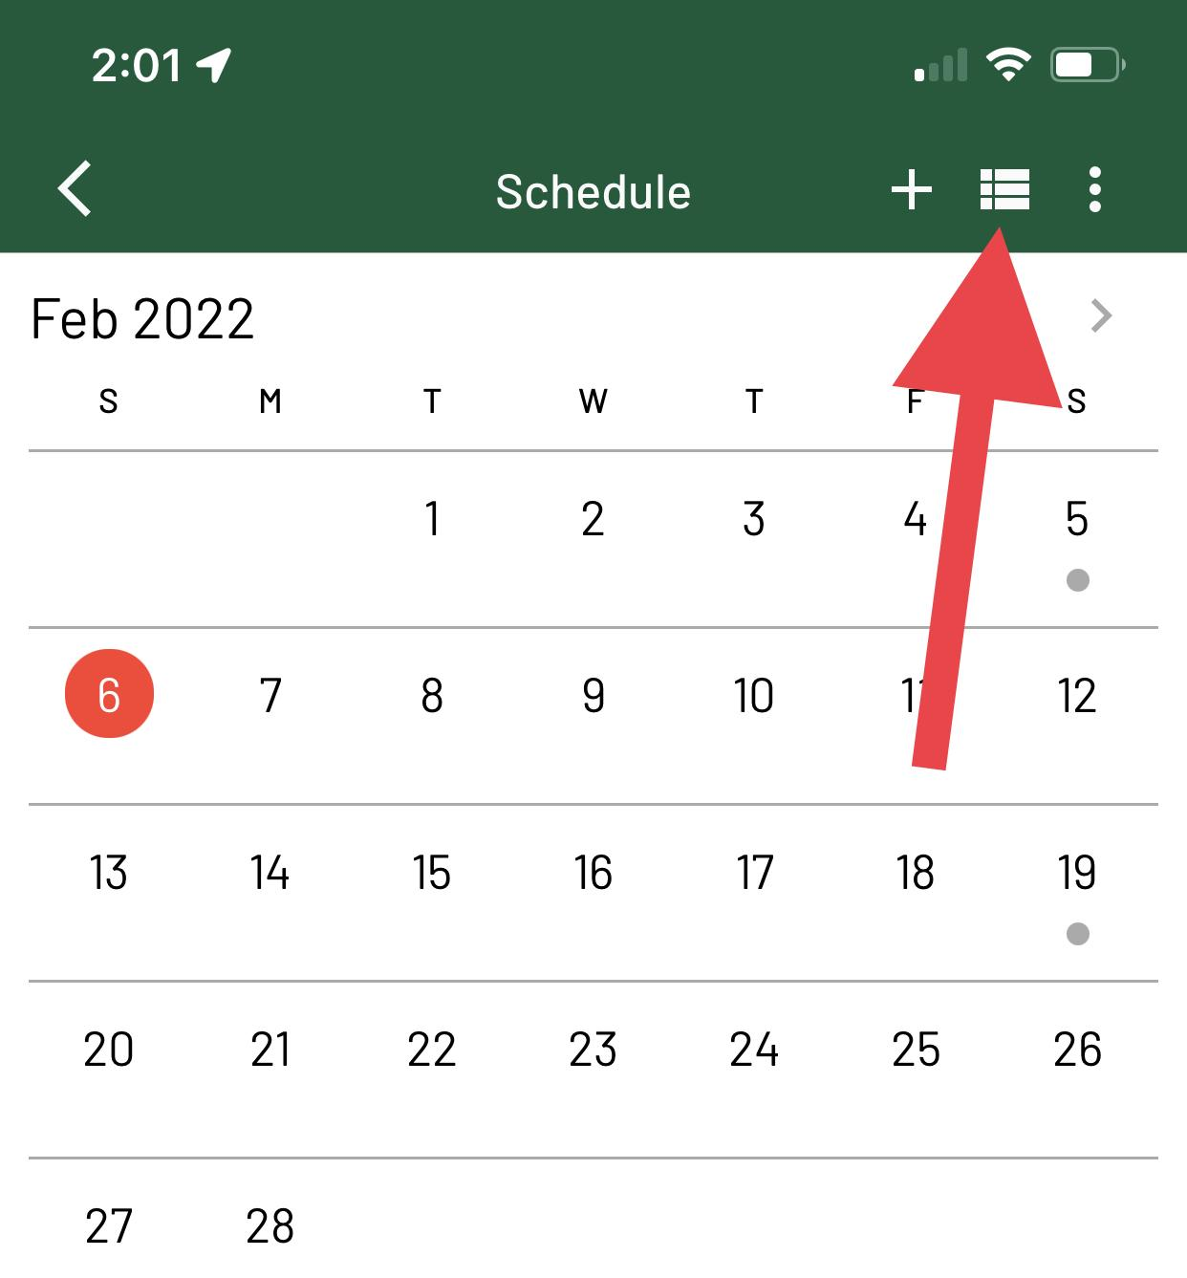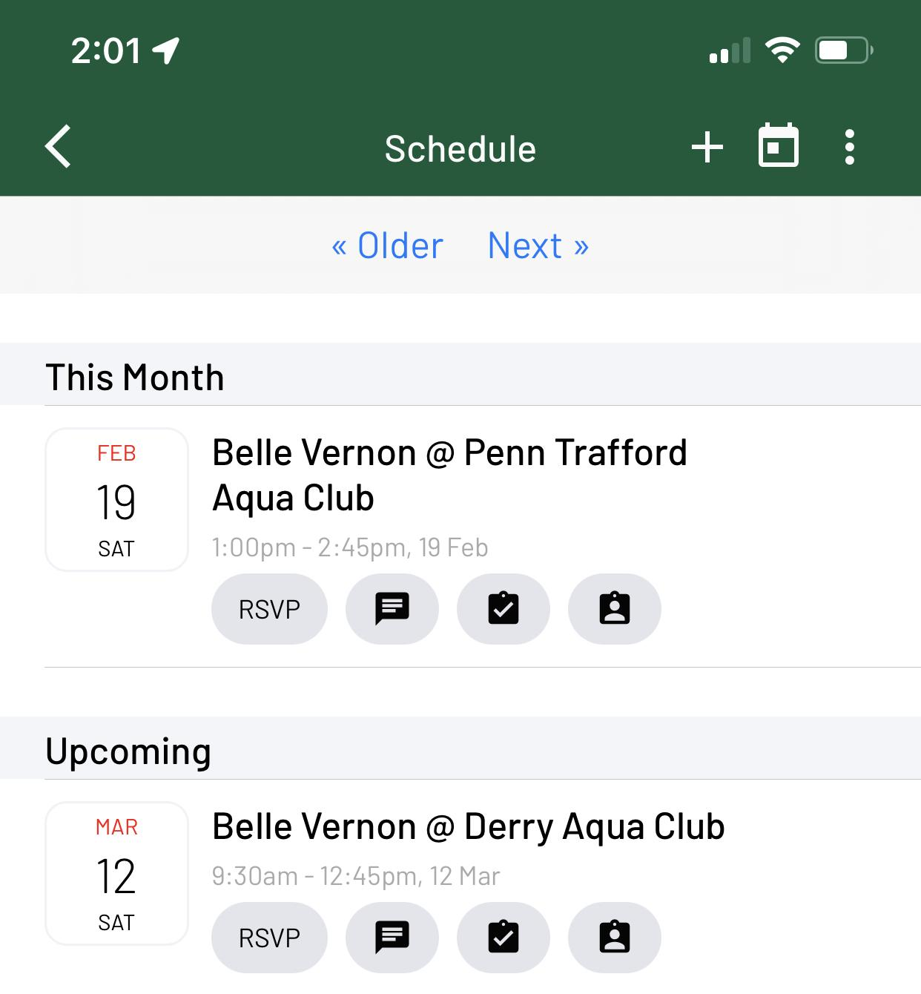

Chat
- Should be used to have private conversations with the club, similar to email, or a group of members.
- Only members that are notified via the app will receive a message. Email users will not get notified of a new chat or replies to a chat.
- Can be used to send one time message to the entire club.
  - Keep in mind that only the initial message notifies members and only those members with the app will get notified. Any users that are email only will not be notified.
  - Subsequent replies in the chat by default will not notify members unless they unmute the chat.

News
- Primary method to relay important club information to members.
- All members will be notified when news is created regardless if the member gets notified via the app or email.

Other FAQs
- TeamApp FAQs Website

