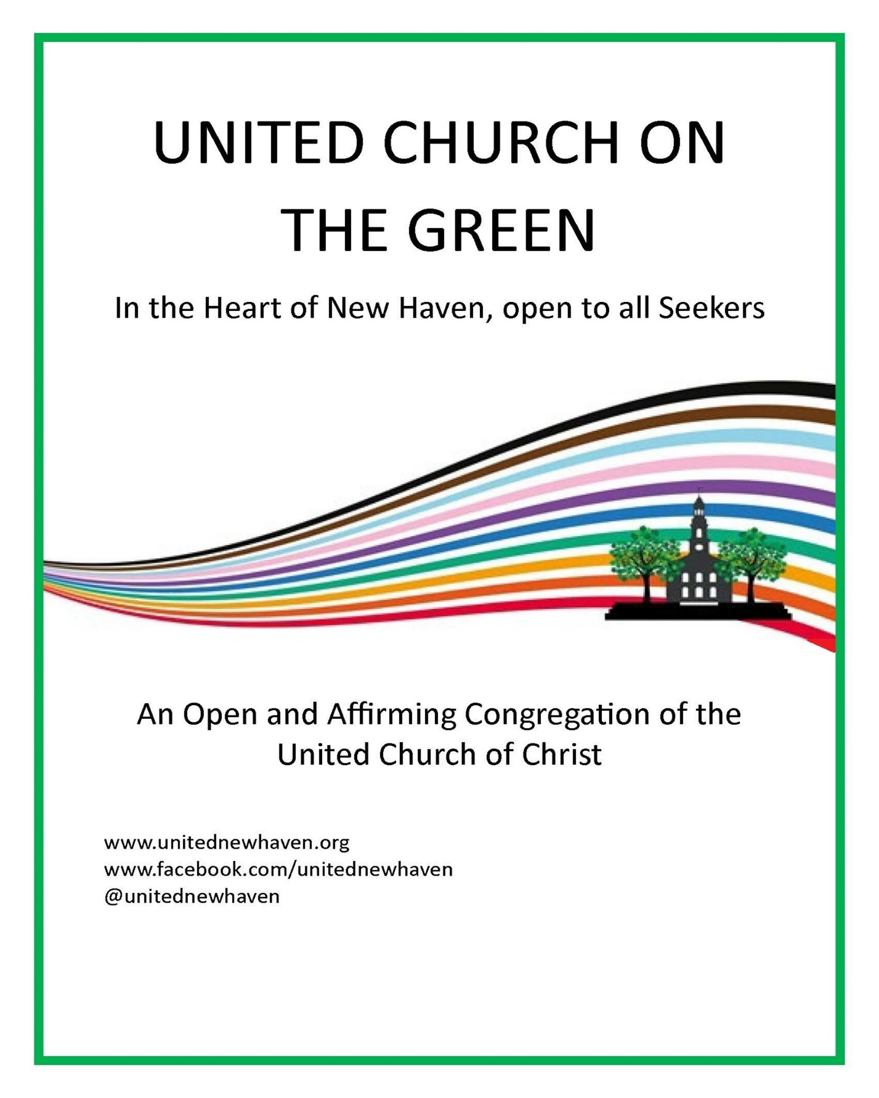

In a world where Christianity is too often associated with intolerance, exclusion, and hate, the mission of United Church on the Green is to proclaim Christ through faith, hope, and love. We are a community of many races, ethnic backgrounds, religious experiences, ages, sexual orientations, and gender identities. No matter where you are on your journey of faith, you will have a home here at United Church on the Green.

October 11, 2026 10:00AM Pentecost 20A

We Gather as Church
*Please stand as you are able
PRELUDE There is a Fountain (Early American Folk Hymn), arr. by Mark Hayes
Preformed by Karen Clute on piano

CALL TO WORSHIP
One: We come, God of the Journey, a people from different places, different histories, different lifestyles.
All: We come hoping to find companionship for the journey, solidarity for the struggle.

One: We gather, God of Hospitality, around your “welcome table, a table not yet round, but rounding.
All: We gather seeking to become a “‘round-table people, welcoming of all, with no preferred seating, no firsts and no lasts and no corners for ‘the least of these.’

One: We yearn, God of the Rainbow, for a new way of living and relating as neighbors not strangers, as siblings and kin not ‘them and us.’
All: We yearn to live fully celebrating both the diversity of our human family, and the unity of our call to love and justice.

One: We hunger, God of Abundant Life, for lives that have meaning and integrity, and for relationships grounded in mutuality and respect.
All: We thirst for places to bring our doubts, our fears; places to express honestly who we are. We thirst for hope and encouragement as we struggle to follow Jesus in the way of life-risking love.

One: With the gift of your grace we are nourished.
All: With the promise of your presence may we be strengthened to be faithful. Amen.
*HYMN #106 Jesus, Joy of Our Desiring JESU, JOY OF MAN’S DESI
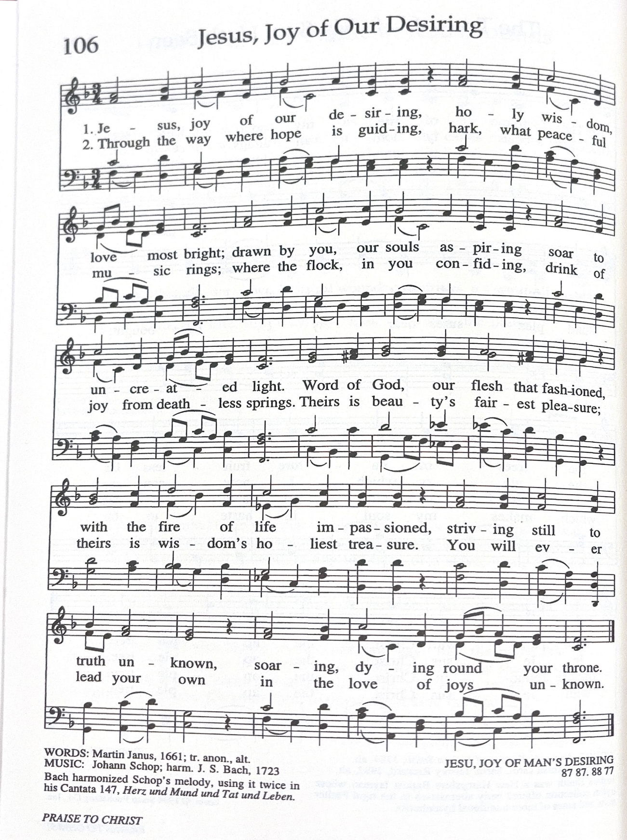

The Bible is Brought into the Sanctuary

GATHERING PRAYER (Unison) Rev. Dr. Stephen G. Ray, Jr.

We give thanks to you, Oh God, for you are good; for your steadfast love endures forever. You have redeemed us from trouble and gathered us in from the lands, from the east and from the west, from the north and from the south. When we cry to you in trouble, you bring us out of our distress.
We thank you God for your steadfast love, for your wonderful works to humankind. We lift up your name here in the congregation of the people and praise you in the assembly of the elders. We worship you here, today, together. Amen.

CHILDREN’S GATHERING
All children are invited to come to the front for a brief time of greeting and prayer. Afterward, children are invited to go to the children’s room, or children may stay with their parents.

Children’s Sermon and Sing-Along
All things bright and beautiful
All creatures great and small
All things wise and wonderful
The Lord God made them all

PRAYER OF CONFESSION Abram Guerra
Gracious God, you tell us to love one another–to love others the way we so naturally love ourselves. Yet each of us must admit that we have failed to do so. Jesus taught us to love our neighbors even if they don’t look like us, even if they don’t think like us, even if they don’t love like us, even if they don’t pray like us, even if they don’t speak like us, even if they don’t vote like us. But we have failed to love one another with no exceptions.
Brief period of silence
Forgive us Holy One and make us again in your image of Love. Blot out our sins, renew our minds, rekindle our hearts, and guide us by Your Holy Spirit into the Love that is your will. Amen.

HYMN RESPONSE Spirit of Love in This Place MEDEMA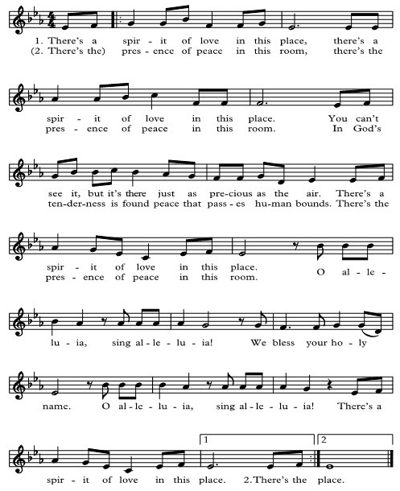
ASSURANCE OF PARDON
One: Siblings in Christ, God’s Spirit did not leave us after that first Pentecost. The Spirit is still with us, empowering us to know mercy and grace, forgiveness and service. In this Spirit, and through Christ, we proclaim the Good News: All: We are forgiven Alleluia! Amen.

We Listen for God’s Word

SCRIPTURE ^{The Golden Calf} Kerry Snyder

32 When the people saw that Moses delayed to come down from the mountain, the people gathered around Aaron and said to him, “Come, make gods for us, who shall go before us; as for this Moses, the man who brought us up out of the land of Egypt, we do not know what has become of him.” 2 Aaron said to them, “Take off the gold rings that are on the ears of your wives, your sons, and your daughters and bring them to me.” 3 So all the people took off the gold rings from their ears and brought them to Aaron. 4 He took these from them, formed them in a mold,[a] and cast an image of a calf, and they said, “These are your gods, O Israel, who brought you up out of the land of Egypt!” 5 When Aaron saw this, he built an altar before it, and Aaron made a proclamation and said, “Tomorrow shall be a festival to the Lord.” 6 They rose early the next day and offered burnt offerings and brought sacrifices of well-being, and the people sat down to eat and drink and rose up to revel.
7 The Lord said to Moses, “Go down at once! Your people, whom you brought up out of the land of Egypt, have acted perversely; 8 they have been quick to turn aside from the way that I commanded them; they have cast for themselves an image of a calf and have worshiped it and sacrificed to it and said, ‘These are your gods, O Israel, who brought you up out of the land of Egypt!’ ” 9 The Lord said to Moses, “I have seen this people, how stiff-necked they are. 10 Now let me alone so that my wrath may burn hot against them and I may consume them, and of you I will make a great nation.”
11 But Moses implored the Lord his God and said, “O Lord, why does your wrath burn hot against your people, whom you brought out of the land of Egypt with great power and with a mighty hand? 12 Why should the Egyptians say, ‘It was with evil intent that he brought them out to kill them in the mountains and to consume them from the face of the earth’? Turn from your fierce wrath; change your mind and do not bring disaster on your people. 13 Remember Abraham, Isaac, and Israel, your servants, how you swore to them by your own self, saying to them, ‘I will multiply your descendants like the stars of heaven, and all this land that I have promised I will give to your descendants, and they shall inherit it forever.’ ” 14 And the Lord changed his mind about the disaster that he planned to bring on his people.

*HYMN #437 It’s Me, It’s Me, O Lord PENITENT 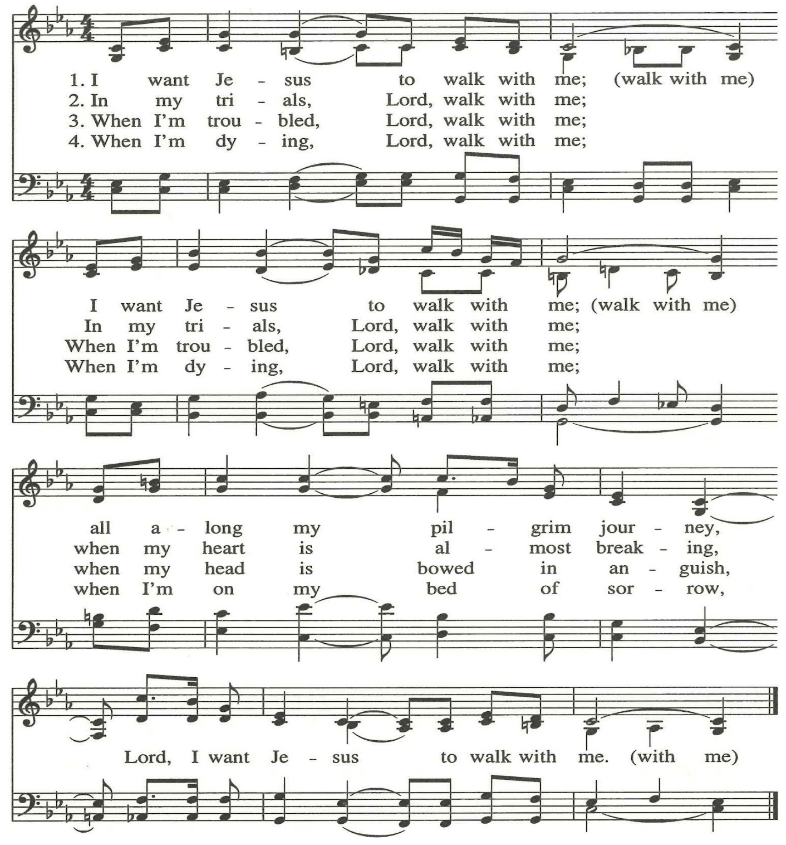

SERMON Rev. Dr. Stephen G. Ray, Jr.

MUSICAL REFLECTION I Lift My Eyes Up to the Hills by Paul Bouman

I lift up my eyes to the hills; from where is my help to come?
My help comes from the Lord, the maker of heaven and earth.
He will not let your foot be moved,
And he who watches over you will not fall asleep.
Behold he who keeps watch over Israel shall neither slumber nor sleep;
The Lord himself watches over you; the Lord is your shade at your right hand,
So that the sun shall not strike you by day, nor the moon by night.
The Lord shall preserve you from all evil; it is he who shall keep you safe.
The Lord shall watch over your going out and your coming in,
From this time forth for evermore.

God be in mine eyes and in my looking.
God be in my mouth and in my speaking.
God be in mine heart and in my thinking.
God be at my end and in my departing

PRAYERS OF THE PEOPLE
The Lord be with you… And also with you… Let us pray...
We join our voices to pray, rejoice and celebrate the good things of our life together and those who are celebrating their birthdays this week - Lisa Guerra and Hanna Peterman
Our prayers begin with rejoicing that in Your love and creativity you have made us a rainbow. Made us in Your image that is multi-splendored and too rich for simple definitions.
We give thanks for the Holy Spirit that is with Us, filling our hearts with hope and power.
With Us your children. Of every hue. Of every race. Of every culture and tongue.
Immigrants. Refugees. Queer. Trans. All of your children; especially those who need special care and protection in these times.
We pray for the many whose lives are being lost in senseless wars. For everyone but especially for the children. May their light not be extinguished because of cruelty and malice but continue to shine in our hearts.
We pray for our world, suffering the ravages of Climate Catastrophe.
Standing expectantly before an uncertain future, we pray for our children, their teachers, school staffs and administrators that they may together teach us to dream of a different world.
We pray for the unhoused in our own city who now face uncertainty because too many believe that warm weather erases their need.
We lift special prayers for those suffering hunger anywhere in the world.
We pray that wisdom and courage might lead those with plenty, to help make a better world for all.
We pray for those challenged by physical and mental illness and for we who love them.
We pray that as Your Church we will be a place of refuge that ever lives in the power of Hope.
SILENT PRAYER

PASTORAL PRAYER
And so, we pray with the words you taught us to pray:
Our Father/Mother/God/Creator, who art in heaven, hallowed be thy name. Thy kingdom come, thy will be done, on earth as it is in heaven. Give us this day our daily bread, and forgive us our trespasses, as we forgive those who trespass against us. And lead us not into temptation but deliver us from evil. For thine is the kingdom, and the power, and the glory, forever. Amen.

SHARING THE PEACE OF CHRIST
We invite you to greet one another with signs of peace

ANNOUNCEMENTS
OFFERING

OFFERTORY Open My Eyes by K. Lee Scott

Open my eyes and I shall see;
Incline my heart and I shall desire;
Order my steps and I shall walk
In the ways of your commandments.

O God, be my only Lord,
And beside you let there be none else,
No other, none else with you.

Teach me to worship you
And serve you in all my undertakings
With truth of spirit,
With honor of body,
With blessing of mouth,
Both in public and private.

Open my eyes...
Amen.

*DOXOLOGY
Praise God from whom all blessings flow;
Praise God, all creatures here below;
Praise God above, ye heavenly host;
Creator, Christ, and Holy Ghost. Amen.

*PRAYER OF DEDICATION
God, thank you, thank you, thank you – for your grace, for this community of faith, for the gifts of our lives. Bless these offerings today that they might be used to further your reign of righteousness here and now. Work through each of us and through the ministries of this congregation that we might glorify you in all we do. Amen.

We Are Sent Out
*HYMN #462 Where Cross the Crowded Ways of Life GERMANY 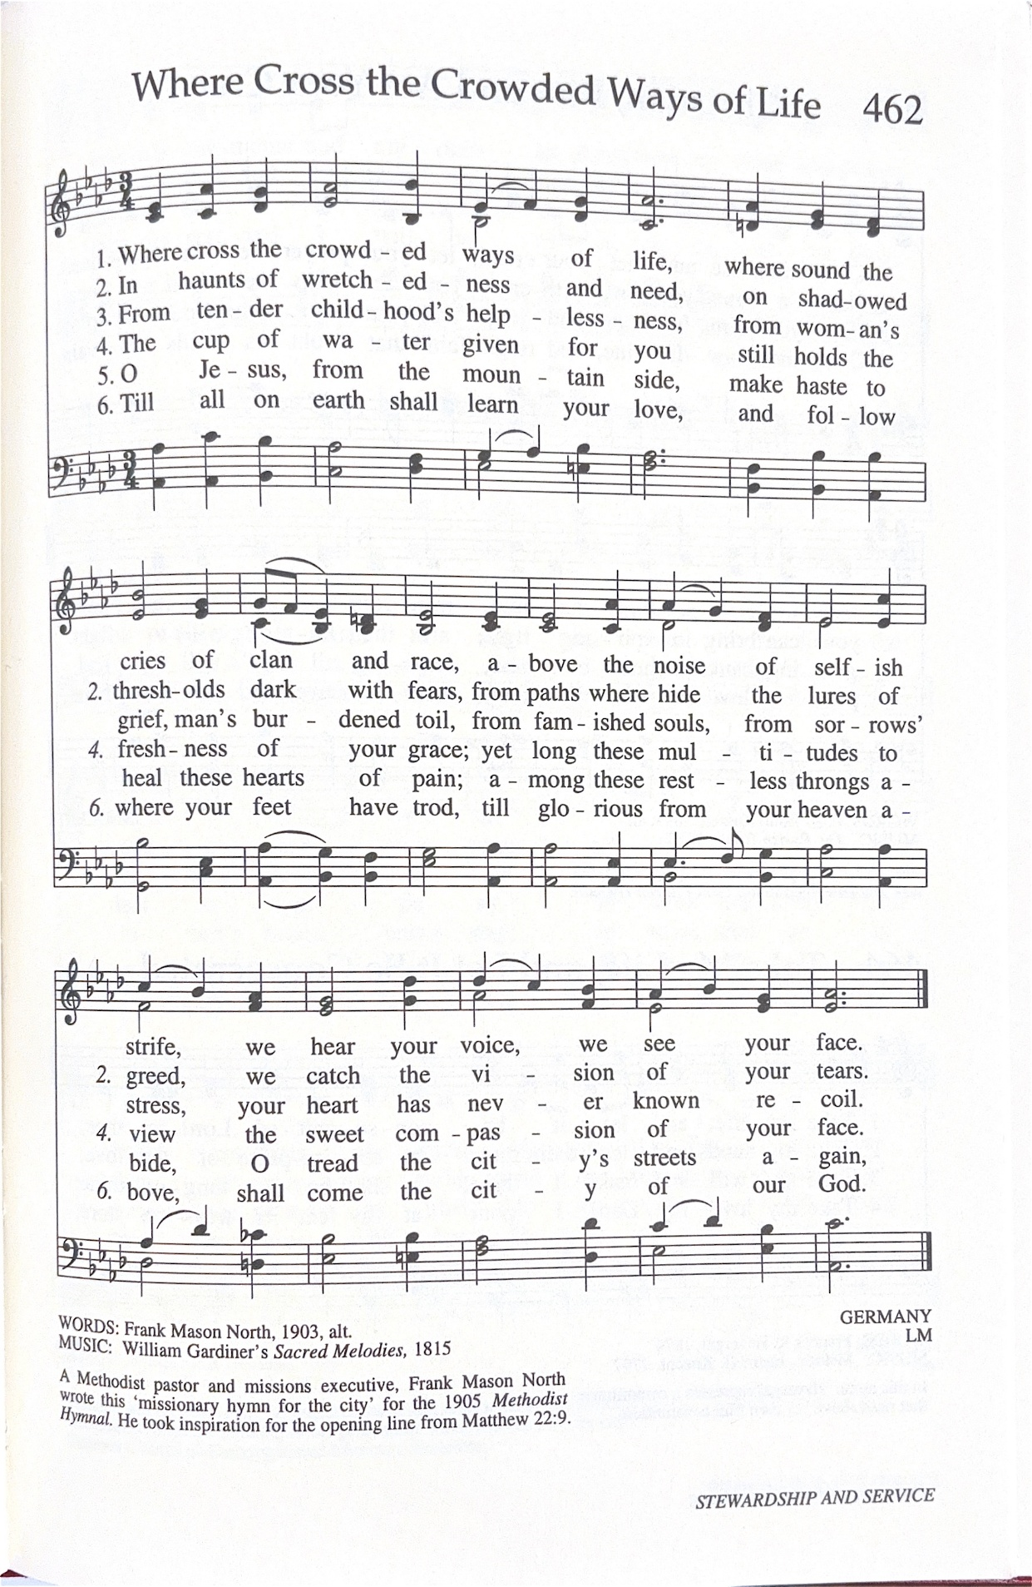

COMMISSION AND BLESSING

May God bless you with discomfort at easy answers, half-truths, and superficial relationships,
so that we may seek truth boldly and love deep within our hearts.

May God bless you with anger at injustice, oppression and exploitation of people,
so that we may work for justice, freedom and peace.

May God bless you with tears to shed for those who suffer pain, rejection, starvation, and war,
so that we may reach out our hands to comfort them.

And may God bless you with enough foolishness to believe that you can make a difference in this world,
so that we can do what others claim cannot be done.

Amen, Ameen, and Ashe!

POSTLUDE And the People Rejoiced (from Biblical Sonata No. 1), by Johann Kuhnau (1660-1722)
Preformed by Karen Clute on piano

Our Worship Has Ended. Let Our Service Begin!

Please join us at Coffee Hour after Worship
https://unitednewhaven.org/this-weeks-worship

THIS WEEK’S WORSHIP LEADERS

Senior Pastor Rev. Dr. Stephen G. Ray, Jr.
Director of Music Caesar Storlazzi
Interim Choir Director Grace Currie
Guest Keyboardist Karen Clute
UCG Choir Cher Balkcom, Judith Carlson, Tess Klibanoff, Chris Leimgruber, Ava Paul, Julia Blue Raspe, Daniel Rausch, Connor Reese, Mary Scanlon
Digital Deacons Worship & Music Ministry Team
Coffee Hour Coordinator Dale Richards
Head Sexton William Henton

THIS WEEK AT UNITED CHURCH

October 11th: 10:00AM Worship Service – Online + Meeting House
October 9th: 6:00PM Bible Study – Online
For Our Full Calendar, go to: www.calendarwiz.com/unitednewhaven

CHURCH NOTES
Musical Permissions
CCLI: 11242315, One License: A-736676
CCS WorshipCast: 22251728 All rights reserved.

MEETING HOUSE WIFI INFORMATION
WiFi Network: UCG Meetinghouse
WiFi Password: 2037874195

Year-Round Narthex Floral Display
﻿The Sacred Spaces Committee would like you to know that you don't have to wait until Easter or Christmas to remember or honor someone with Narthex Flowers. You can bring the floral arrangements yourself, or provide a monetary donation. Suggested donation is $40.
﻿Use a Flower Dedication Form, a Flower Offering Envelope or pay online: https://unitednewhaven.org/donate

At United Church on the Green, we seek to Do Justice, Love Mercy and Walk Humbly with God, following the footsteps of Jesus. We are also a Progressive Protestant Christian Church, a member of the Nationwide United Church of Christ (UCC).
We have a long history.
- Established 1742. Meetinghouse was built in 1815.
- The Amistad Incident? Abolition of slavery? The 1970 Black Panther trials? Divestment in South Africa? United was there.
We believe God is still speaking to the world today... and we're trying to listen.
- Not a "The Bible says it. I believe it. That settles it." kind of church. Questions encouraged. (Actually, they’re necessary.)
- "Open and Affirming" of gay, lesbian, bisexual, and transgender people since 1989.
We are working with God to build a better future.
- Not interested in "saving souls" or "converting the heathen." God's love is for all.
- Trying to "connect the dots" to grow peace, justice, and compassion in the world.

Staff Contacts
Rev. Dr. Stephen G. Ray Jr., senior pastor pastor@unitednewhaven.org
Caesar Storlazzi, director of music music@unitednewhaven.org
Maxim Schmidt, digital media administrator media@unitednewhaven.org
Nancy Lupi, financial secretary nancyalupi@gmail.com
Jack Russell, director of operations operations@unitednewhaven.org
Bailey Murphy, church secretary office@unitednewhaven.org

Rev. Louise B. Higginbotham, minister emerita
Rev. Dr. Bonnie Scott, minister emerita

United Church on the Green, UCC
Meeting House, corner of Temple & Elm
Parish House office, corner of Temple & Wall
323 Temple Street, New Haven, CT 06511

203-787-4195
www.unitednewhaven.org
www.facebook.com/unitednewhaven
@unitednewhaven

