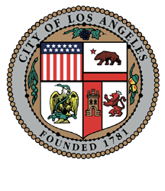
2023 AFRICAN AMERICAN HERITAGE MONTH CALENDAR AND CULTURAL GUIDE
ENTRY FORM FOR PROGRAMMING FROM FEBRUARY 1 TO MARCH 31, 2023

The deadline to return this information is November 28, 2022.

Please Type or Print the Following Information:

Title: ____________________________________________________________
Web Address: _____________________________________________________________
Date(s): _____________________________________ Time: ____________________
Public Info Phone Line: _________________ Cost: ____________
Sponsor/Hosts: ________________________________________________________
Contact Person: _________________________________________________________
Office Phone:___________________________________________________________
E-mail: _______________________________ Website: _________________________
Mailing Address:_________________________________________________________
Type of In-Person or Online Programming (e.g. lecture, exhibition, dance performance, etc.):
______________________________________________________________________
Description and Special Information (50 Words or Less):
______________________________________________________________________
______________________________________________________________________
______________________________________________________________________
Council District:_______________
Email or mail completed form by November 28, 2022 to:

Marcia Harris
Re: DCA 2022 AAHM
Whitley Company, Inc.
13428 Maxella Avenue, # 602
Marina del Rey, CA 90292
mwharris@whitleycompany.com

Questions: Please call 213.536.1378 or send an email to mwharris@whitleycompany.com.

